
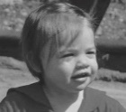

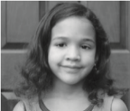
Every Tuesday 10 am-2 pm

Office Hours

To make a Donation or become a
Wish-grantor, Sponsor or Volunteer
GIVE US A CALL.
Phone: 302-698-1900

Mailing Address: PO Box 415
Camden-Wyoming, DE 19934

Location: 2 North Bradford Street
Dover, DE

Directions

We are located in a white house on North Bradford Street at the corner of West Division Street in Dover, DE.


Check out our Website: chhhde.org
Email: caringheartsde@gmail.com
Follow us on Facebook


Caring Hearts Helping Hands, Inc.
P.O. Box 415
Camden-Wyoming, DE 19934

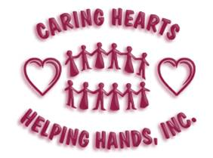

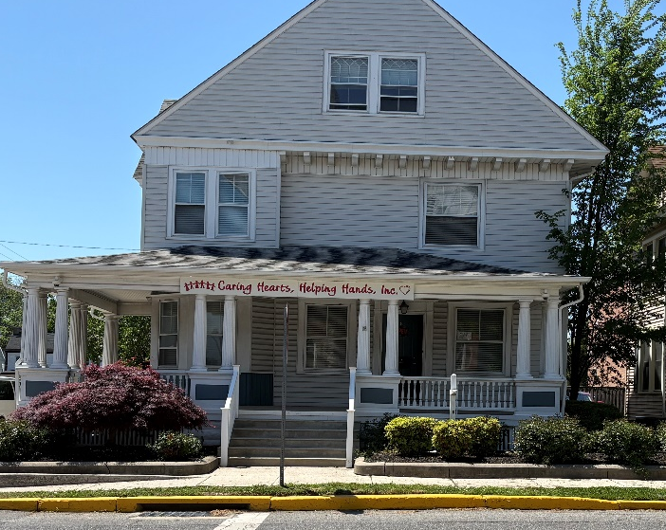
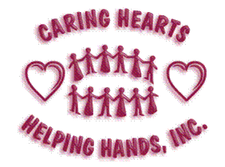
302-698-1900

Check out our Website: chhhde.org
Email: caringheartsde@gmail.com
Follow us on Facebook
We always need:
Wish Grantors
Donations
Volunteers

Caring Hearts Helping Hands, Inc.
(CHHH) is a non-profit (501[3]c) organization, that was incorporated in 2002 and is staffed entirely by volunteers. CHHH supports financially challenged, working families living in Kent County, DE. who could use some assistance.
CHHH has a Christmas and a Back to School (Heart and Sole) program. For Christmas, client families are matched with wish-grantors/sponsors who purchase gifts for the children. For Heart and Sole, each child receives a fully-packed book bag and a gift card for shoes. We always welcome monetary donations and volunteers.
Help us help others. Get involved!! Become a volunteer, a volunteer shopper, a sponsor (wish-grantor) for a child at Christmas or donate school supplies or funding.
If you contribute to United Way or the State Employee Charitable Campaign, you can write-in our agency code (12803). If you shop at Redner’s Market, save us your receipts.

Family Referrals
New client families are accepted at any time during the year prior to Sep. 30th. Referrals often come from school personnel, homeless shelters, and organizations such as Child, Inc. or People’s Place. Self-referrals are also accepted.
Client applications must be fully completed, signed by the client, submitted with proof of employment (pay stubs) and a picture ID for any adults in the family unit.
Applications are reviewed and approved by the Board of Directors at their monthly meetings.
All information is kept confidential.


Requirements for Clients
- The family must reside in Kent County, DE.
- The family must be able to provide proof of residency and photo identification showing address of residency for any adults.
- At least one dependent minor child must be part of the family.
- At least one adult within the family must be employed and is required to provide a copy of his/her latest two pay stubs for proof of employment. Pay stubs must reflect correct address.
- The family may not currently be receiving public (government subsidies, including unemployment) assistance (except for Medicaid and/or SNAP) and may not be the recipient of any other holiday help (i.e. The Salvation Army, Toys for Tots, etc.).
- The family must update their application and re-qualify twice annually.
- The family must demonstrate a genuine need for help by detailing their personal situation.

H o w t o G e t I n v o l v e d:
Monetary donations  may be made directly to Caring Hearts Helping Hands, Inc. and are tax deductible.  EIN# 81-0573899   | Christmas Wish-Grantor/Sponsor  personally shops for gifts for their family or we will have a volunteer shop for the family and be reimbursed. Each child receives at least a new gift or toy and clothes as needed. | Heart & Sole (Back-to-School) assures each school-age child receives a new book bag filled with grade-appropriate school supplies and a gift card for a new pair of school shoes.  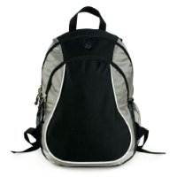

Heart & Sole Deadlines  Client Applications ............. mid-Jul  Gift Drop-off .................. end of Jul  Client Pick-up ……………....... mid-Aug | Christmas Deadlines  New / Reactivate .................. end of Sep  Active Client Applications .......beg. of Nov  Gift Drop-off .........................beg. of Dec  Client Pick-up ..........................mid-Dec

