Please watch CBS news, at 8:39 am, May 29, 2018,
The wireless industry is in a race to roll out 5G service. The network is supposed to be up to 100 times faster than current data speeds, but it requires cellphone tower equipment to be closer to users than before. Wireless companies in the U.S. say they'll have to install about 300,000 new antennas – roughly equal to the total number of cell towers built over the past three decades. That's causing outrage and alarm in some neighborhoods, as antennas go up around homes.
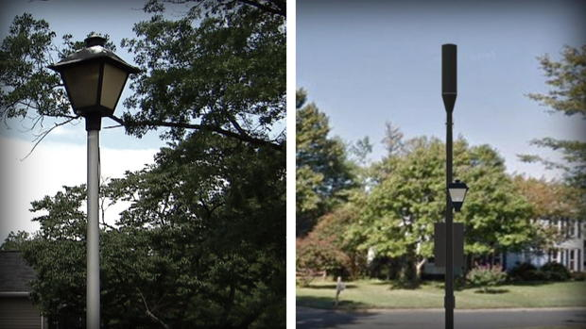AT&T says it will try to use existing infrastructure, like street lights, to install the new antennae required for 5G service. CBS News
At a lab in New York, Verizon invited CBS News' Tony Dokoupil to meet some of the entrepreneurs developing tools to run on the next generation of wireless technology. Jonathan Reeves, the CEO of Arvizio, said 5G service is extremely important to his company's mission. His product allows users in different locations to interact with 3D images projected through a lens.
"Today, we can do this using Wi-Fi technology, and we can do it using landline technology. But of course you're then tied to particular locations. With 5G, now we can begin to extend this. So we can actually begin to start doing this on building sites. We can start doing it on the factory floor. So it really opens up a whole new world," Reeves said.
But before that world can become reality, this one needs to change. 5G requires the installation of new equipment across the U.S. Every wireless company is working to build its own 5G network.
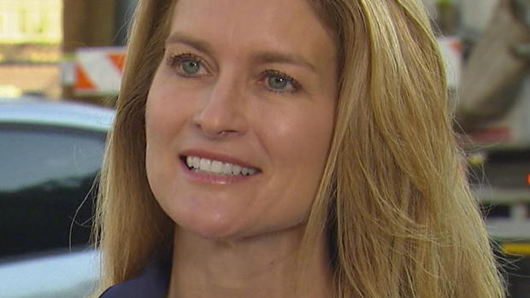Melissa Arnoldi, president of technology and operations for AT&T CBS News
Melissa Arnoldi, who leads AT&T's efforts, said if it's not already in your neighborhood, it's coming.
She said 5G uses high-frequency waves that support faster speeds but don't travel as far as current wireless frequencies. So instead of relying on large cellphone towers spread far apart, they need "small cell" sites that are much closer together.
"We're going to use our existing infrastructure today. Whether it's light poles, whether it's street lights. So we're going to make sure that we don't make it obtrusive to our customers and to the citizens," Arnoldi said.
Yet some don't share the enthusiasm.
"The cell towers are called small cell towers, but they are not so small when they are in your front yard," said Donna Baron. She is protesting plans to convert light poles in her Montgomery County, Maryland, neighborhood into small cell sites.
"This will cause cancer," Baron said. She was one of several people who raised health concerns about the radiation emitted by the equipment at a government hearing last month.
Cell phone equipment does emit radiation but research on its health effects has been inconsistent. According to the National Cancer Institute, "A limited number of studies have shown some evidence of statistical association of cell phone use and brain tumor risks… but most studies have found no association."
Donna Baron CBS News
If Baron loses the fight, she said she'll consider moving. Either way, she fears property values could plummet when 5G equipment pops up.
"It could drop 20 percent," she said. "For that house, that house, that house. And then pretty soon you go around the curb and there's another cell tower. They're all through this neighborhood. So it's going to devastate the neighborhood."
Arnoldi insists her workers are focused on safety, pointing out they live and work near this equipment, too. Although she doesn't have any 5G antennae in her neighborhood yet, she said it's coming soon and she's "absolutely" comfortable with that.
Wireless carriers have announced plans to roll out 5G service to a handful of cities later this year. But to really take advantage, you'll need a 5G-enabled device, which probably won't be available until next year.

https://www.radiationhealthrisks.com
This site is owned and operated by Cornerstone Concepts LLC, a limited liability company headquartered in Idaho, USA. Cornerstone Concepts LLC is a participant in the Amazon Services LLC Associates Program, an affiliate advertising program designed to provide a means for sites to earn advertising fees by advertising and linking to Amazon.com. Cornerstone Concepts LLC also participates in affiliate programs with SmartMeterGuard.com, LessEMF.com, and other sites. Cornerstone Concepts LLC is compensated for referring traffic and business to these companies.
Hi! I’m David. Several years ago I read an article about the harmful effects caused by RF Radiation. This led me to an in-depth study of the subject. As I read the findings of many scientific studies I was flabbergasted that more people did not know about this. I bought some meters and began testing my own house and then researching ways to correct the issues I found. This website grew out of that research. Now it is one of the most trusted sources to learn about RF Radiation.

Why 5G Cell Towers Are More Dangerous
All cell towers emit Radio Frequency (RF) Radiation. This is what makes them dangerous. Plans to transition to the new 5G around the world is already underway. Soon every city will be retrofitted with this technology. Mini cell stations will be placed all throughout our neighborhoods and cities. They will be installed on the sides or tops of buildings and on street light poles.
5G cell towers are more dangerous than other cell towers for two main reasons. First, compared to earlier versions, 5G is ultra high frequency and ultra high intensity. Second, since the shorter length millimeter waves (MMV) used in 5G do not travel as far (or through objects), with our current number of cell towers the cell signal will not be reliable. To compensate many more mini cell towers must be installed. It is estimated that they will need a mini cell tower every 2 to 8 houses. This will greatly increase our RF Radiation exposure.
1G, 2G, 3G and 4G use between 1 to 5 gigahertz frequency. 5G uses between 24 to 90 gigahertz frequency. Within the RF Radiation portion of the electromagnetic spectrum, the higher the frequency the more dangerous it is to living organisms.
With RF Radiation, how close the source is to our physical bodies, is more important than the power level (or wattage) of the radiation. RF Radiation dissipates with distance. In other words, a low powered exposure right next to someone, is more dangerous than a more powerful exposure a long ways away. Also the longer the exposure time is, the more dangerous it is. 5G will be the worst of both worlds. We will have more sources around us, and closer to us. And they will be more powerful and continuous emissions.
In the below video I explain in a bit more detail why 5G is more dangerous than previous technologies. I apologize for looking so beat in this video. I really should not have tried to do a video when I was so tired. This is a video I will be re-doing. However the information is very good and super important. It is a short video and very much worth watching.

RF Radiation Dangers
There have been hundreds of peer reviewed scientific studies done on RF Radiation linking it to health problems such as cancer, DNA damage (especially in fetuses within the 1st 100 days after conception), and sterility in men. And even the World Health Organization classified RF Radiation as a possible “carcinogenic”, meaning “cancer causing”, in 2011. To research some of the actual peer reviewed scientific studies on both general RF Radiation, and 5G, see the “Scientific Studies” page of this website. We will also go over a few of these studies below in this article.

Mini 5G Cell Tower In Your Home
Many people do not realize that they already have a mini cell tower emitting high levels of RF Radiation in their homes and offices right now. Some even have a 5G mini cell tower. We call them WiFi routers. Just like a cell tower, a WiFi router emits at full power 24 hours a day 7 days a week, or as long as you have it turned on. It’s range includes your entire home and beyond. It’s radiation is the exact same RF Radiation that a cell tower emits, or that your microwave oven uses to cook your food.
For example, my WiFi router is a Netgear 5 GHz router that emits both at the 5 GHz and 2.4 GHz frequencies. A microwave oven uses 2.45 GHz frequency to cook food. The new 5G WiFi routers that are available now use the 60 GHz, 5 GHz and the 2.4 GHz frequencies. So having one of those routers is really like having a 5G mini cell tower inside of your home.
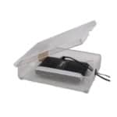
WiFi Router In A WiFi Router Guard

WiFi Router Guard
It is possible to protect yourself from the RF Radiation emitted by your WiFi router. In the picture to the left you can see something called a Wifi Router Guard. By putting your WiFi router in one of these it will block between 90% and 95% of the RF Radiation they emit. And the amazing part is you will still be able to use the WiFi. In my case our WiFi does not seem slow anywhere in our 3 bedroom home.
In the below video I measure the amount of RF Radiation emitted by my 5 GHz Netgear WiFi router. Then I place it in a Wifi Router Guard and test it again so you can see how much RF Radiation it blocks. It is a short video but definitely worth watching.
If you don’t have the ability or resources to hard wire internet through your house, or if for some reason you must have WiFi, a WiFi Router Guard is a very effective solution. For more information on the WiFi Router Guard click this link Wifi Router Guard. Also for more information about other RF Radiation dangers inside your home, please see my article “The 7 Worst Radiation Dangers in Your Home”.

Electromagnetic Radiation
In the chart below you see what is called the “electromagnetic spectrum”. The “Radio waves” and “Microwaves” part of the spectrum is what is referred to as RF Radiation. So microwaves are just a higher frequency radio wave. And remember that within the RF Radiation part of the electromagnetic spectrum, the higher the frequency the more dangerous the waves are to living organisms. (This is not the case in the infrared and visible light portions of the spectrum.)
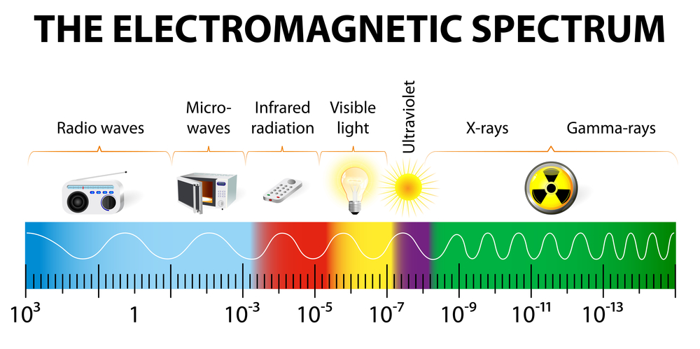

RF Radiation Scientific Studies
In Germany, researchers studied 1000 residents who lived in close proximity to two cell phone towers for about 10 years. According to the study, during the last five years of the observations, researchers discovered neighbors living within 400 meters of the cell towers were diagnosed with cancer at a rate that was three times higher than those who lived much further away.
Another frightening study in 1994, well before 3G, 4G and 5G, links significant health problems with people living in a London apartment building with a cell phone mast on the roof. In this study, the cancer rate of those living on the top floor of the apartment building- the closet to the tower, had a cancer rate of 10 times the average in England.
If that isn’t enough to convince you there is a significant link between cell phone towers and health problems consider a recent study in Italy. In March 2018, the researchers at the world-renowned Ramazzini Institute released the shocking results of a large-scale study of lab animals exposed to cell tower radiation over a lifetime.
“The Ramazzini study exposed 2448 Sprague-Dawley rats from prenatal life until their natural death to “environmental” cell tower radiation for 19 hours per day. RI exposures mimicked base station emissions like those from cell tower antennas, and exposure levels were far less than those used in the NTP studies of cell phone radiation.”- ehtrust.com
NTP refers to the National Toxicology Program study that recently linked cell phone radiation to heart cancer in male rats. The Ramazzini study is the first to complete a study of this scale, over a significant period of time. Together, the studies make a strong argument for more guidelines and standards to protect public health. Health experts from around the world are weighing in on the significance of the findings and urging the World Health Organization to act.
“This study raises concerns that simply living close to a cell tower will pose threats to human health. Governments need to take measures to reduce exposures from cell tower emissions. Cell towers should not be near schools, hospitals or people’s homes. Public health agencies need to educate the public on how to reduce exposure from all sources of wireless radiofrequency radiation- be it from cell towers or cell phones or Wi-Fi in schools,” said Dr. David Carpenter, former Dean of the School of Public Health and the University of Albany.
“This is particularly urgent because current plans to place small 5G cell towers about every 300 meters in every street across the country. These 5G “small cell’ antennas will result in continuous exposure to everyone living nearby and everyone walking down the street. The increased exposures will increase the risk of cancer and other diseases such as electro-hypersensitivity,” said Dr. Carpenter.
The risk is very real. As Dr. Carpenter indicated, public health is at risk with plans for more and more smaller towers to go up on every street corner around the world.
According to experts, doctors and researchers, radiation has the power to change our bodies on the cellular level. These changes, as supported in several studies, create a perfect environment for cancer and other ailments to take over inside our body.
Other studies link cell phone and cell tower radiation to memory loss, headaches, changes in vision and mood, sleep disorders and leukemia. The rollout of 5G and the infrastructure to support it will only increase our risk of suffering major health issues down the road.

Cell Tower Radiation Measured
In the below video I am standing next to an office building that just had a huge cell tower built right next to it. From the office building I measure how much RF Radiation the cell tower is raining down upon the office building. I just cannot believe they build these things so close to people.
See also “Is 5G Safe or Dangerous? Here are the Facts.”

5G: What Do The Studies Say?
As companies prepare to make 5G a reality, may doctors and scientists believe the technology will be a “massive public health experiment.”
According to Dr. Joel Moskowitz, a public health professor at the University of California, the increase in mini-cell towers across towns and cities is only part of the concern. Dr. Moskowitz says the lower frequency millimeter waves used in 5G could cause major skin, eye, and nervous system problems.
“The deployment of 5G, or fifth generation cellular technology, constitutes a massive experiment on the health of all species… Because MMWs are weaker than microwaves, they are predominantly absorbed by the skin, meaning their distribution is quite focused there. Since skin contains capillaries and nerve endings, MMW bio-effects may be transmitted through molecular mechanisms by the skin or through the nervous system,” said Dr. Moskowitz.
Dr. Moskowitz also believes that MMV can make some pathogens resistant to antibiotics.
Dr. Moskowitz is not alone in his concern about 5G. Dr. Yael Stein from Jerusalem’s Hebrew University recently wrote a letter to the Federal Communications Commission outlining his major concerns about 5G, MMV and how it could impact human skin.
Dr. Stein argues the human skin has the ability to absorb more than 90% of microwave radiation and will cause major problems from head to toe- especially for the vulnerable such as kids, elderly and pregnant women.
MMVs are also believed to cause physical pain. A recent article in Eluxe Magazine takes a deeper look at the issue. According to the article, MMVs could cause pain receptors to flare up in the human body, and cause great damage to our eyes, cell growth and compromise our immune system.
In fact, the U.S. Government currently uses MMV energy as a non-lethal weapon. This weapon is direct and more intense than the MMVs from a 5G network, however, it’s similar and concerning. According to the U.S Department of Defense, the active denial system creates a focused MMV beam that is capable of penetrating the skin, which can create a burning or a stinging sensation.
Some experts even argue 5G will have a devastating impact on our environment as well. A 2010 linked aspen leaf damage to MMV exposure. Some researchers also found MMV’s can cause cell damage in wheat plants, impact wildlife and affect our atmosphere.
Only time will tell how the 5G network will impact our health and the environment. We know existing cell towers are dangerous and with plans to build thousands, if not millions more- it could become very interesting. It’s clear though, MMVs are not safe for the general public- especially considering we will be exposed everywhere we go, even at home.

Ways to Reduce Exposure to 5G
5G is expected to be ready to go by 2020 so you have plenty of time to prepare and make plans to reduce your exposure to MMVs and other cell towers. Because 5G towers will be everywhere it will be difficult to avoid all exposure, so you’ll have to take care of your immune system and make healthy choices.
Boosting your immune system with natural fruits and vegetables is a great way to keep your cells healthy and keep diseases at bay. In addition to making healthy food choices, you can take several precautions around your home.
Some experts believe the best way to keep cell tower radiation from penetrating your home is to create a highly conductive enclosure around your home. So, what does this mean? It means first measuring the levels of radiation with HF35C meter. This meter will give you various levels throughout your home and determine what areas you need to focus on first. Right now, there are various window coverings, paints that will keep radiation from penetrating your home.
Many doctors suggest keeping your distance from the cell towers in question. This could be very hard to do given these 5G towers will be on every corner on every building. Unless you never leave the house, I don’t see this as being a realistic expectation.
I’m hoping there will be an app or map listing all the cell phone towers in every neighborhood, in every city across the world. This would certainly make it easier to know where the new 5G towers are located and how to avoid them when necessary. This information would be helpful to those who are exceptionally vulnerable to cell tower radiation such as children, infants, elderly and pregnant women.

Reducing Radiation In Your Home
While you can’t control where the cell towers go, you can control how and when you use your own cell phone. By limiting your time on your phone and using radiation blocking cases and shielding headsets, you can greatly reduce your exposure to cell phone radiation. Every little bit helps. Please see also our article entitled “Why Are 5 GHz WiFi Routers More Dangerous?”
Also, if you have an office- make sure you turn off your Wi-Fi router when you’re not using it. And keep your cell phone out of your room at night. Various studies link cell phone radiation to disruptive sleep patterns. When you don’t sleep well, it can throw off your entire day. By leaving your cell phone out of your room at night, you’ll never have to count sheep again.
Take a closer look at your meter outside your house. Many power companies are switching to smart meters. These meters take the guesswork out of how much energy you are using. Smart meters wirelessly transmit data constantly throughout the day, giving the power companies real-time information about your energy consumption. Smart meters take the place of meter readers. Smart meters, however, transmit harmful levels of radiation. If you can, get a smart meter guard to protect you and your family from harmful radiation. You can purchase a smart meter guard for your router and cell phone for under $100.
By reducing your risk of radiation, you can improve your chances of staying healthy and living a long and joyful life.
If you have kids, pay attention to the Wi-Fi situation at school and in their classrooms. Some studies link ADD, ADHD, memory issues, and behavior problems with Wi-Fi routers and nearby cell towers. Cell phone towers are a big business for school districts. Many districts across the country are selling or renting land for cell phone towers. If this is happening in your neighborhood, speak up. It’s only going to become more prevalent with the rollout of 5G.

Why Are Companies Pushing 5G?
5G is the wave of the future. This advanced bandwidth will allow you to download movies in a matter of seconds and is expected to support at least a100 billion devices. That’s a whole lot of devices one bandwidth. In general, 5G will be up to 100 times faster than 4G. That’s fast!
5G stands for 5th generation cellular technology. This is the latest development in the cellular world. Major cell phone companies and other tech giants are making progress right now to be ready to launch 5G capable devices by 2020.
I won’t get over technical but in general, 5G will make technology faster, smarter and create a more connected world. According to Tech Radar, 5G will have an average download speed of about 1GBps (1 gigabyte per second).
With faster connectivity, this network will be capable of supporting the Internet of Things, your personal devices and various networks without any delay. Plus, with 5G the connections will be more reliable as well. No more dropped calls or delays when trying to browse the internet.
“It’s all about making better use of the radio spectrum and enabling far more devices to access the mobile internet at the same time”-BBC.
5G is being touted as the golden ticket to cellular connectivity. More speed, less waiting and more people and things connected than ever before. However, as I mentioned earlier, advances in technology will no doubt have an impact on our health- impacts we may not even realize are happening until it’s too late.

How Will 5G Work?
5G is the super highway for speed, information, and connections. To create this incredible speed and reliability, 5G uses the millimeter wave. This millimeter wave operates between 30GHZ and 300 GHz. According to the BBC, “The higher-frequency bands have a lot of capacity but their shorter wavelengths mean their range is lower.” This means the 5G signal is easily blocked by buildings, cars, planes, plants and other objects.
Because the signal will face so many obstacles, an entire web of small-mini cell towers will need to go up in every city, on every block in every neighborhood around the world. No word yet on exactly how many towers or small masts will need to be installed to support this network. It could easily add up to billions of towers.
A recent article in the UK estimated at least 400,000 extra phone masts would be needed to bring rural Britain to be 5G compatible. That’s just the rural part of Britain. It’s estimated there could be thousands of extra small masts in every single city around the world.
According to experts, the 5G masts will be about four feet tall- not nearly the same height as needed with 4G and 3G networks. These towers will be around every corner and will make communicating with your house, car, and family a breeze. However, being that connected- with so many signals around may cause major health problems. I’ll address this later on in this article.
So, who decides where these towers will go? That’s a great question and one local government across the country and world are addressing right now. However, internet and cell phone providers have lobbyists working with state lawmakers to restrict how much say local government has as to where and when the 5G network cell towers will be placed. As I write this article, 13 states have laws on the books to limit local governments from having a say in the 5G process.

The Difference Between 3G, 4G, and 5G
To understand why 5G cell towers are more dangerous than other cell towers, we need to take a closer look at how each network operates. As I mentioned earlier, 5G is the 5th generation of cellular technology and needs shorter waves to function at a high speed. Shorter waves mean there’s a greater need for more cell towers because these specific waves have lots of obstacles.
Let’s start with 3G. 3G stands for the 3rd generation of cellular technology. This advancement in technology was unveiled in 2003. 3G operates using cellular technology, as in the signals are passed from tower to tower. Then onto the next cell phone tower and so on. This continues until you answer your phone, find your answer on Google and finish watching YouTube.
Cell phone companies strategically place the cell towers in various locations and different heights to give you the best signal possible. 3G was mostly used to make phone calls, texting, and limited internet use.
With 3G the signal can travel farther- however, there has to be another tower around to pick up the signal and you’re moving. If there isn’t another tower then you experience a temporary interruption in service. With 3G you need fewer towers than 5G to operate. Fewer towers mean less exposure to potentially harmful cell tower radiation.
3G is also referred to as mobile broadband. This term became a catchy way to sell phones and tablets in the mid-2000s. Mobile broadband basically means there are enough cell towers to keep your signal connected while you’re moving around town or traveling around the world!
The data speeds for 3G are much slower than 4G and certainly much slower than 5G.
Let’s take a closer look at 4G. 4G is what most of us are using today. It’s the reason you can Facetime with your best friend in Europe or download an entire movie on your tablet. Some tech experts describe 4G as removing speed bumps in the cellular signal, “allowing traffic to move much faster.”
4G uses cell towers, just like with 3G- however, the speed at which data and information can travel is much different. 4G uses more bandwidth than 3G, which means towers need to be more powerful. The more powerful the cell phone towers, the more potential for radiation to be emitted into our environment.
Even though 4G is more powerful than the 3G network- it’s not nearly as powerful as 5G. 5G is the super horse, a new wave of technology designed to connect everything via the internet. It’s a game changer. This big shift could mean big health consequences as well.

Future of 5G
The future is here and companies are building the infrastructure needed to create a full world-wide rollout of 5G by 2020. AT&T is leading the way in this major effort to make cities 5G compatible. In July, the tech giant announced plans to have the 5G infrastructure in place and ready to go in 12 cities by the end of this year. Verizon and T-Mobile are also planning limited rollouts of 5G in the next year or so.
There is still a lot of work to be done on the 5G front. In May, Verizon announced Los Angeles will be one of the first cities in America to make the move to 5G. This is not a small feat by any means. According to an article in Tech Crunch, Lowell McAdam, Chief Executive for Verizon, said the company purchased 36 million miles of fiber so they can support the hundreds of megahertz of bandwidth needed to deliver “the whole suite of 5G.” McAdam said Verizon has added 1,000 extra cell sites in LA to make the 5G experience possible.
Verizon also has plans to bring Boston and other major cities into the 5G era as soon as possible. AT&T announced it’s working on 5G capabilities in Atlanta, Dallas, and Waco, TX. Sprint says its bringing 5G to NYC, Phoenix and Kansas City.
Right now, AT&T is running 5G trials in Waco, TX, and Dallas. South Korea unveiled its 5G system during the Winter Olympics this year.
South Korea, Sweden, Turkey, Japan, and China are also working hard to create a seamless transition to 5G. Some industry insiders are calling the 5G networks a technological revolution. The information, data, and insights made possible by 5G will change how people interact with each other and how businesses operate. According to one article I recently read, 5G has the power to increase revenue across a variety of industries- to the tune of $12 trillion dollars. Yes, trillion dollars.
“Unlike its predecessors though, 5G is a technological paradigm shift, akin to the shift from typewriter to computer. And it isn’t just a network. 5G will become the underlying fabric of an entire ecosystem of fully connected intelligent sensors and devices, capable of overhauling economic and business policies, and further blurring geographical and cultural borders. It will be capable of delivering at every rung of the ecosystem’s ladder and will provide seamless, continuous connectivity for business applications,” Technology Review.
“All industries will feel the effects of the shift to 5G. In particular, automotive, health care, and the Internet of Things (IoT) are expected to bring about dramatic transformations in our daily lives.”- Technology Review.
Most companies in the United States hope to have the 5G infrastructure in place by 2020. Each country has its own timeline on a 5G rollout.

Will I need a new Phone/Tablet?
Yes, you will most likely need to buy a new phone to take advantage of the speed and reliability promised by 5G. However, if you like your phone and don’t want to spend the extra money, your current 4G phone will continue to work just fine- for now.
As I mentioned earlier, 5G offers more bandwidth- which means it can support more data. This network is also more reliable. Some cell phone and tech companies are already offering 5G compatible phones and tablets that make the most out of the new technology.
Your phone is only part of the 5G equation. You may have to pay more for 5G service. It’s unclear what the new plans will cost, but it’s likely all the major carriers will be competitive to keep customers from jumping ship. In general, you get what you pay for. Better service will mean you will have to pay at least more than your currently used to. Time to start your 5G fund!

5G and You
There’s no doubt 5G will change our physical and virtual landscape. However, it’s clear this technology comes with major health concerns too. The wave of the future may also mean a wave of new cancers, illnesses, and disabilities.
More research and studies need to be completed before the entire 5G rollout is complete. The potential health consequences associated with the 5G infrastructure is too great to ignore. If you can, stay in contact with your government and advocate for local control over where 5G mini cell towers are located. We must approach this new technology with respect and caution.
For more information on the dangers of cell phone tower radiation check out my blog, Is Cell Phone Tower Radiation Harmful?

5G Radiation Dangers – The Definitive Guide
by Christian March 17, 2019
written by Christian March 17, 2019
https://emfacademy.com/5g-radiation/
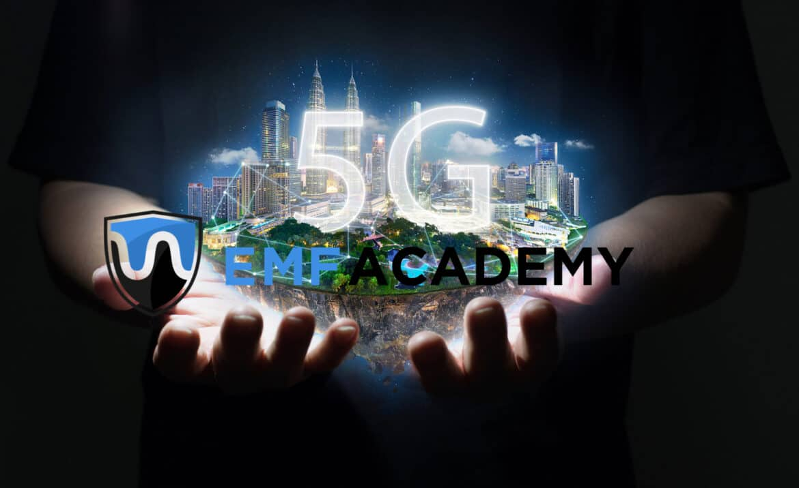<img src="https://emfacademy.com/wp-content/uploads/2019/03/5G-Radiation-1170x716.jpg" width="1170" height="716" class="attachment-penci-full-thumb size-penci-full-thumb wp-post-image sp-no-webp rocket-lazyload" alt="5G Radiation" data-lazy-src="https://emfacademy.com/wp-content/uploads/2019/03/5G-Radiation-1170x716.jpg 1170w, https://emfacademy.com/wp-content/uploads/2019/03/5G-Radiation-300x184.jpg 300w, https://emfacademy.com/wp-content/uploads/2019/03/5G-Radiation-768x470.jpg 768w, https://emfacademy.com/wp-content/uploads/2019/03/5G-Radiation-1024x627.jpg 1024w, https://emfacademy.com/wp-content/uploads/2019/03/5G-Radiation-585x358.jpg 585w, https://emfacademy.com/wp-content/uploads/2019/03/5G-Radiation.jpg 1500w" sizes="(max-width: 1170px) 100vw, 1170px">
This article is the result of nearly a hundred hours of research, and almost a full week writing
My hope that this can be the definitive source for information about the danger that 5G radiation will bring to the world as it continues to be rolled out in the future.
I will be continually updating this resource as I learn more and as more information is released to the public. However, if you feel that there is anything significant missing from this article, please comment below so that I can look into it, and add it if needed.
Although at the time of writing this, 5G is being tested in some markets, it is far from being fully released.
Some telecom companies mention that they hope to have it available by sometime this year (2019). However, even if that is the case, it will likely be years later before it has the majority market share.
The increased radiation danger will be a result of both the new technologies and the dramatic new landscape of infrastructure that 5G will require.
We’ll get to all of this, but before we do, I wanted to provide you with the structure of this article. If you click on any of the links in the table of contents, it will jump you straight to that section.

Table of Contents
- Why Will 5G Radiation Be Dangerous? – A Summary
- Why Is There A Need For 5G?
- What Is 5G, and How Does It Work?
- 5G Radiation – Danger Of RF Radiation
- RF Radiation Studies
- 5G Radiation Danger – What We Know
- What Experts Are Saying About 5G Radiation
- The Information War Over 5G
- How To Protect Yourself Against 5G Radiation
- Ways to Reduce Exposure to 5G Radiation
- Other Ways To Reduce EMF Radiation Exposure
- 5G Radiation – My Final Thoughts
Let’s start by summarizing why the radiation from 5G wireless will be dangerous:

Why Will 5G Radiation Be Dangerous? – A Summary
The current portion of the radio frequency spectrum used by 1G, 2G, 3G, and 4G LTE (what we currently have) is crowded, and will not be able to support the sheer quantity of devices coming online every day.
That means that 5G will utilize millimeter waves in the 30-300 gigahertz frequency, which hasn’t been used in the past. These higher frequencies have short wavelengths and are categorically more dangerous.
The shorter wavelengths also do not travel as far, or as well through objects. This means that 5G will require hundreds of thousands of small cell towers to compensate. You’ll likely see small micro-cell towers on street signs, light poles, on the sides of buildings, on homes, and just about anywhere else the telecom companies can legally place them.
So, not only will it be a much higher frequency, shorter wavelength form of electromagnetic radiation, it will also be in much closer proximity, increasing our exposure and the danger.
Remember the inverse square law of physics. This law essentially states that as we double our distance from a source of EMF radiation, we quarter our exposure to it. This concept means that distance gives us exponential protection.
With the current 4G LTE networks, we can simply use resources to locate cell towers and choose our homes accordingly. This will likely be near impossible in the future with the sheer proliferation of 5G cell towers.
Alright, now let’s talk a little bit about what 5G really is, so we can better understand why it could be exponentially more dangerous than our current 3G and 4G wireless.

Why Is There A Need For 5G?
So, if you’ve had a cellphone for quite a few years as I have, then you probably are familiar with the various generations of wireless technology. 5G doesn’t stand for 5 GHz, it stands for the 5th Generation of telecom wireless.
1G was the original generation and essentially just allowed for analog voice between callers. 2G, the second generation introduced in the 1990’s first allowed data to be sent in the form of simple text messages.
3G allowed for high-speed internet through faster data transfer. This gave us a connection to the internet and opened up a whole new world for smartphones.
4g expanded on this, allowing for significantly faster data transfer. This allowed us to watch Netflix practically in the middle of nowhere, and made it possible to scroll endlessly through social media.
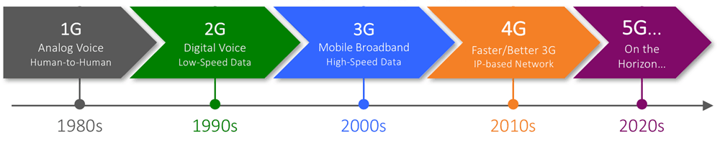
Now, we’ve all been using 4g LTE for about the last 10 years, and for the most part has worked quite well. However, with a growing network of smart devices and smartphones, this network is getting extremely crowded.
The speeds that 4G support are also not keeping up with technologies demands. With Artificial Intelligence controlling more and more things, and autonomous vehicles hitting the roads, our current network isn’t cutting it. These types of devices not only require faster speeds and more bandwidth, but also significantly lower lag-tim, or latency.
Which brings us to the advent of 5G, which has been researched and talked about for nearly a decade, but has only in the last few years been remotely a reality. Already being tested in several cities, 5G is closer than ever. Many phones are already out that will support it.
However, it isn’t entirely here yet, and that is mainly an infrastructure issue. However, likely sometime in 2019, companies like Verizon and AT&T will have separate hotspots available for purchase that will allow you to harness the speed of 5G
So, now you understand a bit of why 5G came about, let’s dive a bit deeper into what exactly it is, and how it works.

What Is 5G, and How Does It Work?
(Warning: gets a bit technical)
All generations of mobile networks have used similar cellular infrastructure. The service area that you are connected to is actually part of a digital geographical grid called a “cell.” Data is transferred from your device to a local cell tower in packets. This data is then transferred via a telephone network and the internet to wherever it was being sent.
As you move around, these cell-towers are capable of handing you off without a disruption in your phone call, or the data that you are receiving. You’ve probably noticed the many cell towers in your area or your city. That is because these large cell towers are able to maintain connection to your device over long distances, and through many objects due to the wavelength of the frequency being used.
The downside is that the 4g LTE network that these cell-towers currently support, is becoming outdated as new technology demands enter the market.

How Fast Will 5G Be?
5G, or the fifth generation of wireless, will solve this speed issue. With data transfer rates of up to 10 Gigabytes per second, you will be able to download an HD movie in just a few seconds. This means that you will have internet that is 100-200 times faster than the current 4G networks support.
Not only will the mobile network for 5G be much faster, but possibly more importantly, will have far lower latency, or lag-time. Imagine you are playing a game on your phone, and you tell it to make an action. Currently, this takes around 40-50 milliseconds to complete. 5G will allows latency as low as 5 milliseconds. Now, for games, this is not a big deal and we hardly notice it.
However, take this and expand it into emerging technologies such as AI and autonomous driving. Lower latency means that vehicles can respond that much faster to new inputs of data, making them safer to drive.
So, as far as speed, latency, and connectivity go, 5G will have some huge advantages, but will this be worth it? Don’t worry, later in the article we’ll get to some of the science and research behind why 5G radiation could potentially be so extremely harmful.

How Will 5G Work?
In order to better understand some of this next part, take just a second and watch this quick video. It isn’t the most recent video, but does a really good job outlining some of the technologies that will allow a 5G network to exist and function.
Don’t worry, I’ll break down the current (2019) updates on how 5G works after the video.
Now that you have a little bit better idea of how all these technologies work together, let’s break it down so we can understand it a bit better.
5G will use what are called millimeter waves that fall in the higher frequency ranges of 30 to 300 GHz. The network your phone is currently connected to uses microwave bands between 700 MHz and 3 GHz.
First of all, since the range of 30-300 GHz is essentially unused, carriers will have infinitely more bandwidth to provide users with. Not only that, but these shorter waves will allow for sending and receiving data to be transmitted on a single carrier wave simultaneously.
One of the problems with these Millimeter waves, is that they are not nearly as good at penetrating things as our current cell towers are. So, the radiation from the radio waves gets blocked by simple things like trees and buildings.
This means that instead of having large high-powered cell towers every half-mile or so, we’ll have thousands of smaller antennae on buildings, street signs, lamp posts, etc.
Having these small cell towers nearby is a double-edged sword. Although they will allow the facilitation of these high network speeds, they will also be closing the gap on 5G radiation, putting it closer to our bodies than ever.

Massive MIMO
These small millimeter wave antennae will also allow for something that you saw in the video, called massive MIMO (multiple-input multiple-output). This essentially means that instead of data passing back and forth on a single radio wave, data can be passed from a single device to multiple antenna at the same time. This allows for faster transfer of data.
In order to keep this all straight, an algorithmic technique called Beamforming will be used. This essentially means that the best route for these data arrays will be calculated constantly, changing as your device moves around. This allows the thousands of small 5G antennae to know where to send the data at any given time.
Now, as you’d imagine, the insane amount of new infrastructure that will be required will make this extremely expensive to install. So, most experts believe that it will only initially be available in larger cities, where carriers can actually see a return on their money.
It will likely be some time before we see 5G in rural areas. Some pundits believe that it may never be financial viable to put 5G in very rural areas.
So, if you are worried about 5G radiation like I am, that is one thing you could always consider, get just outside the city.

5G Radiation – Danger Of RF Radiation
Now, when it comes to the dangers of RF radiation that 5G will bring, there are two things we need to talk about.
- General Risk of RF Radiation Exposure
- Specific Risk of 5G Exposure
So, I want to break these down, and walk you through the studies for each one that show us just how dangerous this new technology will be.
Let’s start by looking back at the studies showing how cell-phone, and cell-tower radiation harm the body.

RF Radiation Studies
You’ve probably heard of a few of the big studies, and I won’t cover them all in this, but I wanted to give a general summary of some of the science and evidence showing that high-levels of exposure to RF radiation from cell-phones and cell-towers really can be harmful to your health.
Interphone Study – This extensive study looked at over 5000 cases of Glioma and Meningioma to determine what level of cell-phone use was observed. Ultimately they found that those with the highest exposure to RF radiation from cell-phones did have an increased chance of developing brain tumors during their lifetimes.
This study along with a mountain of other evidence was part of the reason that the World Health Organization classified RF radiation as a “possible carcinogen” in 2011, shortly after the study was published.
“The Influence of Being Physically Near To A Cell Phone Transmission Mast On the Incidence of Cancer. – I know, it’s a long name, but it is an extremely important study showing how being physically close to cell-towers of any kind, can increase your risk of certain cancers.
This is particularly important with the coming of 5G, as our proximity to these micro-cell towers will be much closer.
The study, conducted in 2004 in Germany, looked at the case histories of 1,000 different patients between the years 1994 and 2004. They classified the participants into groups based on how close to cell-towers they lived.
The study ultimately found that there was a significant correlation between how close people lived to these cell-towers and their risk of developing cancer.
They wrote:
“The proportion of newly developing cancer cases was significantly higher among those patients who had lived during the past 10 years at a distance of up to 400 meters (1,300 feet) from the cellular transmitter site, which has been in operation since 1993, compared to those patients living further away, and that the patients fell ill on average eight years earlier.
Ramazzini Study – Perhaps one of the most frightening studies actually came out quite recently. The well respected Ramazzini Institute out of Italy studied how frequent exposure to RF radiation at levels consistant with legal cell-tower radiation affected their lives.
The Environmental Health Trust, a respected virtual think-tank and non-profit did a great job summarizing the results, so I’ll use their words and quotes instead of my own:
(Really take a second and read this, the conclusions are quite telling)
The Ramazzini study exposed 2448 Sprague-Dawley rats from prenatal life until their natural death to “environmental” cell tower radiation for 19 hours per day (1.8 GHz GSM radiofrequency radiation (RFR) of 5, 25 and 50 V/m). RI exposures mimicked base station emissions like those from cell tower antennas, and exposure levels were far less than those used in the NTP studies of cell phone radiation.
“All of the exposures used in the Ramazzini study were below the US FCC limits. These are permissible exposures according to the FCC. In other words, a person can legally be exposed to this level of radiation. Yet cancers occurred in these animals at these legally permitted levels. The Ramazzini findings are consistent with the NTP study demonstrating these effects are a reproducible finding,” explained Ronald Melnick Ph.D., formerly the Senior NIH toxicologist who led the design of the NTP study on cell phone radiation now a Senior Science Advisor to Environmental Health Trust (EHT). “Governments need to strengthen regulations to protect the public from these harmful non-thermal exposures.”
“This important article from one of the most acclaimed institutions of its kind in the world provides a major new addition to the technical literature indicating strong reasons for concern about electromagnetic radiation from base stations or cell towers,” stated Editor in Chief of Environmental Research Jose Domingo PhD, Professor of Toxicology, School of Medicine at Reus University, Catalonia, Spain.
“The US NTP results combined now with the Ramazzini study, reinforce human studies from our team and others providing clear evidence that RF radiation causes acoustic neuroma (vestibular schwannoma) and gliomas, and should be classified carcinogenic to humans,” stated Lennart Hardell MD, PhD, physician-epidemiologist with the Department of Oncology, University Hospital, Örebro, Sweden, who has published extensively on environmental causes of cancer including Agent Orange, pesticides and cell phone radiofrequency radiation.
“The evidence indicating wireless is carcinogenic has increased and can no longer be ignored,” stated University of Toronto Dalla Lana School of Public Health Professor Emeritus Anthony B. Miller MD, Member of the Royal Colleges of Physicians of Canada and the UK, and Senior Medical Advisor to EHT who is also a long-term advisor to the World Health Organization.
I could go on and on about all of the studies and evidence linking RF radiation to negative health effects, but I think that should suffice for the purposes of this article.
Instead, I want to spend some time talking specifically about how 5G Radiation has been shown to affect our health. Since it has not been released on a wide-scale, our exposure to it and ability to study it’s effects has been limited. However, there is still plenty to look at that should make you nervous.

5G Radiation Danger – What We Know
Alright, now it’s time to talk specifically about some of the ways that 5G radiation will specifically be harmful.

Dr. Moskowitz Warnings
To start with, I want to quote a bit of what Dr. Joel Moskowitz, a public health professor at the University of California told the Daily Mail about how 5G will be harmful.
‘The deployment of 5G, or fifth generation cellular technology, constitutes a massive experiment on the health of all species. Because MMWs are weaker than microwaves, they are predominantly absorbed by the skin, meaning their distribution is quite focused there.
Since skin contains capillaries and nerve endings, MMW bio-effects may be transmitted through molecular mechanisms by the skin or through the nervous system.
He also told Daily Mail Online that he’s concerned that ‘5G will use high-band frequencies, or millimeter waves, that may affect the eyes, the testes, the skin, the peripheral nervous system, and sweat glands.’
‘Millimeter waves can also make some pathogens resistant to antibiotics,’ he added.
Dr Moskowitz is not alone in aprehensions.
The International Society of Doctors for the Environment, its subsidiaries in 27 countries and more than 200 doctors and scientists are all calling for a stop to be put to the roll out of 5G, ‘due to concern that 5G radio frequency radiation will have adverse health effects,’ Dr Moskowitz says.
“So far, their warnings have gone unheeded.”
Dr. Moskowitz comments to the Daily Mail are a frightening warning about just some of the physical effects experts and scientists expect to see with the continued rollout of a 5G cellular network.
Now I want to a really important letter.

Dr. Yael Stein Letter of Opposition to 5G
In 2016 a Physician named Dr. Yael Stein of the Hadassah Medical Center in Jerusalem wrote a letter opposing the implementation of 5G and the Millimeter Wave Technology it would utilize.
He addressed the letter to the United States Federal Communication Commission, the U.S. Senate Committee on Health, Education, Labor and Pensions and the U.S. Senate Committee on Commerce, Science, and Transportation.
Dr. Stein began the letter by saying:
“A group of physicists from the Hebrew University in Jerusalem, together with several physicians, have researched “G5” millimeter wave technology (Sub Terahertz frequencies) and its interaction with the human body. I am a physician who participated in this research.”
I won’t include the entire letter in this article, but will include all of the groups conclusions, as they are extremely telling of the danger that 5G radiation will expose people to.
The groups conclusions were:
- Public exposure to millimeter waves, in the sub-Terahertz frequency range, is currently less common. If these devices fill the public space they will affect everyone, including the more susceptible members of the public: babies, pregnant women, the elderly, the sick and electro hypersensitive individuals.
- Human sweat ducts transmit and perhaps also receive electromagnetic waves that reflect the person’s emotional state, as an extension of the sympathetic nervous system that innervates sweat ducts
- These newly suggested physiologic and psychological functions of human sweat ducts have not yet been researched by neurophysiologists or by psychologists
- Computer simulations have demonstrated that sweat glands concentrate sub-terahertz waves in human skin. Humans could sense these waves as heat. The use of sub-terahertz (Millimeter wave) communications technology (cellphones, Wi Fi, antennas) could cause humans to percept physical pain via nociceptors.
- Potentially, if G5 WI FI is spread in the public domain we may expect more of the health effects currently seen with RF/ microwave frequencies including many more cases of hypersensitivity (EHS), as well as many new complaints of physical pain and a yet unknown variety of neurologic disturbances.
- It will be possible to show a causal relationship between G5 technology and these specific health effects. The affected individuals may be eligible for compensation.
There is a host of research showing the potentially harmful effects of pulsed MMV’s, but I don’t want to bog this post down too much. However, the group over at saferemr.com put together a good compilation of research and letters related to 5G radiation that I would encourage you to check out when you have a chance.
Or, if you’d like to read a large collection of letters sent by various doctors and scientists on the dangers of 5G radiation and cell towers, the Environmental Health Trust put together a great list.

What Experts Are Saying About 5G Radiation
Along with the research, hundreds of letters have been sent by scientists, doctors, and researchers, to organizations around the world calling for a halt to the rollout of 5g.
A group of over 250 scientists from around the world in 2017 wrote and published a declaration called the “5G Appeal” asking for a moratorium on the building of 5G infrastructure. This was a followup to a previous letter sent to the United Nations with a similar request.
They said in part:
“We recommend a moratorium on the roll-out of the fifth generation, 5G, for telecommunication until potential hazards for human health and the environment have been fully investigated by scientists independent from industry…RF-EMF has been proven to be harmful for humans and the environment.”
You can read the entire published appeal here.
A few other notable comments made by experts (thanks to EHtrust.org for putting these together)
“There is a substantial body of evidence that this technology is harmful to humans and the environment. The 5G millimeter wave is known to heat the eyes, skin, and testes… Of particular concern are the most vulnerable among us — the unborn, children, the infirm, the elderly and the disabled. It is also expected that populations of bees and birds will drastically decline.” –Letter from oncologist Lennart Hardell MD & Colleagues
“A growing body of scientific literature documents evidence of nonthermal cellular damage from non-ionizing wireless radiation used in telecommunications. This RF EMR has been shown to cause an array of adverse effects on DNA integrity, cellular membranes, gene expression, protein synthesis, neuronal function, the blood-brain barrier, melatonin production, sperm damage, and immune dysfunction”. –Dr. Cindy Russell 2018 paper entitled “5 G wireless telecommunications expansion: Public health and environmental implications.”
“This is a unique situation in the history of the human kind when the whole human population will be exposed to man-made devices emitting non-ionizing radiation that was insufficiently tested before deployment. What is and what will be the responsibility of the scientists, decision-makers and industry leaders who permit deployment of insufficiently tested technology that will affect us all? The answer is simple – no responsibility… because if any health problems will show up in the future, these will most likely take tens of years of time to manifest and, by then the persons that currently enable deployment of insufficiently tested radiation-emitting 5G technology will be retired or the proverbial ‘six feet under.’” -Dr. Darius Leszczynski, July 18th, 2018 in Assumption of Safety for 5G by Government Agencies, No Science.
https://www.jrseco.com/european-union-5g-appeal-scientists-warn-of-potential-serious-health-effects-of-5g/

