TOUR OF SOUTH JERSEY 2019
August 10, 2019 10am
Rain Date: August 11, 2019 10am

Guys, Gals, please come out to join us for this year’s Tour of South Jersey. This year’s Tour will feature some of South Jersey’s finest driving roads. This year’s Tour is geared towards the driving enthusiast with smooth roads, several hairpin turns, lots of twists and gorgeous scenery! The starting location for 2019 will be:
THE WOODSTOWN DINER. Located at 16 East Ave., (Rt. 40), Woodstown, NJ 08098. Please come early if you would like to have breakfast first, just be sure to allow time to be ready to start the Tour at 10am.
Upon exiting the Boro of Woodstown, we will proceed along a route of scenic back roads passing through Historic Alloway Township and Quinton Township, and meandering into the marshes of Lower Alloways Creek Township along the Salem River. We will continue following this route until eventually reaching our rest point at THE HANCOCK HOUSE MUSEUM in Hancock’s Bridge.
Upon leaving the Hancock House, we will proceed through beautiful wooded backroads into the Township of Elsinboro where we again pick up the Salem River and wind our way through Mannington Township, past Mannington Creek, and eventually into Pilesgrove Township where we pick up back on Rt. 40 and follow to our destination at the Olympia Dairy Bar.
OLYMPIA DAIRY BAR is located directly on Rt. 40 just past Cowtown and the Salem County Fairgrounds. They have food there as well as ice cream. There is a large parking lot for our vehicles and tables both inside and outside. Please be advised that Olympia is a CASH ONLY business, so if you wish to partake, please bring cash with you.
Both the Woodstown Diner and Olympia Dairy Bar are located directly on Rt. 40 making it easy to reach from whatever direction you are coming from. The Olympia Dairy Bar is also near the 295 North/South Exits, Turnpike Exit, as well as Rt. 49 and Rt. 45 making your ride home as convenient as possible.
I would also invite all of you to check out the Cowtown Flea Market after the Tour for your shopping pleasure, or make a day of it and stay for the Rodeo! Also check out page 2 of this flyer for places of note along the Tour.
Stay tuned for more information regarding the Tour. A weather update is planned for Friday evening. Please check the Event Hotline Number: 856-878-8084 after 9pm on Friday August 9.
Please reply to this email with any questions you may have.
~Tracy Westergard
Places of Note Along the Tour

David Bassett House, Woodstown, NJ
“The Glory Tavern.” It is now a home and called the David Bassett House. Obviously, she was built in 1755 as per her initials on the South corridor. It’s one of the oldest existing structures in Woodstown.
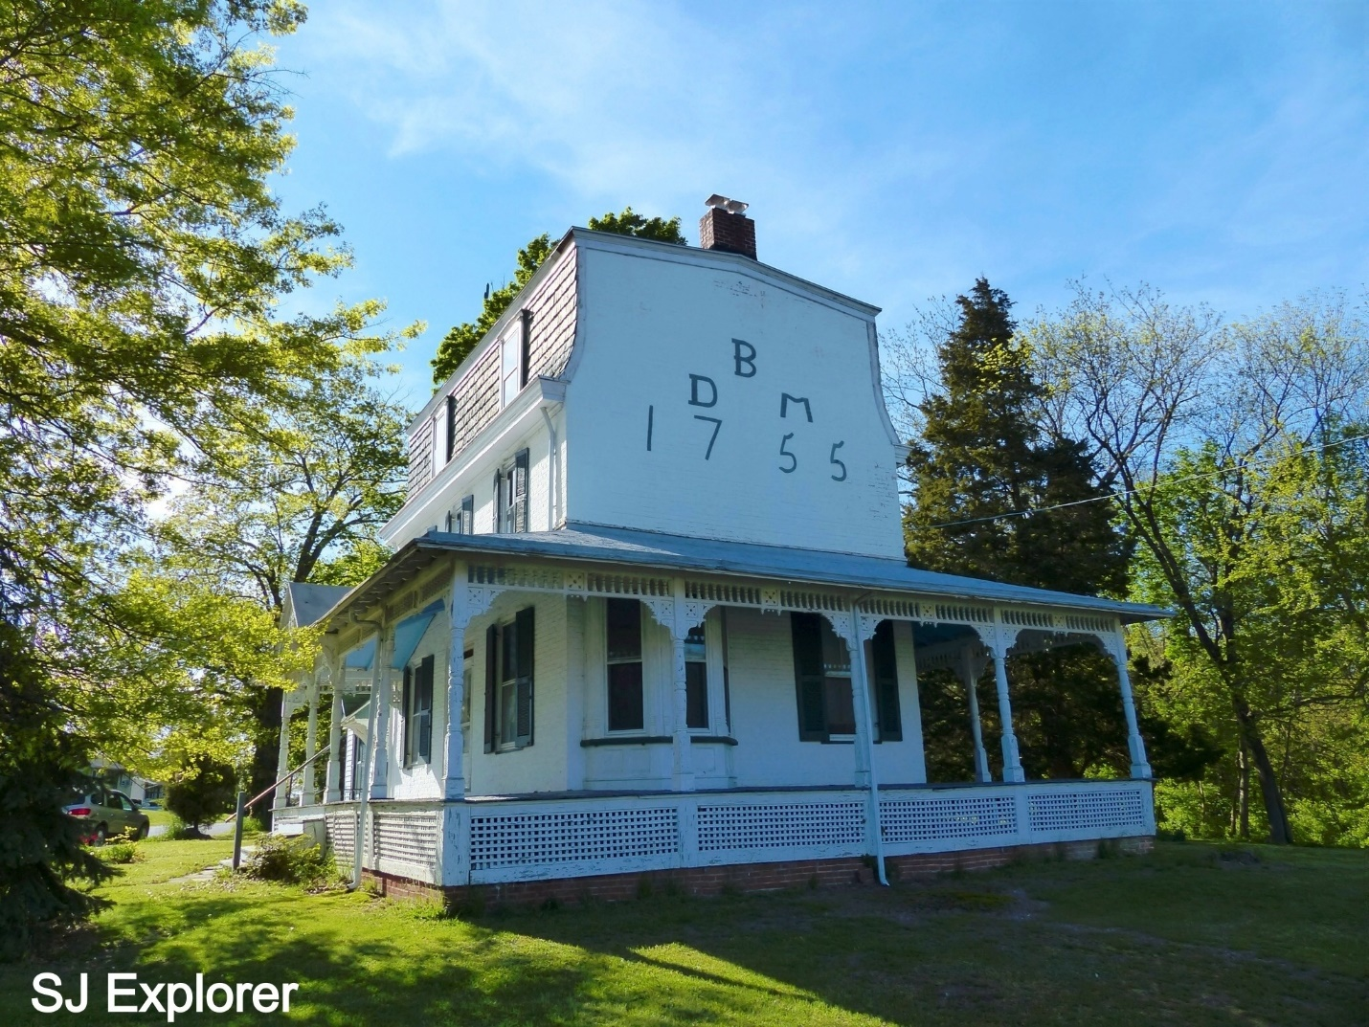

The Cowtown Rodeo
Founded in 1929, the Cowtown Rodeo is oldest weekly professional rodeo in the United States. The rodeo runs from May through September every Saturday night. Be sure to check it out, they put on a great show from Bull Riding, Bronc Riding and Calf Roping to Barrel Racing and Rodeo Clowns. They also feature a Junior Rodeo for kids. The Cowtown Rodeo is even still televised for championship competitions. Always a great time!
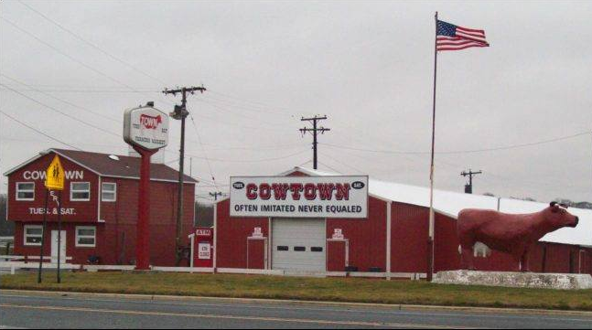

Cowtown Flea Market “Often duplicated Never equaled.”
The Cowtown Flea Market is well-known throughout the entire East Coast. With over 400 vendors, Cowtown is among the largest flea markets in the country. Founded in 1927, it is also among the oldest. You can pretty much buy anything here, from t-shirts to electronics to household goods, as well as farm fresh produce and livestock. Cowtown also features several restaurants and even fresh roasted peanuts, (be sure to check this out, they are the best peanuts I’ve ever eaten). Open year round every Tuesday and Saturday.

