**13TH ANNUAL WISCONSIN GRILLED CHEESE CHAMPIONSHIP** 

**DEPOT@MHTC.NET**

**APRIL 25th | 2026**

**SPONSORSHIP APPLICATION**

Post deadline submissions will not be eligible for some print promotional materials. **PROMOTIONAL MATERIAL DEADLINE:** DECEMBER 1ST, 2025

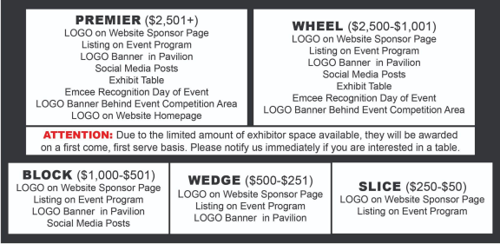***Please send most current LOGO file to depot@mhtc.net***

**Sponsor Amount:_______________***Payments should be submitted with completed application.*

Business Name:__________________________________________________________________________________________

Contact Name:___________________________________________________________________________________________

Contact Email:______________________________________________ Contact Phone Number: ________________________

Website or Facebook Link:

**Checks Payable to:** Dodgeville Area Chamber // **Credit Cards** are accepted but transactions include a 3.5% processing fee. **Applications may be directed to:** 338 N. Iowa St., Dodgeville, WI 53533 or depot@mhtc.net

depot@mhtc.net Dodgeville Area Chamber Of Commerce(608) 935-9200