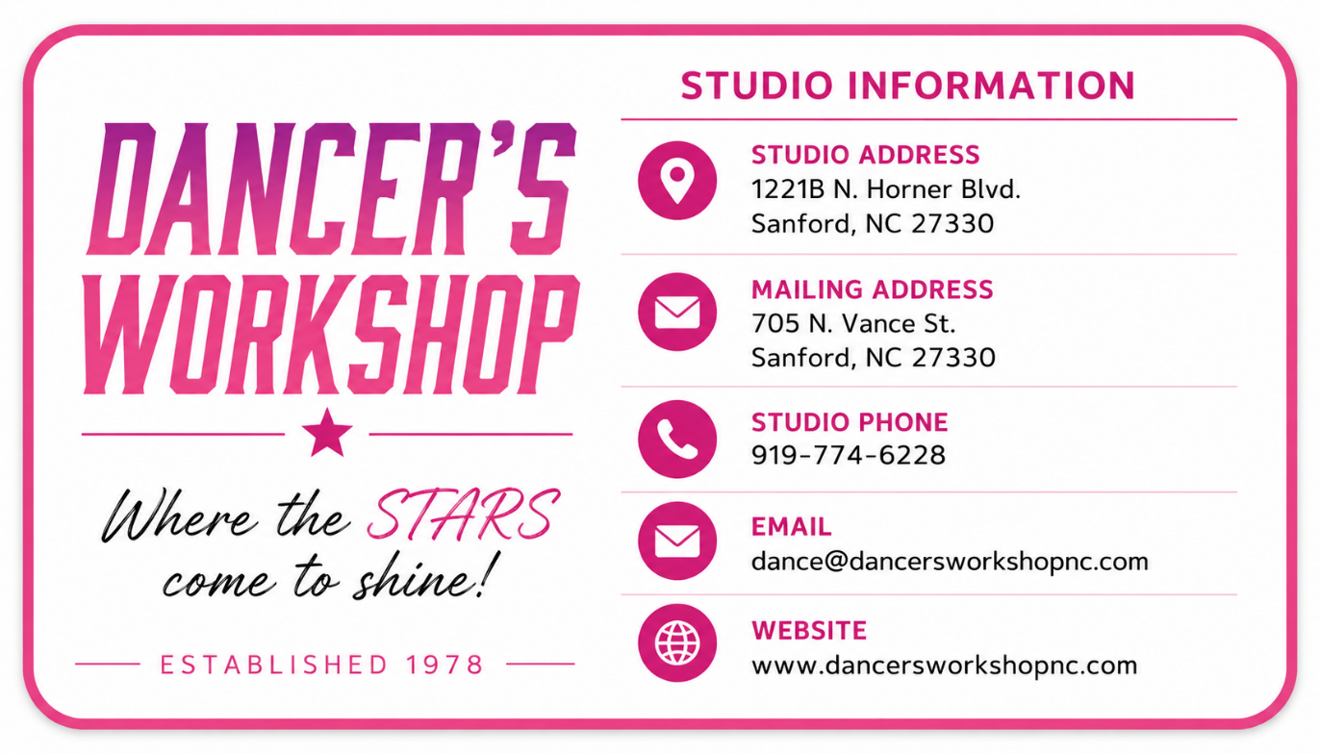

We’re So Glad You’re Here!
Welcome to the Dancer's Workshop, where every dancer is encouraged to learn, grow, and shine in a positive, family-friendly environment. Since 1978, we have been committed to providing quality dance education while building confidence, character, and a lifelong love of dance. We are honored to be part of your child's journey and look forward to an exciting season together!

Why Dance?
Dance offers so much more than learning steps—it helps children grow physically, mentally, and emotionally. Students develop strength, flexibility, coordination, confidence, self-discipline, teamwork, and respect while learning to express themselves through movement. Whether your child dreams of a professional dance career or simply wants to have fun, the skills and confidence they gain in dance will benefit them for a lifetime.

CLASSES

Subjects Offered
Preschool ∙ Lyrical/Contemporary ∙ Acrobatics ∙ Mommy & Me
Adult ∙ Tap ∙ Jazz ∙ Hip Hop ∙Lyrical ∙ Ballet ∙ Elementary Dance

Private Classes
Lessons in any dance subject are available for students interested in individualized instruction for technique, competition or in preparing for special events such as talent shows, pageants, etc. Private classes are only available to full-time students who also take group lessons in the same dance subject.

Teams
Through audition or invitation, we offer special classes for students who are interested in additional performances or competitions. Ballet and technique classes are required for all team members. Failure to attend classes will result in dismissal from the team.

REQUIREMENTS

Dancewear
Correct dance wear should be worn for all classes. Any style leotard may be worn, and tights are required for all subjects. No sweatpants, jeans, street clothes, no halter tops or two pieces, etc. are allowed for students. All supplies should be in a dance bag with their name or on it.

Shoes
Student’s name should be in all shoes. Correct shoes are necessary, but color of shoes is not important until recital time.
Preschool - Tan Buckle Mary Jane tap Shoe & Pink Ballet Shoes
Ballet - Pink Ballet Slippers
Lyrical/Contemporary - Turners
Acrobatic – bare feet
Jazz - Turners
Tap 8 years old and under- Tan Buckle Mary Jane
Tap 9 years old and up - Black Lace Up
Hip Hop - White Tennis Shoes Teams

Hair
Hair should be pulled back away from the face and secured in the back, no exception. Long ponytails should always be put in a bun so that the hair does not hit the child in the eyes when turning or get under foot when tumbling.

Jewelry
Jewelry, for reasons too numerous to list here, should never be worn at any time. Earrings in an Acro class are an absolute NO!!

Attendance
Regular dance attendance is vital to a successful dance year for all Students. Students with four or more absences after March 1st will not be allowed to dance in the Spring Performances without approval from their teacher. Accepting obligations is good training for students.

PERFORMANCE

Spring Performance
A costumed performance concludes the dance year in late May or early June. A student will usually perform a dance in each subject that they study unless it’s a non-performance class. Preschool students usually perform 1 number.

Non-Performance Classes
Certain classes are designed as non-performance classes and do not perform in the spring show. These include, but are not limited to, Technique, stretch, some acro, solo, duet, trio.
Extra Performances
We encourage students to perform for any function that issues them an invitation. We will be glad to help and if you know of any civic club or organization that would like a program please keep us in mind. Performance plays an important part in a child’s dance education.

COMMUNICATION

Teacher Conference
During class hours our instructors are available for brief comments only, as lengthy conversations or discussions interfere with class time. If you have something that you need to discuss with a teacher, please leave a note with the receptionist asking the teacher to call you and they will do so at their earliest convenience.

Observation or Visiting Day
From time to time, teachers allow parents to come in at the end of class so that the students can show off their accomplishments.
Front Desk Staff
Ebony Johnson and Gaylene Marsh
PLEASE STAY INFORMED!!
YOU SHOULD ALSO CHECK EMAIL DAILY. WE ALSO USE BAND FOR COMMUNICATION PURPOSES. THE LINK TO JOIN IS BELOW:
https://band.us/n/a4a004p8S88by

GENERAL INFORMATION

About Our Studio
Our regular dance year begins in September and concludes with an end of the year performance in May or early June depending on the availability of auditoriums. A summer session is also offered. Classes are available for students beginning around age 2 and continue through adult. We are always open to suggestions for new classes to meet the needs of our growing “dance family”. Dancer’s Workshop students can improve their performance levels by working toward acceptance into a variety of performing and competitive groups. Our goal is to give students a dance class of technique, fun, and love.

Safety
All preschool students are required to stay in their classroom until their teacher returns them safely to parents in the waiting room. All other students should wait inside the studio until they can safely go to their parked car. Parents are required to come to the entrance for the child and walk with them to their car. The sidewalk and the parking lot are NOT play areas as there is too much traffic and you cannot see a small child when they cut between two cars.

Weather Cancellations
When schools in Lee County are closed due to bad weather, we are closed. Unless otherwise posted.
Holidays
We observe the following holidays: Labor Day, Thanksgiving, Christmas, Easter and, 4th of July but no other holidays. We do not close for teacher workdays.
Illness:
If your child is running a fever, please keep them at home. They can return to class when they have been fever free for 24 hours without fever reducing medication.
We reserve the right to separate your child from other children and ask you to return for pick up if your child is ill. Please help us keep the studio safe by not sending your children if they are not feeling well.
Never Miss a Chance to Dance!

Payments

Tuition
Tuition is due the 10th of each month and will be drafted on that day unless it is paid before then on the parent portal or in person at the studio. Some months will have 5 lessons and that will make up for the months that only have 3 lessons because of holidays. There are no reductions for missed classes, therefore, we encourage regular and prompt attendance. Lessons missed because of weather will be made up. If for any reason your child discontinues classes, you will be charged until you, the parent, notifies us personally. Please do not give checks to teachers unless it is for a private class. We do not send out monthly bills unless your account is seriously past due and then you will be asked to discontinue classes until you can bring your bill up to date.

Registration Fee
A $40.00 non-refundable registration fee is charged yearly at the beginning of fall. Please note that a current, working credit card is required to register for classes. If your account is not paid in a timely manner, we will run autopay via the card listed in Dance Studio Pro. If your card is declined for incorrect number or if the card has expired, Dance Studio Pro will charge a $10 fee.

Late Fee
A late fee of $10.00 will be added to monthly tuition paid after the 10th of the month.
Returned Checks
A $35.00 service charge will be added to your account for each check returned to us.
Account Information
See the receptionist at the front desk for information concerning your account. Teachers do not have information concerning accounts for payment available.

Costume Payments
Students participating in the end of year recital are required to pay non-refundable costume payment for each subject that they take. Preschool is considered 1 subject. This deposit may be paid anytime, but no later than November 15th. Costumes are ordered during Christmas break and will not be ordered unless your deposit is made. Costumes cannot be returned to the companies we order from, therefore, your commitment is necessary. Final costume payment is due February 15th.

Recital Fee
A $65 recital fee will be charged for every student to cover the auditorium rental, program printing, tech crew, ads and other production expenses associated with the spring recital. This allows our performances to be open to the public without admission charges and for you to invite as many guests as you wish.

Competition Entry Fees
Competition fees are due at the time that each individual competition specifies and will be mailed by the required deadline, but fees will not be paid by the studio or the teacher. Please understand our position on this matter, Also, entry fees for competition will not be accepted if tuition is past due and there will be no exceptions to this rule. Money should be applied to tuition first. Please consider the financial requirements of a competition team before accepting this responsibility.

