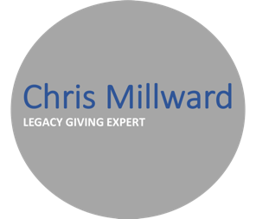

**Legacy measurement and KPIs**

Some top tips

(And a handy case study to help bring them to life)

**1 – Understand your organisation**

* Internal discussions relating to legacy measurement and KPIs can be difficult. You need to be able to present your case effectively. You can’t predict the future – nor should you say you can, or be put into a situation where you feel you need to. But, you do need to be able to prove the impact and efficacy of your activity over time.
* Measure those things that you know are of value to the organisation and internal stakeholders - so you have the data you need to inform, influence and communicate most effectively. This will help strengthen your case for further investment, resource and access to audiences and channels.
* Measure what you (and others) can influence. It's more motivating to see progress against something you know you have control over. Pledges are generally uncovered as opposed to generated, but opportunities to see and more actively consider can be controlled, created and counted.

**2 - Establish a clear vision and objectives for your programme**

Know what success looks like long-term for your programme and establish measurements and KPIs to help demonstrate you’re headed in the right direction and when milestones are reached. Some potential objectives:

* Increase overall legacy income
* Increase the number (or % of supporters) leaving a legacy
* Optimise current channels to provide more opportunities for consideration to warm supporters
* Increase pipeline volume (awareness and consideration stages) through external acquisition
* Uplift in frequency and quality of engagement with and stewardship of existing prospects
* Increased opportunities for feedback and insight generation to improve understanding of motivations

**3 – Adopt a donor-centric view**

Legacy giving is a journey. Unlike other forms of fundraising, people may take some time to come to a decision, and can change their minds. Think about your legacy giving activity as a pipeline (as others would when approaching major donor or corporate fundraising) will help you adopt a more structured approach and optimise available resources. Aligning measurements to this model will help you establish a clear donor-centric view of the potential and activity within your legacy prospect pool. The key stages of Prochaska’s model as applied to legacy giving are as follows:

See <https://en.wikipedia.org/wiki/Transtheoretical_model> for more info on Prochaska’s model

**4 – Challenge short-term-ism**

Legacy giving is inherently volatile. Short-term measurement/ROI alone cannot effectively show the full impact of investment. We need to help others focus on the things that matter.

Think short (campaign), medium (impact of overall programme over 3-5 years) and long-term measures (linking future income back to marketing activity where possible) to paint a fuller picture.

|  |  |
| --- | --- |
| **Short** | Campaign-specific measures such as numbers relating to:   * reach * open rates * responses * cost per response * people uncovered at each stage of consideration in the legacy supporter journey |

|  |  |
| --- | --- |
| **Medium** | Measures concerning the impact of overall legacy giving activity:   * reach - how many people on your database have seen a legacy message * number of responses * percentage of supporters at each stage of the legacy supporter journey * number of positive (and negative) moves over time between stages of supporter journey * cost of activities to get supporters to action stage |

|  |  |
| --- | --- |
| **Long** | Closing the loop on investment v return (where and when possible):   * number and value of gifts * percentage of legacy gifts from those people known to organisation * percentage of legacy gifts from those people known to the legacy team * conversion rates to legator.   This stage requires close collaboration between the fundraising and administration teams to bring both sides of the legacy-giving journey together. Legacy fundraising and legacy administration are two sides of the same coin and you need to measure and record findings on both sides. Don’t think about key performance indicators in isolation. |

*Reproduced with thanks to DSC, Legacy and In-Memory Fundraising – Developing a Strategic Approach (Chapter 4), C Millward*

**5 – Establish a balanced approach**

Use a mix of quantitative and qualitative measures to get a more balanced view of performance. This will also help to counteract any short-termism in relation to investment v return. What might this look like for your organisation? A few thoughts to get you started:

* **Financial** – £s raised, ROI on marketing, cost per lead etc.
* **Customer** – interaction (likes/shares, feedback received, case studies received
* **Process** – data capture (CRM pipeline), data analysis - systems and process – efficiencies / added value, ways of working – culture, communications, journey planning, collaboration
* **Learning** – insight (audience), data analysis and modelling - optimise activity, market understanding, product development, personal development

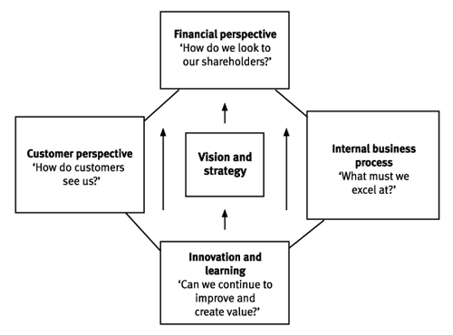

After *David Norton and Robert Kaplan 1992. – see link in further resources/guidance*

Don’t just measure that which you easily can. Identify what you **need** to measure to show the impact of your campaign/programme/legacy giving and work towards being able to capture and report on that. This process is also an opportunity to build internal relationships, understanding and ownership around legacy giving activity.

**6 – Benchmark mindfully**

Although generally favourable, the long-term ROI for legacy activity is not an absolute. It will vary depending upon activity and the size, nature and maturity of both your organisation and legacy programme. Be careful who you compare yourself to and how you set benchmarks.

KPIs and targets should be set, where known, upon pervious campaign performance alongside external benchmarking and insight from commercial partners. If you haven’t undertaken the activity before consider using the first year/few months – depending upon the nature of the activity - to test and review targets. Be mindful of the ‘low hanging fruit’ effect. Don’t let potentially heightened response rates from new audiences or activities lead you to set overly-optimistic longer-term targets!

To inform your activity, it’s useful to establish reliable sources of external market data to help you benchmark performance. Organisations such as Legacy Foresight, Smee and Ford and Remember a Charity are reliable sources of quality external market data and insight. Links in further resources and guidance.

|  |
| --- |
| **CASE STUDY**  Many of us are using digital and social media channels far more than we ever used to. The perfect way to more actively engaging existing and potential supporters.  Measuring the impact and success of increased activity over these channels - given the broad range of measurements available to show the impact of such campaigns - presents us with a new set of decisions.  A few thoughts below. Which do you think would be most appropriate for your organisation?  There’s not wrong answer btw.  Campaign reach – overall number of impressions  Cost per impression  Interactions – likes / Shares / Comments  Qual. feedback – via comments  Responses to call to action e.g. web site visits / downloads / online will writing etc.  Number and quality of leads  Cost per lead generated  Quality of targeting – optimization over time – reduction in cost per impression / lead / action  % / number who opt in to further communication  % / number who go on to support in other ways – cash / regular / volunteer etc.  Value of additional life-time support  % / number who convert to pledge  Number and quality of case studies identified and developed  Value of gifts pledged  Maturation rate – % of known pledgers who go on to gift  Value of legacy gifts received  No of familiar relationships established with next of kin  Value of future in-memory giving  Value of future (perhaps in-memory motivated) legacy gifts from family/friends |

**Further resources and guidance**

* Institute of Fundraising

<https://www.institute-of-fundraising.org.uk/groups/sig-legacy-marketing-and-in-memoriam/>

* Institute of Legacy Management

<https://legacymanagement.org.uk/>

* Directory of Social Change

<https://www.dsc.org.uk/publication/legacy-memory-fundraising/>

* Legacy Foresight

<https://www.legacyforesight.co.uk/>

* Smee and Ford

<https://smeeandford.com/>

* Dr Russell James

<https://plannedgivingadvisors.com/tag/russell-james/>

* Cabinet Office Behavioural Insights Team

<https://www.bi.team/blogs/applying-behavioural-insights-to-legacy-giving/>

* David Norton and Robert Kaplan – Balanced Scorecard

<https://www.pocketbook.co.uk/blog/2017/08/22/robert-kaplan-david-norton-balanced-scorecard/>

* Dr James Prochaska’s theoretical model of behavioural change

<https://en.wikipedia.org/wiki/Transtheoretical_model>

**Contact**



If you’d like to discuss measurement and KPI setting (or any other element of your legacy giving programme) further, please do get in touch.

[Chris@LegacyGivingExpert.co.uk](mailto:Chris@LegacyGivingExpert.co.uk)

+4407970308981

[www.LegacyGivingExpert.co.uk](http://www.LegacyGivingExpert.co.uk)

Follow chris**i**millward on Twitter