Timeline: How today’s restaurant industry came to be

Key milestones from the last 100 years.
By Peter Romeo and Myra Engers Weinberg, Feb. 21, 2019
1900-1920: A period of rampant immigration introduces new cultures and cuisines to the United States. By the second decade of the century, some 4 million people had come from Italy alone, bringing with them the foods and cooking styles of their homeland.
1918: “The War to End All Wars,” aka World War I, ends with Germany’s defeat and the emergence of the United States on the world stage.
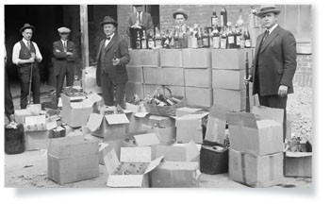
1919: The National Prohibition Act, outlawing most adult beverages, is passed. It would remain in place until 1933.
1919: Roy Allen uses a root beer recipe he bought from a pharmacist and sells the brew for a nickel a glass; three years later, he and partner Frank Wright begin A&W Root Beer.
1919: Restaurateurs form The National Restaurant Association in Kansas City, MO, to deal with issues of rationing, price gouging, unions and Prohibition.
1921: The first White Castle restaurant opens in Wichita, KS. The “white” was chosen to signify purity, and the “castle” to indicate permanence and strength.
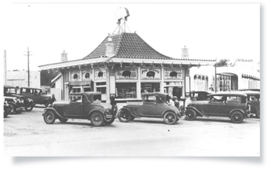
1921: The Pig Stand, one of the first “drive-ins,” opens in the Dallas-Fort Worth area.
1923: Merritt J. Osborn starts the Economics Laboratory company with a product to clean hotel carpeting. His mission to provide customers with “economic” solutions developed through “laboratory” research is the beginning of Ecolab.
1924: Caesar Cardini concocts the salad that will become a restaurant staple named after him: the Caesar Salad.
1924: Twenty-two local restaurant associations collaborate with the National Restaurant Association on issues of importance to the business. Most would become today’s state restaurant associations.
1926: The Palm Restaurant (originally called The Parma but misspelled by a license clerk) opens in NYC. It would close, in a different location, in 2015, though spinoffs remain open today.
1926: The Charleston hits its peak as a dance craze. The provocative gyrations were seen as a way of mocking the proponents of Prohibition.
1927: J. Willard Marriott, a Utah transplant living in Washington, D.C., uses $3,000 to open an A&W franchise in the district.
1928: Sliced bread is invented.
1929: The U.S. stock market crashes and the Great Depression sets in.
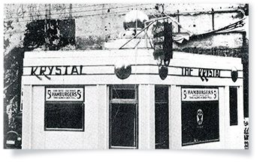
1932: The Krystal hamburger chain opens its doors in Chattanooga, Tenn., its name purposely misspelled with a “K” to snag attention.
1933: Prohibition ends, giving a boost to fine-dining restaurants and supper clubs such as The Pump Room in Chicago and The Rainbow Room in New York City. “21,” a well-known New York City speakeasy, can now operate legally.
1935: Beer is sold in cans for the first time.
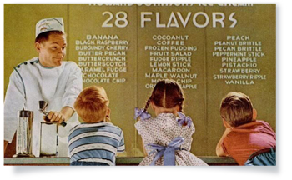
1935: A New England ice cream seller named Howard Johnson hits on the idea of letting other restaurant operators use his business’ name for a fee. Restaurant franchising is born.
1935: Duncan Hines, a traveling salesman from Kentucky, publishes “Adventures in Good Eating,” believed to be the first nationwide restaurant guide.
1936: The 40-hour work week is mandated by Congress.
1936: Robert Wian opens a hamburger stand in California. The following year he comes up with a double-decker burger and a mascot for his business, and Bob’s Big Boy is born.
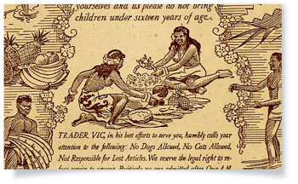
1937: Victor Bergeron opens Trader Vic’s in San Francisco. His exotic cocktails, adorned with miniature umbrellas, foreshadowed today’s mixology.
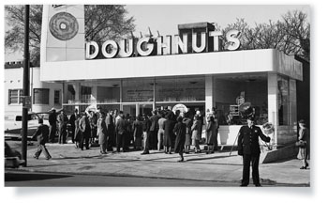
1937: Vernon Rudolph opens the Krispy Kreme doughnut shop in Winston-Salem, N.C.
1938: At age 19, Bill Darden opens his first restaurant, The Green Frog, which promises “Service with a Hop.” He would go on to develop a bargain-priced full-service seafood concept, Red Lobster, which would be the foundation for the company that bears his name, Olive Garden parent Darden Restaurants (it sold Red Lobster in 2014).
1939: President Franklin D. Roosevelt serves Nathan’s Hot Dogs to the King and Queen of England during their visit to the U.S.
1939: The New York World’s Fair features innovative cuisine from nearly 60 countries, giving many Americans their first exposure to exotic ethnic foods.
1940: A veteran dairyman who respected cows as the queens of the business opens a shop in Joliet, Ill. J.F. McCullough calls his brainchild Dairy Queen.
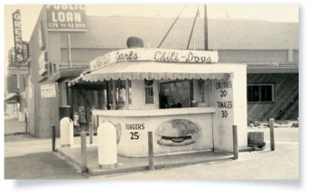
1941: An entrepreneur scrapes together the money to open a hot dog cart in Southern California. That enterprise from Carl Karcher would become the Carl’s Jr. burger chain.
1941: Japan bombs Pearl Harbor, pulling the U.S. into World War II.
1941: Regular TV broadcasting begins in the U.S.
1943: Wartime rationing comes to restaurants. Restaurants are allowed to use 1 pound of coffee for every 100 meals and 1 pound of sugar for every 33 customers.
1943: Ike Sewell and business partner Ric Riccardo open a restaurant in Chicago called Pizzeria Uno, introducing the nation to deep-dish pizza.
1945: World War II ends, leaving a much-changed world. A war-weary U.S. settles into a post-war period focused on family, financial security and creature comforts, including a new thing called television. A massive shift of the population from city to suburbs reshapes the nation.
1946: Frances Roth and Katharine Angell establish the New Haven Restaurant Institute to train returning military veterans to become chefs. It would move to Hyde Park, N.Y., and become the Culinary Institute of America.
1948: Harry Snyder and his wife, Esther, open a drive-thru restaurant featuring burgers, fries and little else. He names the California outpost In-N-Out Burger.
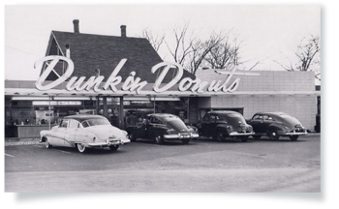
1950: Dunkin' Donuts is founded by Bostonian Bill Rosenberg, whose business plan is simple: "Make and serve the freshest, most delicious coffee and donuts quickly and courteously.” He would begin to franchise the concept, making it a pioneer of the development strategy that would change the industry a decade later.
1952: The first sugar-free soft drink, No-Cal, is introduced as a specialty beverage for diabetics. It was initially available only as a ginger ale.
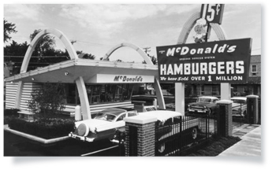
1953: The first McDonald’s featuring “golden arches” architecture opens, in Phoenix.
1953: Burton Baskin and Irvine Robbins combine their California ice cream shops to form Baskin-Robbins. From the beginning, pink spoons were offered to let people sample any flavor.
1954: A milkshake blender salesman named Ray Kroc visits his star customers, Dick and Mac McDonald, to see why they were buying so many of his machines. He finds a glass-walled drive-up place that can sell hamburgers for 15 cents, or roughly half the prevailing rate, because of its batch-cooking system and operational procedures. Kroc realizes he’s witnessing a breakthrough and pursues a collaboration.
1954: Jim McLamore and Dave Edgerton decide to open a new burger concept, differentiating it from the pack by broiling the patties over open flames. Burger King is born.
1954: Southern Californian Glenn Bell sees an unoccupied niche in his native area’s booming fast-food industry and decides to open Taco Tia, a restaurant featuring a Mexican street-food staple in a crunch taco shell. He would later change the name to Taco Bell.
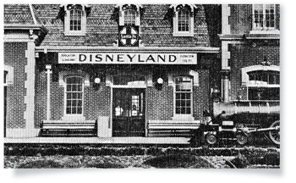
1955: Disneyland, a theme park dedicated to fairy tales and Disney characters, opens in Anaheim, Calif.
1955: Waffle House is founded.
1959: Gennaro and Carmela Sbarro open an Italian grocery store in Brooklyn, N.Y. Out of that retail base would come a pizza and pasta restaurant chain called Sbarro.
1960: The National Restaurant Association moves its annual convention in Chicago to McCormick Place, drawing 50,000 attendees.
1960: Thad Eure Jr. and Charles Winston turn a red barn in North Carolina into a restaurant with an emphasis on hospitality and strong value for families. The Angus Barn would become one of the nation’s highest-grossing establishments and a driver of fine dining’s “casualization.”
1961: The first astronaut orbits the earth.
1962: The first model food and sanitation code is drafted, with input from the National Restaurant Association.
1964: Harland Sanders sells his Kentucky Fried Chicken restaurants to John Y. Brown and Jack Massey, with the deal entitling Sanders to an annual salary for life for serving as company spokesperson.
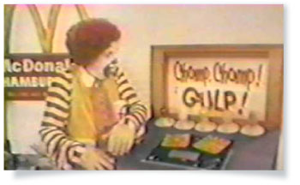
1965: Ronald McDonald makes his debut on television. He would become the chain’s official spokesman a year later.
1965: Alan Stillman notices the young partiers flocking to bars in New York City, and figures he’d try something geared specifically to those single professionals prowling for fun. He opens a quirky place called TGI Fridays, the first of what would initially be called fern bars, and then casual-dining chains.
1966: A young, charismatic entrepreneur sees a gap in the restaurant mix of Dallas: Young families and singles in the 25-to-44 age bracket had to choose between fast food and the sedate full-service restaurants frequented by their parents. Norman Brinker decided to sandwich something in between. He called it Steak and Ale, inspired by the hit movie “Tom Jones,” and featured steak and other upscale choices at prices young people could afford.
1969: Jack in the Box introduces a breakfast sandwich, believed to be the first offered by a quick-service chain.
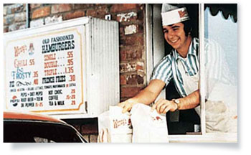
1969: After selling off his Kentucky Fried Chicken franchises, bored Midwesterner Dave Thomas decides to enter into the quick-service sector’s biggest market, burgers. Although that arena is already packed, Thomas hatches the idea for a new type of place, featuring burgers made with fresh meat, baked potatoes and chili. He names it Wendy’s, after his daughter.
1969: Based on a school project, the Victoria Station chain is launched by three graduates of the Cornell Hotel School. To lower opening costs, the restaurants were converted from railway boxcars. They featured prime rib at a bargain price and the restaurants quickly became a hit in the 1970s—but the business model ultimately proved unsustainable.
1969: John Baugh, a small food distributor in Houston, convinces eight other distributors to join forces and create a national distribution network called Sysco. Sales that year were $115 million; estimates for sales in 2012 topped $42 billion.
1971: A Chicago entrepreneur named Rich Melman opens a restaurant featuring a salad bar consisting of some 40 items. R.J. Grunts would become a hit, and Melman would go on to build Lettuce Entertain You Enterprises, the model multiconcept restaurant operation, or a collection of concepts varying in format and name.
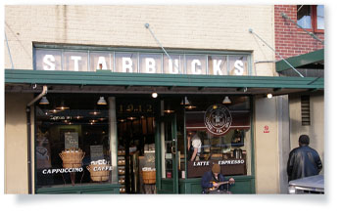
1971: The first Starbucks opens in Seattle’s Pike Place Market, with its name taken from a character in Herman Melville’s “Moby Dick.”
1971: The Center for Science in the Public Interest, a consumer advocacy organization, is formed in Washington, D.C.; the following year, its founder, Michael Jacobson, popularizes the term “junk food.”
1973: Johnson & Wales University in Providence, R.I., introduces what would become its College of Culinary Arts and begins offering an associate degree in that field.
1973: McDonald’s introduces the Egg McMuffin, an idea hatched by a franchisee.
1973: The first Golden Corral opens in Fayetteville, NC.., offering its now famous “endless buffet” of comfort food items.
1974: The first personal computer is manufactured.
1974: Burger King’s game-changing “Have It Your Way” marketing campaign is launched, introducing customization as a major point of differentiation.
1974: The first Ronald McDonald House, providing comfy lodgings for families seeking care for an ill child far from home, opens in Philadelphia. It is funded by sales of the chain’s Shamrock Shake.
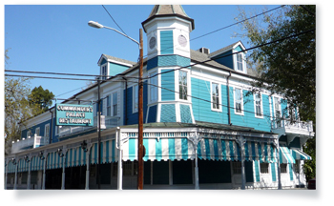
1974: The Brennan family takes over New Orleans’ iconic Commander’s Palace Restaurant, updating both the exterior and its acclaimed kitchen.
1975: McDonald’s’ Hamburger University training facility opens, offering would-be managers a degree in hamburgerology and a minor in french fries. The college campus-like facility would be much copied by competitors.
1976: Windows on the World, the brainchild of New York City restaurant creators Joe Baum and Michael Whiteman, opens on the 107th floor of the World Trade Center.
1977: Denny’s introduces its signature Grand Slam Breakfast to honor baseball great and home-run record breaker Hank Aaron.
1977: Fresh from creating Atari, game inventor Nolan Bushnell creates the first Chuck E. Cheese’s Pizza Time Theatre in San Jose, Calif.
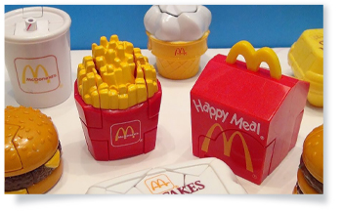
1978: McDonald’s launches kid-sized portions paired with toys and calls them Happy Meals.
1979: Paul Prudhomme opens K-Paul’s restaurant in New Orleans, sparking a renaissance in Cajun cooking and heightened interest in American cuisine.
1979: The National Restaurant Association relocates its headquarters and most operations to Washington, D.C., a reflection of its greater involvement in public advocacy.
1980: McDonald’s offers a new dish of “chopped chicken meat, mechanically compressed and factory shaped” known as the Chicken McNugget.
1982: During a major snowstorm in Atlanta, George McKerrow places a sign in the window of his year-old LongHorn Steakhouse, promising “Drinks $1 While It Snows.” The place is packed for the three days of the storm. LongHorn takes off, helping to foster the herd of cowboy-themed steakhouses such as Lone Star, Texas Roadhouse and Logan’s Roadhouse.
1982: A British magazine coins the term “foodie,” to describe a person “… for whom food became ... a hobby, pastime, and topic of discussion.”
1983: Hooters opens its first restaurant.
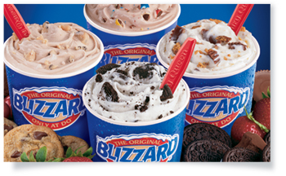
1985: Dairy Queen introduces a super-thick milkshake studded with mixed-in treats such as candies and crumbled cookies. The Blizzard would become one of the most successful new products of all time.
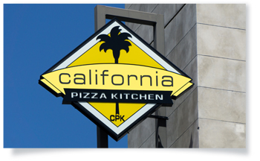
1985: After watching crowds flock to Wolfgang Puck’s original Spago for so-called gourmet pizza, attorneys Rick Rosenfield and Larry Flax decide to adopt the notion for a new mass-market concept called California Pizza Kitchen.
1985: Two men begin selling rotisserie chickens and sides in Newton, Mass., and call the business Boston Chicken; in 1995 they expand the offerings and change the name to Boston Market.
1987: The original owners of Starbucks sell the brand to a former manager and supplier, Howard Schultz, who had his own coffee brand at the time, called Il Giornale. Schultz would convert his cafes into Starbucks outlets and expand the brand.
1989: Drawn together for a story and photo slated to run in Restaurant Business, 14 prominent women in the foodservice industry decide there is a need to promote more diversity in the field. They form the Women’s Foodservice Forum to develop leadership talent and foster career advancement of executive women.
1990: With backing from six major industry organizations, the National Restaurant Association launches the ServSafe program to foster voluntary food safety training. The course and certification process teaches restaurant professionals to safeguard their business by ensuring the safety of guests and employees.
1990: McDonald’s opens its first unit in the Soviet Union and begins serving more than 50,000 people a day.
1991: The last Horn & Hardart Automat closes in New York City.
1991: Domino’s Pizza puts out a warning to franchisees that war is likely, based on record orders of pizza from the Pentagon the previous evening.
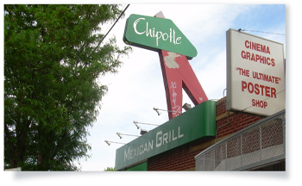
1993: Steve Ells, a Culinary Institute of America grad and former line chef at Stars in San Francisco, opens the first Chipotle Mexican Grill.
1993: TV Food Network, the first of what would be a flurry of cable and network TV programs devoted to cooking and celebrity chefs, airs its first broadcasts. Restaurateurs welcomed the attention brought to the industry by the interest-whetting onslaught of food programs, but they would rue the great knowledge of food amassed by viewers. It was harder to get any slack from customers.
1995: Restaurant industry sales totaled more than $295 billion, up nearly sevenfold from sales of approximately $42 billion in 1970.
1997: Tricon Global Restaurants is formed to manage three quick-service chains spun off from PepsiCo: Kentucky Fried Chicken, Pizza Hut and Taco Bell. The name would change in 2003 to Yum Brands.
1998: Chuck Templeton founds OpenTable, allowing diners to make dinner reservations online.
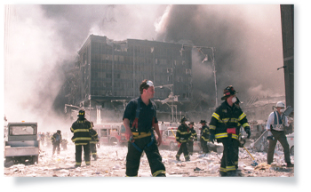
2001: Seventy-three employees of Windows on the World are among the victims of the 9/11 terrorist attacks
2002: Burger King introduces its Value Menu of 11 items priced at 99 cents.
2003: Darden Restaurants opens the first Seasons 52 restaurant, featuring seasonally inspired menu items and a wide array of wines. The concept is intended to be the next logical progression for consumers who had grown up on fast food, graduated to casual dining, and were looking for more healthful and sophisticated fare.
2004: The administration of George W. Bush sounds what is believed to be the first viable call for voluntary menu labeling.
2005: Hurricane Katrina devastates the dining mecca of New Orleans and surrounding areas.
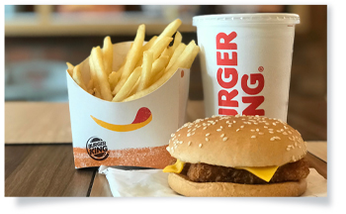
2006: Restaurant sales are forecast by the National Restaurant Association to pass the $500 billion mark.
2006: Three out of four adults report they are trying to eat more healthfully in restaurants.
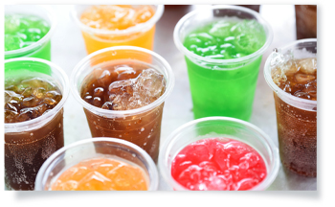
2006: The three major soft drink companies agree to stop selling sweetened sodas in schools.
2006: The New York City Board of Health votes to institute a ban on trans fat oils and shortenings in restaurants.
2008: Three out of four full-service restaurants have a website.
2009: A National Restaurant Association survey of American Culinary Federation chefs identifies the use of local produce as the restaurant industry’s No. 1 food trend.
2009: Industry icon Norman Brinker, widely recognized as a father of casual dining, dies at age 78.
2012: ServSafe issues its 5 millionth ServSafe certification.
2012: Locke-Ober, the iconic watering hole of Boston politicians and Brahmins, closes after being in business since 1875. Other fine-dining graybeards similarly fire down their ovens, the victims of a shift in consumer preferences to more casual fare and settings.
2012: Hurricane Sandy pummels New York and New Jersey, hurting thousands of restaurants and small businesses throughout the area. The National Oceanic and Atmospheric Administration (NOAA) estimates the damages at $65 billion.
2013: The National Restaurant Association hosts the first annual Restaurant Innovation Summit, focusing on “customer engagement through emerging technology.”
2013: Burger King introduces Satisfries, a lower-calorie, healthier french fry; less than a year later, the product is removed from all U.S. menus.
2014: The U.S. Senate rejects legislation that would have raised the federal minimum wage from $7.25 to $10.10 an hour.
2014: Burger King pays more than $11 billion to purchase iconic Canadian donut chain Tim Hortons.
2014: The Food and Drug Administration releases its final menu labeling regulations, passed in 2010 as part of the Affordable Care Act.
2014: California passes a law mandating paid sick leave for all employees who have worked for one employer for more than 30 days.
2014: Seattle votes to increase its minimum wage to $15 an hour.
2015: Restaurateur Danny Meyer, founder and CEO of Union Square Hospitality Group, announces that his restaurants will phase out tipping in an attempt to “… address a system that is broken and that is not sustainable.”
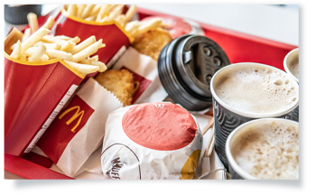
2015: McDonald’s announces plans to offer a number of its breakfast items throughout the day.
2015: The Supreme Court rules that gay and lesbian couples have a constitutional right to be married.
2016: Republican Donald Trump is elected the 45th president of the United States.
2016: Famed New York City restaurant the Four Seasons closes in July, only to open later in a different location, to varied reviews.
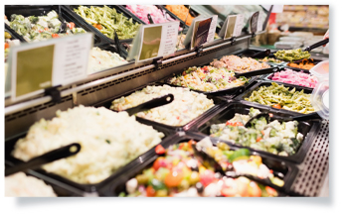
2016: A Technomic study, done in conjunction with the Food Marketing Institute, shows a growth of $15 billion in supermarket foodservice over the last eight years.
2018: After 10 years of fits and starts, federal menu labeling requirements take effect. The National Restaurant Association had been a proponent of the regulations, which set out precisely how nutritional information must be displayed on the menus of chain restaurants.
2018: While overall restaurant sales are flat to slightly positive, delivery booms. Sales through third parties during the first half of the year topped $5 billion, a 55% increase over the prior year. That volume would have made the delivery specialists the industry’s third-largest chain, behind McDonald’s and Starbucks.

###

