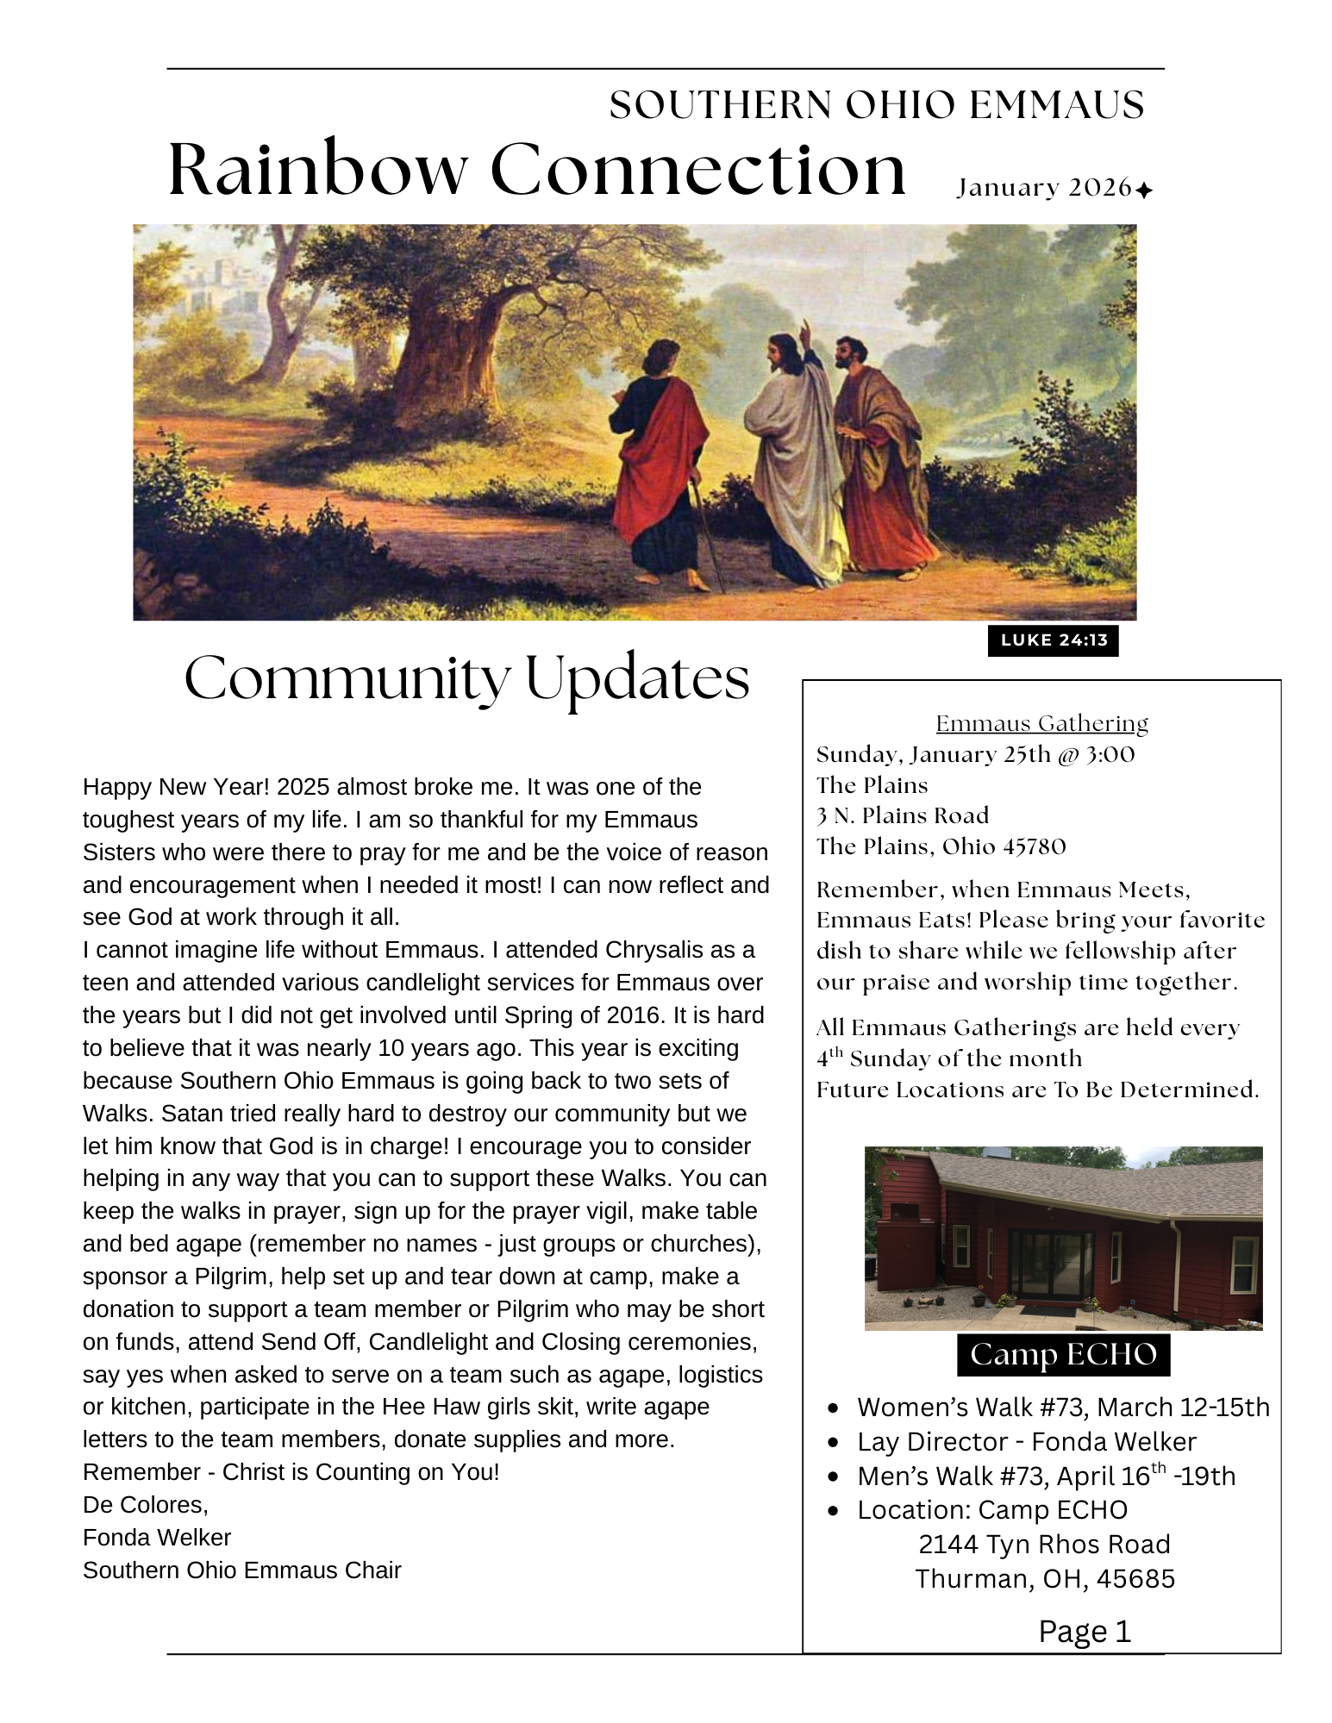

MOST WANTED
My name is Pastor Sharon Slowter. I was on Southern Ohio Emmaus Walk #9 Table of Mary.
This is a call out to all clergy who have been on an Emmaus Walk……URGENT:
At this time, I am the newly appointed Community Spiritual Director. I served under the last Community Spiritual Director Steven Krumm who has served the Emmaus Community outstandingly. However, I feel I just stepped off the deep end of the pool and have no idea how to swim. Not that Pastor Krumm left me high and dry just the opposite; he has given me detailed information to help me.

The problem is our Clergy Pool is being drained which is a surprising discovery for me.
The Emmaus Walks cannot function without Spiritual Directors serving and Pastors willing to give essential talks.
The Emmaus Community functions around the Walk to Emmaus in which Jesus was right smack dab in the center of AFTER dying on that old, rugged cross!
Where are you? Pastors, Clergy, religious leaders of our day?????
How can Emmaus carry on their mission of raising up pilgrims to become leaders in their Churches when the leaders of the Church won’t even step up.

Perhaps you feel left out, ignored, forgotten and rightfully so. Please forgive us for the oversight.
To the many who always show up, I pray God blesses you and your ministry abundantly.
Jesus’ commission still stands and the call to serve is more urgent now than ever before.
As Pastors, Clergy, religious leaders, you know how imminent Jesus’ return is and our responsibilities are to the souls under us and those placed before us.
The Emmaus Community needs you to step up and fill Spiritual Director roles and Pastors

willing to give a talk for this year:
Women’s Walk #73 - March 12-15
Men’s Walk #73 - April 16 – 19
Women’s Walk #74 - September 17 – 20
Men’s Walk #74 - October 15 - 18

Team meetings for the Women’s Walk begins Feb. 7 at Haydenville Church so please, please contact me as soon as possible. 740-509-2743

Now is your time:

GOD’S CALLING YOU - SOUTHERN OHIO EMMAUS NEEDS YOU

In Matthew 25: 14-30, Jesus speaks to the faithful and the wicked SERVANTS. One hears, “Well done, good and faithful servant and to the other, “you wicked and lazy servant…be cast into the outer darkness.”

DeColores,

Pastor Sharon Slowter
740-509-2743
Move With the Lord
Here we are in the New Year of 2026. We look at the year with great expectations. But too often we tend to look backwards instead of forwards. We tend to look down and around instead of looking upward to the Lord. We think of the things that beset us in the previous year, month or even yesterday causing us to be paralyzed with fear. We tend to worry over the things that we cannot change instead of doing the things that we can change. We must continue to move with the Lord.
Our first and only step must be to place our complete trust in the Lord with no doubt in your mind and heart. Second, let the Lord to use your weaknesses to bring Him the glory. The Apostle Paul reminds us of this very fact as we read in 2 Corinthians 12:9-10. Christ tells Paul, “My grace is sufficient for you, my strength is made perfect in weakness.” It is only when we are weak that Christ’s power is made more apparent to others. Let all that we say and do in this year of 2026; all glory and honor go to the Lord. Let us boast in the Lord and not ourselves. Let us be bold toward others in the Lord with love in our hearts and encouragement in our words. Third, as the Apostle Paul reminds us in 2 Timothy 1: 6-7 “For God has not given us a spirit of fear, but of power and of love and of a sound mind” and to “fan the flame” the Lord has given us. It is only then that can we truly move with the Lord. The writer of Hebrews puts it like this:
“Therefore we also, since we are surrounded by so great a cloud of witnesses, let us lay aside every weight, and the sin which so easily ensnares us, and let us run with endurance the race that is set before us, Looking unto Jesus, the author and finisher of our faith, who for the joy that was set before Him endured the cross, despising the shame, and has sat down at the right hand of the throne of God.” Hebrews 12:1-2 (NKJV)
Let us take the writer of Hebrews words seriously and lay aside everything that would hinder us from running the race that the Lord has called us to run. Let us look upward, fixing our eyes on the prize that awaits us. Let us be like Christ and endure any hardship and sacrifice so that we may fulfill the race we have been called to run. Let us do the things that will bring God glory and move with the Lord.
This will probably not be my last article for the Rainbow Connection. But I now step down as your Community Spiritual Director and have turned over those duties to my esteemed colleague and dear friend, Sharon Slowter. Many of you know and have worked with Sharon and she is a true warrior for the Lord and His Kingdom. So, I ask you to lift her up in your prayers and support her in any way that you can as she takes over as the new Southern Ohio Emmaus Community Spiritual Director. Listen to her words of wisdom and encouragement. Her words have brought me great comfort and reassurances when I needed them. I also like to say thank you to the Southern Ohio Emmaus Community for giving me the opportunity of being the Community Spiritual Director and the support that you have shown me for the past 2 years. Don’t worry, I will still be part of the Southern Ohio Emmaus Community and will see you all at the upcoming gatherings and walks.
So, now let us all fully serve the Lord in 2026. Walk by faith and follow the Lord as He moves this Emmaus Community forward. Let us all move with the Lord.
DeColores
Steven Krumm

