Migraine management for the Pharmacy team : overview
This is a self-study module for all members of the Pharmacy team.

Intended audience

This module has been designed for all members of the pharmacy team:
Title | Role
Prescribing pharmacists | Migraine management including prescribing where appropriate
Pharmacists | Migraine management
Pharmacy technicians | Recognising ‘green flags’ and signposting patient to pharmacists
Medicine counter assistants | Recognising ‘green flags’ and signposting patient to pharmacists

Intended learning outcomes

On completion of this training module, you should be able to:

- Explain why a person-centred approach is important
- Recall the common characteristics and symptoms of migraines
- Identify common myths and misconceptions about migraine
- Explain how migraines differ from other types of headaches
- Recall potential red flags which require a patient to be signposted to another practitioner
- Describe green flags which make primary headache more likely
- Identify the types of pharmaceutical management of migraines

Section 1 of 8 What is Migraine?

On completion of this section, you should understand the prevalence of migraine and details about the condition.

Migraine – the commonest disabling primary headache
Migraine is more than just a headache. It is a neurologic disorder characterised by moderate to severe head pain that can be exacerbated by movement and frequently accompanied by nausea, vomiting, noise and light sensitivity and disruption of daily activities.
Migraine can be a lifelong condition that waxes and wanes with good and bad periods. It can often be more frequent and severe in women at times of hormone changes such as puberty and perimenopause./menopause. Periods of stress can make it worse and it can be problematic for shift workers due to disruption of routine.
Clinical findings suggest that migraine can progress over time.^{31,32} Approximately 3% of patients with migraine transition from episodic migraine (< 15 headache days per month) to chronic migraine (≥ 15 headache days per month for > 3 months, with features of migraine ≥ 8 days per month) every year.
This on line learning course will help you understand more about the features and diagnostic criteria for migraine, how to distinguish it from other headache disorders and how to manage it.

Migraine prevalence

- Over a billion people worldwide get migraine, including over 10 million in the UK.
- Migraine is estimated to affect 15-23% of the UK population (Who is living with migraine in the UK? Rapid research review - Migraine Trust)
- It is initially as common in boys and girls, but from puberty onwards it affects three times as many women as men due to the effect of oestrogen.
- People can get migraine at any age. It often starts at puberty, and it usually peaks between the ages of 35 and 45.
- Migraine commonly runs in families with two thirds of migraine sufferers having a positive family history

The burden of migraine: how does it affect people?

Migraine is the second commonest cause of years lived with disability and the first in young women.

https://thejournalofheadacheandpain.biomedcentral.com/articles/10.1186/s10194-020-01208-0

It is often under-diagnosed and under-treated . In one study only 56% pf patients with migraine had been given a medical diagnosis.

The burden of migraine can impact several domains of patients’ lives.^{2,5-14}
- 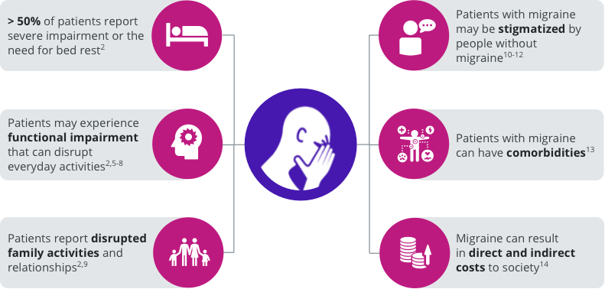

It can be difficult to live with a condition that is very painful and means people can’t function normally – but is often dismissed as ‘just a headache’. It’s estimated that 190,000 migraine attacks occur every day in the UK. Over three quarters of people who get migraine have at least one attack each month. These can last between from a few hours to several days.
We know that people with migraine feel it had a significant impact on their relationship with their partner or spouse and it can also significantly affect people’s mental health.
This section is summarised in the Migraine Trust document What is migraine factsheet (The Migraine Trust)

What causes migraine?

Whilst the cause of migraine is not completely understood, a lot of research into the pathophysiology in the last 20 years, have led to the development of new specific medicines to treat migraine attacks. Various pain proteins (neuropeptides) such as CGRP (calcitonin gene related peptide) are increased during a migraine attack and this leads to a “wind up” of both the brain and the peripheral nervous system via the trigemino-vascular system. This results in altered sensory processing, resulting in symptoms such as sensitivity to light, sound, smell and motion.
For up to 60% of people with migraine there is a possible link to their genes, making them more sensitive to changes in their environment. That’s why migraine often runs in families.
There is a small increased risk of stroke in migraineurs, especially those with aura. The absolute risk is very small and other more common risk factors such as hypertension and diabetes are more significant.
Professor Peter Goadsby a world leading headache researcher and a Trustee of the Migraine Trust summarises that
“Migraine is an inherited tendency to have headaches with sensory disturbance. It’s an instability in the way the brain deals with incoming sensory information, and that instability can become influenced by physiological changes like sleep, exercise and hunger."

Professor Peter Goadsby, Professor of Neurology, King’s College London; Director, NIHR-Wellcome Trust Clinical Research Facility, King’s College Hospital London; Trustee of The Migraine Trust"

Different types of migraine
There are different types of migraine.
Doctors use a classification system to diagnose and treat different types of migraine effectively. The most common types fall into two categories:
• migraine without aura
• migraine with aura.
About one in three people with migraine have migraine with aura. Aura is the result of an electrical wave of nerve activity that spreads over the brain (cortical spreading depression) and develops into reversible neurological symptoms that warn of a migraine attack. The most common is visual disturbance. Aura can also be sensory with numbness and pins and needles and rarely motor with loss of strength.
Migraine with and without aura are divided into episodic, meaning having a headache on fewer than 15 days a month and chronic defined as having headache on at least 15 days per month, with eight of these having migraine symptoms, for at least three months.
Further information Types of migraine - The Migraine Trust

Section 2 of 8 Person-centred care

On completion of this section, you should be able to:
- Enable and empower collaborative person-centred approaches to support those living with migraine.
- Understand the importance of language
- Appreciate the role of Realistic Medicine in migraine management

Language matters

"Our approach needs to be collaborative and inclusive, not judgemental; as words (verbal or nonverbal) can have an impact far reaching than one can comprehend, especially in the setting of a long term condition" Dr Partha Kar

Review the Migraine Trust blog : Migraine and Language

Consider how you would you change your approach going forward?

Facilitating teamwork

Every member of the pharmacy team provides a vital service to patients and the public. Effective team working is an essential part of providing good-quality, person-centred care. And this includes not just the local pharmacy team but the wider group of health professionals who may have links to or involvement with the patient.
Overview of links in the ‘team’
- How can you help the patient self-manage their migraine?
- How can the patient help their pharmacist?
- How can the GP help the headache specialist?
- How can the headache specialist help the pharmacist / GP?
Why is this important?
- Migraine is a genetic condition with tendency to migraine headache over lifetime
- Not all patients respond to, or tolerate medication
- Migraine Disability
  - Migraine (including medication overuse headache as a complication) is the second cause of years lived with disability in the world, and the first in people under 50¹

1. Steiner et al. The Journal of Headache and Pain (2018) 19:17 https://doi.org/10.1186/s10194-018-0846-2

How can you help the patient self-manage their migraine?
- Listen to their story
- Be honest
- Encourage to be proactive
- Signpost to information (list on next slide)
- Personalised information tailored to patient’s needs
- Support with tools eg diaries, appropriate rescue treatment
- Offer follow up
- Recognise migraine disability
Patient Information and Health Literacy
- “Health literacy” refers to people having the appropriate skills, knowledge, understanding and confidence to access, understand, evaluate, use and navigate health and social care information and services.
- In England, 42% of working-age adults are unable to understand and make use of everyday health information, rising to 61% when numeracy skills are also required for comprehension.
- Health literacy is also influenced by services’ engagement of users and provision of clear, accessible information for all (service responsiveness).
- In the clinical setting health literacy can be considered as a ‘set of capacities that facilitate patient compliance with medical care, the lack of which poses a ‘risk’ to health

A mismatch between population health literacy and the complexity of health information: an observational study - Gillian Rowlands, Joanne Protheroe, John Winkley, Marty Richardson, Paul T Seed and Rima Rudd, British Journal of General Practice 2015; 65 (635): e379-e386. https://doi.org/10.3399/bjgp15X685285

Health Literacy: an example
- Instructions on using a triptan may be “ take when you get a migraine” and don’t use more than prescribed or specific instructions given but not understood
- “1 TABLET AT THE ONSET OF MIGRAINE ATTACK.CAN BE REPEATED AFTER 2 HOURS IF MIGRAINE RECURS. DO NOT REPEAT IF FIRST TABLET DID NOT HELP.MAX 2 DOSES IN 24 HOURS.DO NOT TAKE MORE THEN 2 DAYS PER WEEK.”
- Using a triptan is quite complicated
  - When in the migraine attack should it be taken?
  - When can the dose be repeated?
  - How many doses in a day?
  - How many doses a month?
  - What to do if it does not work

Additional training and information on health literacy can be found on TURAS including this short video introduction “Health literacy in Scotland – Making it Easy” (2m 23s).
Also on TURAS, this eLearning module on health literacy was developed and tested by community pharmacists to help to use health literacy tools and techniques.

The Health Literacy Place is the NHS Scotland resource for information, toolkits, and news on health literacy topics.

How can the patient help their pharmacist?
- Give your doctor as much information as possible about your condition. Rehearse what you need to discuss. It may help to keep a migraine diary, or to write some information down.
- Keep a record of the impact your migraines are having on your life, both during and in between attacks. The doctor will only understand how disabling the condition is if you tell him or her.
- Remember that migraine is a very individual condition. There is a wide range of treatment options available, and with perseverance you will hopefully find the right one for you.
- Recognise time pressure on GP and if other health issues make a separate appointment
- Be proactive with arranging follow up

How can the pharmacist help the headache specialist?
- Follow local and national guidance
- Clear reason for referral and expectation of specialist
- Give provisional diagnosis
- Complete headache medication history

How can the headache specialist help the pharmacist?
- Have a clear management plan with action points for GP and/or pharmacist
- Clear advice on titration regimes and how long to try each dose
- Provide Information in letters on medications and doses
- Follow up complicated patients proactively
- Be a resource for education
- Make onward referrals if appropriate

Realistic Medicine

Realistic Medicine is an approach to healthcare that aims to put the patient at the centre of decisions made about their care. Shared decision making and a personalised approach to care are key elements of practising Realistic Medicine.
Realistic Medicine is relevant to all health and social care professionals, and a multi-disciplinary approach is vital to ensure that Realistic Medicine becomes standard care for people in Scotland.
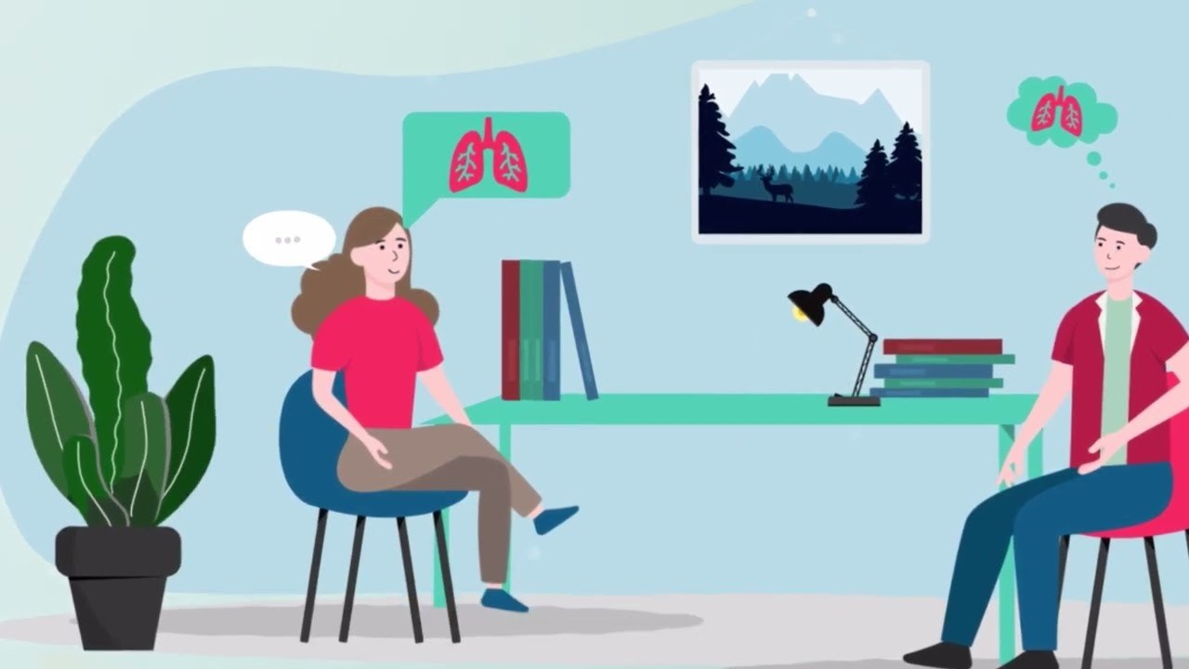
2 - View on YouTube
If you haven't done so already, please consider completing The 6 pillars of Realistic Medicine TURAS eLearning

It's OK to ask
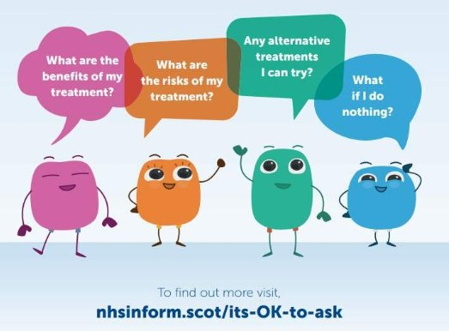
3 - The more involved patients are in their own treatment and care decisions, the more likely we are to succeed in our shared goals.
'It’s OK to ask' aims to supports patients to ask the right questions which allows for true shared decision making.
Visit the NHS Inform website or download a PDF of the leaflet NHS Scotland 'It's OK to ask leaflet.pdf

Section 3 of 8 Diagnostic criteria and features of migraine

On completion of this section, you should be able to identify the common characteristics and symptoms of migraine.

The International Classification of Headache Disorders (ICHD 3)describes migraine as a Recurrent headache disorder manifesting in attacks lasting 4-72 hours. Typical characteristics of the headache are unilateral location, pulsating quality, moderate or severe intensity, aggravation by routine physical activity and association with nausea and/or photophobia and phonophobia. The ICHD 3 Diagnostic criteria are
- At least five attacks¹ fulfilling criteria B-D
- Headache attacks lasting 4-72 hr (untreated or unsuccessfully treated)
- Headache has at least two of the following four characteristics:
  - unilateral location
  - pulsating quality
  - moderate or severe pain intensity
  - aggravation by or causing avoidance of routine physical activity (eg, walking or climbing stairs)
- During headache at least one of the following:
  - nausea and/or vomiting
  - photophobia (light sensitivity)and phonophobia ( noise sensitivity)
- Not better accounted for by another ICHD-3 diagnosis.
It is important to remember that the ICHD-3 criteria are primarily a research tool so that there are standardised criteria for patients with migraine recruited into clinical trials. The criteria are agreed by a group of experts and modified every few years. In the real world of clinical practice there will always be shades of grey. For example a patient may have light sensitivity with all their migraine but only noise sensitivity with their very severe migraine.
Patients presenting with the following symptoms all meet the criteria for migraine
- One sided severe headache lasting 12 hours associated with light and noise sensitivity
- Two sided pulsing moderate headache lasting 4 hours associated with light and noise sensitivity
- Two sided pulsing moderate headache lasting 72 hours associated with nausea

Clinical Phases of Migraine
Migraine can be divided into 5 phases. In addition to the characteristic moderate-to-severe head pain experienced during the ictal period, each of these phases may be associated with a range of non-headache symptoms.

Phases of migraine and associated symptoms
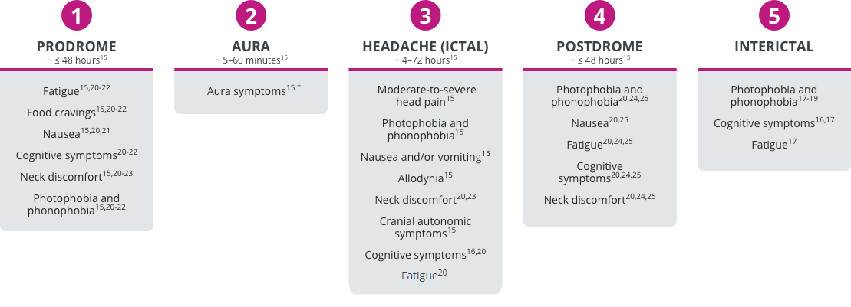
The Aura Phase
An aura involves focal, reversible neurologic symptoms that often precede the headache. It is usually visual, but can also affect other senses, or affect motion or cause verbal disturbance. Aura symptoms are often positive and negative, eg flashing lights and some loss of vision and are often progressive.
Aura symptoms are believed to arise from an electrical disturbance called cortical spreading depression (CSD); it occurs in approximately was 15-32% of migraine attacks.
Auras are not always followed by headache pain; such auras are called acephalgic migraine or migraine aura without headache.
The Headache Phase
Note other symptoms not in the ICHD 3 diagnostic criteria include allodynia (skin sensitivity), cranial autonomic symptoms such as nose and eye watering, and dizziness. Neck discomfort is common due to the connections of the trigeminal nerve with pain fibres arising from the upper neck (C2 and C3). Many patients with migraine also experience dizziness which can include true vertigo and gait imbalance.

Migraine: A Continuum of Symptoms
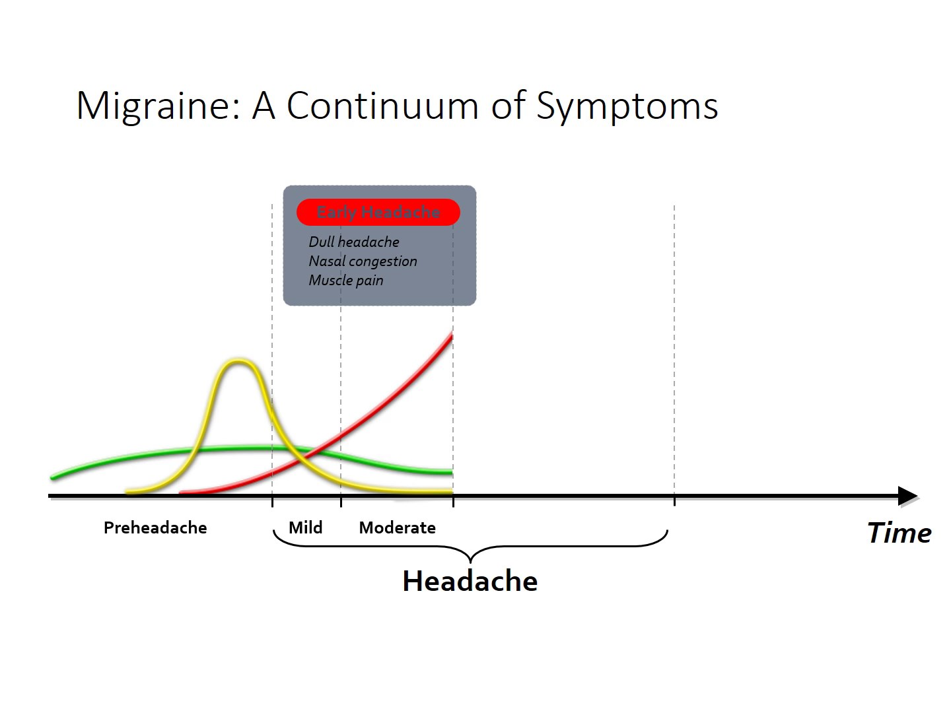
Migraine occurs as a variety of symptoms that evolve through the phases of a migraine attack. Experience shows that symptoms associated with each phase of an attack often occur during other phases as well. This results in a ‘continuum’ of symptoms, rather than a succession of distinct phases.
The Premonitory Phase/Prodrome
Seventy percent of patients suffering from migraine (either with or without aura) will experience these symptoms.
Premonitory symptoms are often seen as a signal for the headache attack.
Mood alterations, muscle pain, food cravings, cognitive (memory or attention) changes, fluid retention, and yawning are common premonitory symptoms.
Eighty-three percent of people with premonitory symptoms could predict over 50% of their attacks.
Linde M. Acta Neurol Scand. 2006;114:71–83.
Linde M. Cephalgia. 2006; 26; 712–721.

Migraine: Headache not always gradual
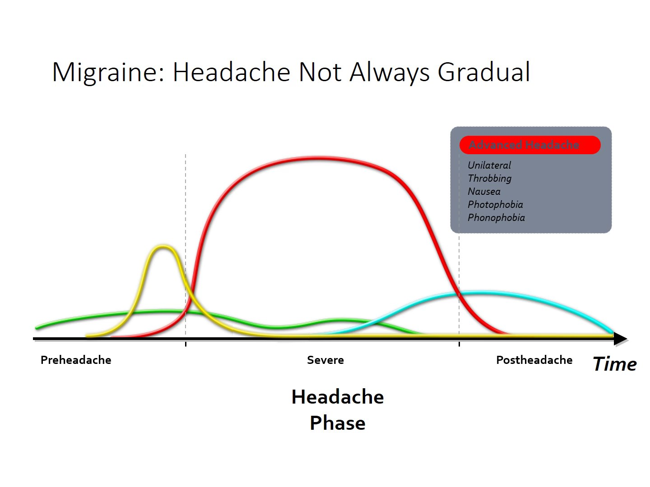
Even though the pain usually increases gradually, in some patients this happens faster.

References:
Cady R et al. Headache. 2002;42:204–216.
Linde M. Acta Neurol Scand. 2006;114:71–83.
Linde M. Cephalgia. 2006; 26; 712–721.
Select each of the boxes below to watch a video of a patient describe their symptoms

Moderate to severe head pain
Nausea
Sensitivity to light/ sound
Sensitivity to movement
Aura
Allodynia

Section 4 of 9 Myths and misconceptions about migraine

Migraine has a broad spectrum of symptoms and as discussed previously the ICHD 3 classification of migraine is largely a research tool so that patients recruited into clinical trials meet the diagnosis of migraine as per the criteria. In the real world not all patients will have every symptom and some will be more bothersome for some patients than others. This section explores some common migraine myths and misconceptions.
MYTH: Visual auras occur in every migraine attack
Reality
- Aura is a spreading electrochemical event in the brain surface within the brain’s cortex
- 30% of people with migraine experience aura and typically last 5-60 minutes, in some cases even longer
- Aura can also be sensory, verbal, or motor including vertigo (the sensation that you, or the environment around you, is moving or spinning), numbness, slurred speech and unsteady gait.
MYTH: Migraine head pain must be pulsating
Reality
- Head pain quality varies considerably, and descriptors may include as stabbing, throbbing or crushing due to pressure
- Throbbing pain is the most common descriptor of the headache involved in migraine, but symptoms are individualised
- Some migraine attacks may not even include headache
MYTH: Migraine head pain is always one sided
Reality
- Among people with migraine, only 15% of attacks are “side-locked”, meaning they always occur on the same side.
- 60% of attacks have head pain on one side
- 40% of attacks have head pain on both sides
- Some attacks have no head pain but may have aura and other migraine symptoms such as dizziness
MYTH: Migraine attacks only last 4-72 hours
Reality
- Some individuals may experience an attack lasting over 72 hours which is known as Status Migrainosus, and which may become a debilitating, chronic condition
- The International Headache Society’s International Classification of Headache Disorders (ICHD-3) criteria limits an attack to 4-72 hours, but this does not reflect everyone’s experience

Section 5 of 9 How migraine differs from other type of headache

This section covers the difference between primary and secondary headaches and compares the symptoms of three primary headaches, namely migraine, tension and cluster.
Primary Headache
Primary headaches are the most common headaches that lead people to seek medical treatment. Primary headache disorders are not associated with any pathology and include migraine, tension type headache and cluster headache. Migraine is the most common severe form of primary headache. Primary headaches are due to “up-regulation” of normal pain pathways. In effect the brain becomes more sensitive to the normal signals it gets.
The following table lists features of these three headache types. Note that migraine and tension headache tend to be long headaches lasting more than 4 hours untreated whereas cluster headache is a short headache lasting less than 4 hours. Tension headache is generally featureless and non-disabling compared to migraine and cluster which are both disabling.
A good question to ask a patient to help differentiate between these headaches is “ what would you usually do when you get your headache?” Patients with migraine generally wish to be still and may have to stop or restrict activities. Cluster patients are unable to do activities and tend to be agitated and restless and prefer to move. Patients with tension headache are generally able to continue activities.
The concept of “green flags” are features of the headache that suggest the headache is more likely primary than secondary. The Scottish National Headache pathway recognises 2 green flags
1) Recurrent episodic headache, particularly with features of migraine
2) Long history of daily headache

DIAGNOSIS OF COMMON HEADACHES Headache feature Migraine (with or without aura) Tension-type headache Cluster headache Prevalence in primary care 94% of people presenting in primary care with episodic headache will have migraine Not often seen as usually self-managed 1 in 1000 patients Duration of headache 4 – 72 hours in adults 1 – 72 hours in young people 30 minutes – continuous 15 – 180 minutes Pain location Unilateral or bilateral (head, face or neck) Bilateral (head, face or neck) Unilateral (around the eye, above the eye and along the side of the head/face) Pain quality Pulsating (throbbing or banging in young people) Pressing/tightening (non-pulsating) Variable (can be sharp, boring, burning, throbbing or tightening) Pain intensity Moderate or severe Mild or moderate Severe or very severe Effect on activities Aggravated by, or causes avoidance of, routine activities or daily living (prefer to stay still or go to bed) Not aggravated by routine activities of daily living Restlessness or agitation Other symptoms • Photophobia (light) • Phonophobia (sound) • Nausea and/or vomiting • Allodynia (sensitivity to touch) • Cranial autonomic symptoms • Aura (lasts 5 – 60 minutes) can include: o Flickering lights, spots or lines and/or partial loss of vision o Sensory symptoms such as numbness and/or pins and needles o Speech disturbance None Cranial autonomic symptoms on the same side as the headache: • Red and/or watery eye • Nasal congestion and/or runny nose • Swollen eyelid • Forehead and facial sweating • Constricted pupil and/or drooping eyelid Patients with cluster can get migrainous symptoms and aura

Secondary Headache
Secondary headache disorders are attributed to an underlying pathological condition. This includes:
- medication overuse : this is important in the context of primary headache, see definition below
- infection
- head injury
- vascular e.g. subarachnoid haemorrhage

ICHD-3 criteria for medication overuse headache
Headache occurring on ≥ 15 days per month in a patient with a pre-existing headache disorder
Regular overuse for > 3 months of ≥ 1 drug that can be taken for acute and/or symptomatic treatment of headache, with medication overuse defined as:
≥ 10 days per month for triptans, opioids, combination analgesics,* and a combination of drugs from different classes that are not individually overused
≥ 15 days/month for aspirin, paracetamol and NSAIDs
Note that this also applies to analgesia taken for other co-morbid pain conditions such as back pain in a patient with a primary headache.
Medication overuse headache is important to recognise and is covered in more depth in the section on headache management.
The diagnosis and management of Secondary headache is not within the scope of this training. However it is important to be aware of ‘Red Flags’ which may suggest the potential of secondary headache requiring onward referral to another practitioner. This is the topic of the next section.

Section 6 of 9 Potential red flags which require a patient to be signposted to another practitioner

This section covers important red flags that pharmacists should be aware of.

Red flags
Serious causes of secondary headache are rare, accounting for less than 1% of people presenting with headache. Pharmacy staff are not expected to learn about the different causes of secondary headache. However it is important that pharmacy staff recognise certain red flags for headache that may suggest a potentially serious cause of secondary headache requiring urgent GP or hospital assessment. The following are all potential red flags for headache and clicking on the box will give further information for those that want it.
Sudden onset severe “thunderclap” headache reaching maximum intensity within 5 minutes. This is the most important red flag as this may indicate bleeding in the brain even if the headache has resolved. Anyone with this history requires immediate assessment in the emergency department.
Further information box
Sudden-onset severe ('thunderclap') headache reaching maximum intensity within 5 minutes may indicate subarachnoid haemorrhage or other intracerebral haemorrhage, venous sinus thrombosis, malignant hypertension, vertebral artery dissection, or intracranial hypertension.
New onset headache in a person aged over 50 years
Further information box
New-onset headache in a person aged over 50 years may indicate temporal arteritis or a space-occupying lesion like a brain tumour.
Progressive worsening headache, or headache that has changed dramatically.
Further Information box
If there is evolution of headache over days to weeks, particularly with focal neurological signs, consider a space-occupying lesion or subdural haematoma.
Current or recent pregnancy.
Further information box
Consider pre-eclampsia, cerebral venous sinus thrombosis
Previous history of cancer
Further Information box
Current or past malignancy (especially if age under 20 years); a history of malignancy known to metastasise to the brain (such as lung, breast, and malignant melanoma) — consider cerebral metastases.
More reading for those that wish
https://cks.nice.org.uk/topics/headache-assessment/diagnosis/headache-diagnosis/

Section 7 of 9 Diagnosing migraine

This section is designed to guide you into making a migraine diagnosis based on the knowledge you have gained from the previous sections.
This section is most relevant to pharmacists, however awareness of diagnosis is useful for other pharmacy team roles to know when to involve the pharmacist into a discussion or consultation.
It is important to note that migraine is a clinical diagnosis based on taking a medical history. If there is concern about secondary headache blood tests and scans can rule out sinister causes but there is no diagnostic test for migraine.
From the previous sections we know that migraine affects about 10% of the population and is the most disabling primary headache. This means that most patients with migraine will seek advice on treatment from their pharmacist or primary care health professionals. The Landmark Study summarised below showed that most patients consulting in primary care had migraine. Although there is no data for pharmacy consulting it is likely to be similar for migraine.

A study was undertaken (Landmark Study, Tepper et al ,Headache 2004 Oct,44(9):856-64) of 1200 patients who had consulted their GP about headache, and where the GP had diagnosed a primary headache . These patients were given a diary to fill out to record their headache symptoms for the next 6 attacks. The diaries were then reviewed by an expert panel who gave a diagnosis based on the diary evidence.
- The study concluded “consider all disabling episodic headache with a normal physical examination to be migraine” and this was shown in the study to be correct 94% of the time.
- Of patients who were given a diagnosis of migraine by the GP, 98% met the International Classification for Headache Disorder (ICHD) criteria for migraine
- Of patients who were given a different headache diagnosis, the evidence from the diaries showed 82% had migraine. The most common mis-diagnosis was tension type headache or sinus headache.
Thus there is a high probability that patients attending a pharmacy with headache are likely to have migraine. A full migraine history to explore all the criteria for migraine as per the ICHD 3 classification can take 5-10 minutes. However a validated questionnaire, the three item ID migraine screener, has shown that some criteria are of high diagnostic value. Three simple screening questions can be asked in 1-2 minutes.

Three screening questions
- Do you feel nauseated or sick to your stomach?
- Did your headache limit you from working, studying, or doing what you needed to do for any day in the previous 3 months?
- Does light bother you a lot more than when you don’t have headaches?
Two or more positive responses suggests the patient has migraine. The positive predictive value is high at 0.93%. In other words, for 100 patients diagnosed as having migraine by the ID Migraine screener 93 will have migraine.
Other clues to migraine and pitfalls to be aware of
Although migraine has common symptoms, these are not always present in every case or the patient does not think to mention them. Making a diagnosis is a bit like making the pieces of a jigsaw fit. The more pieces the easier it gets. Sometimes symptoms have to be teased out of a patient and can be at times quite subtle. Patients with migraine often underplay symptoms. Questions often have to be phrased so that the patient has to think about the answer. An example:
Do you find noise difficult when you have a headache? The answer may be a clear yes or no. If the answer is no it may be that the patient has never really thought about it. Other ways of asking this question may be :when you have a headache do you find the kids seem to be more noisy/ partner’s snoring louder/ you have to turn the tv down etc.
Many patients refer to migraine as a “ normal headache” as that is what they have always had or experienced from living with other relatives who get “normal headache”. Never accept the term normal headache without exploring migraine symptoms. If a lady gets headache with menstruation it is almost always migraine and usually gets better in pregnancy.

Diagnostic Thinking Errors
The two commonest misdiagnoses for migraine are to think the patient has tension headache or sinus headache. For example a patients with neck pain and pain at the back of the head who is currently stressed may be diagnosed as tension headache. Remember that
- 70% of people with migraine get neck pain during a migraine attack
- 40% of migraine pain affects both sides
- Migraine pain can be anywhere on the head
- Stress is a common trigger for migraine
Ensure you have gathered all the detail from the patient before ruling out a migraine diagnosis. Premature closure is the tendency to stop too early in the diagnostic process before gathering all necessary information. In this case the clinician diagnosed tension headache based on two sided pain in the neck and head in a patient suffering stress. Without asking about disruption of activities, noise and light sensitivities and nausea migraine cannot be ruled out.
Migraine is often diagnosed as sinus headache by both patients and clinicians. An observational study showed (N = 2991) 88% of people with a self-diagnosis or medical diagnosis of sinus headache were classified with migraine based on ICHD criteria.
The patient with facial pain and nasal congestion who often gets “sinus pain” eased by decongestants in 1-2 days is often diagnosed as having “sinus headache”. Most of these patients have migraine and the decongestant has not really helped as the patient was going to get better anyway.
This is an example of ascertainment bias ie our thinking is shaped by what we expect to see, patients often come to pharmacies with facial pressure/pain and a blocked nose seeking decongestants. It is also an example of diagnostic momentum, once a diagnostic label has been assigned to an individual or by an individual it is difficult to remove that label. “ I am back with my sinus headache and the decongestant you gave me last time worked in 2 days.”
Understanding the pathophysiology of migraine and the anatomy of the trigeminal nerve( the migraine nerve) can help
- The trigeminal nerve has 3 branches going to the forehead , cheek and jaw so pain can be felt in any part of the face
- Migraine pain can be two sided.
- Patients can get nasal congestion and watering during a migraine. This is due to the activation of part ( para-sympathetic) of the autonomic nervous system. This is known as cranial autonomic symptoms.
As with the tension headache example there is Premature Closure if all the “migraine symptom” questions have not been asked.

