Direct Access of imaging for General Practitioners
These notes are for guidance only. Local frameworks should be developed with relevant clinical providers. Dr D. Kernick November 2025
Background
GP direct access to imaging has been defined as a priority within the National Health Service (NHS), with direct access to brain MRI for the diagnosis of brain cancer identified as a specific initiative. (Department of Health Direct access to diagnostic tests for cancer: best practice referral pathways for general practitioners, 2012.)
The risk of brain tumour when adult patients present with headache is 0.09% in primary care, 0.8% in neurology and 0.17% in A and E. A majority of tumours are diagnosed in A and E, an inappropriate setting for diagnosis of this condition.
Evidence suggests that when GPs have access to direct brain imaging there is a reduction in neurology referrals and an overall reduction in healthcare costs. However, most studies are observational and can be criticised on methodological grounds.
Estimates of impact vary, depending on the setting. Where GPs have direct access to neuroradiological investigation there are a wide range of reported investigation rates between 1.2-25% of headache presentations. Overall, rates of positive findings are equivalent to neurologists. GP studies report 0.5 to1.4% positive findings.
A wide range of neurology referrals avoided have been described from 41 to 86% and mean cost per patient reduction between direct imaging access and neurology referral of £245 against £578.
Clinical considerations
1. Incidental abnormalities
Incidental abnormalities can cause significant anxiety. There are a wide range of estimates but consider counselling patient at a rate of 15% for under 50 years of age, and “likely” above the age of 50. White matter changes are increasingly common with age (and migraine with aura) and are particularly problematic as their origin is not clear. Figure 1 shows a typical breakdown of abnormalities identified.
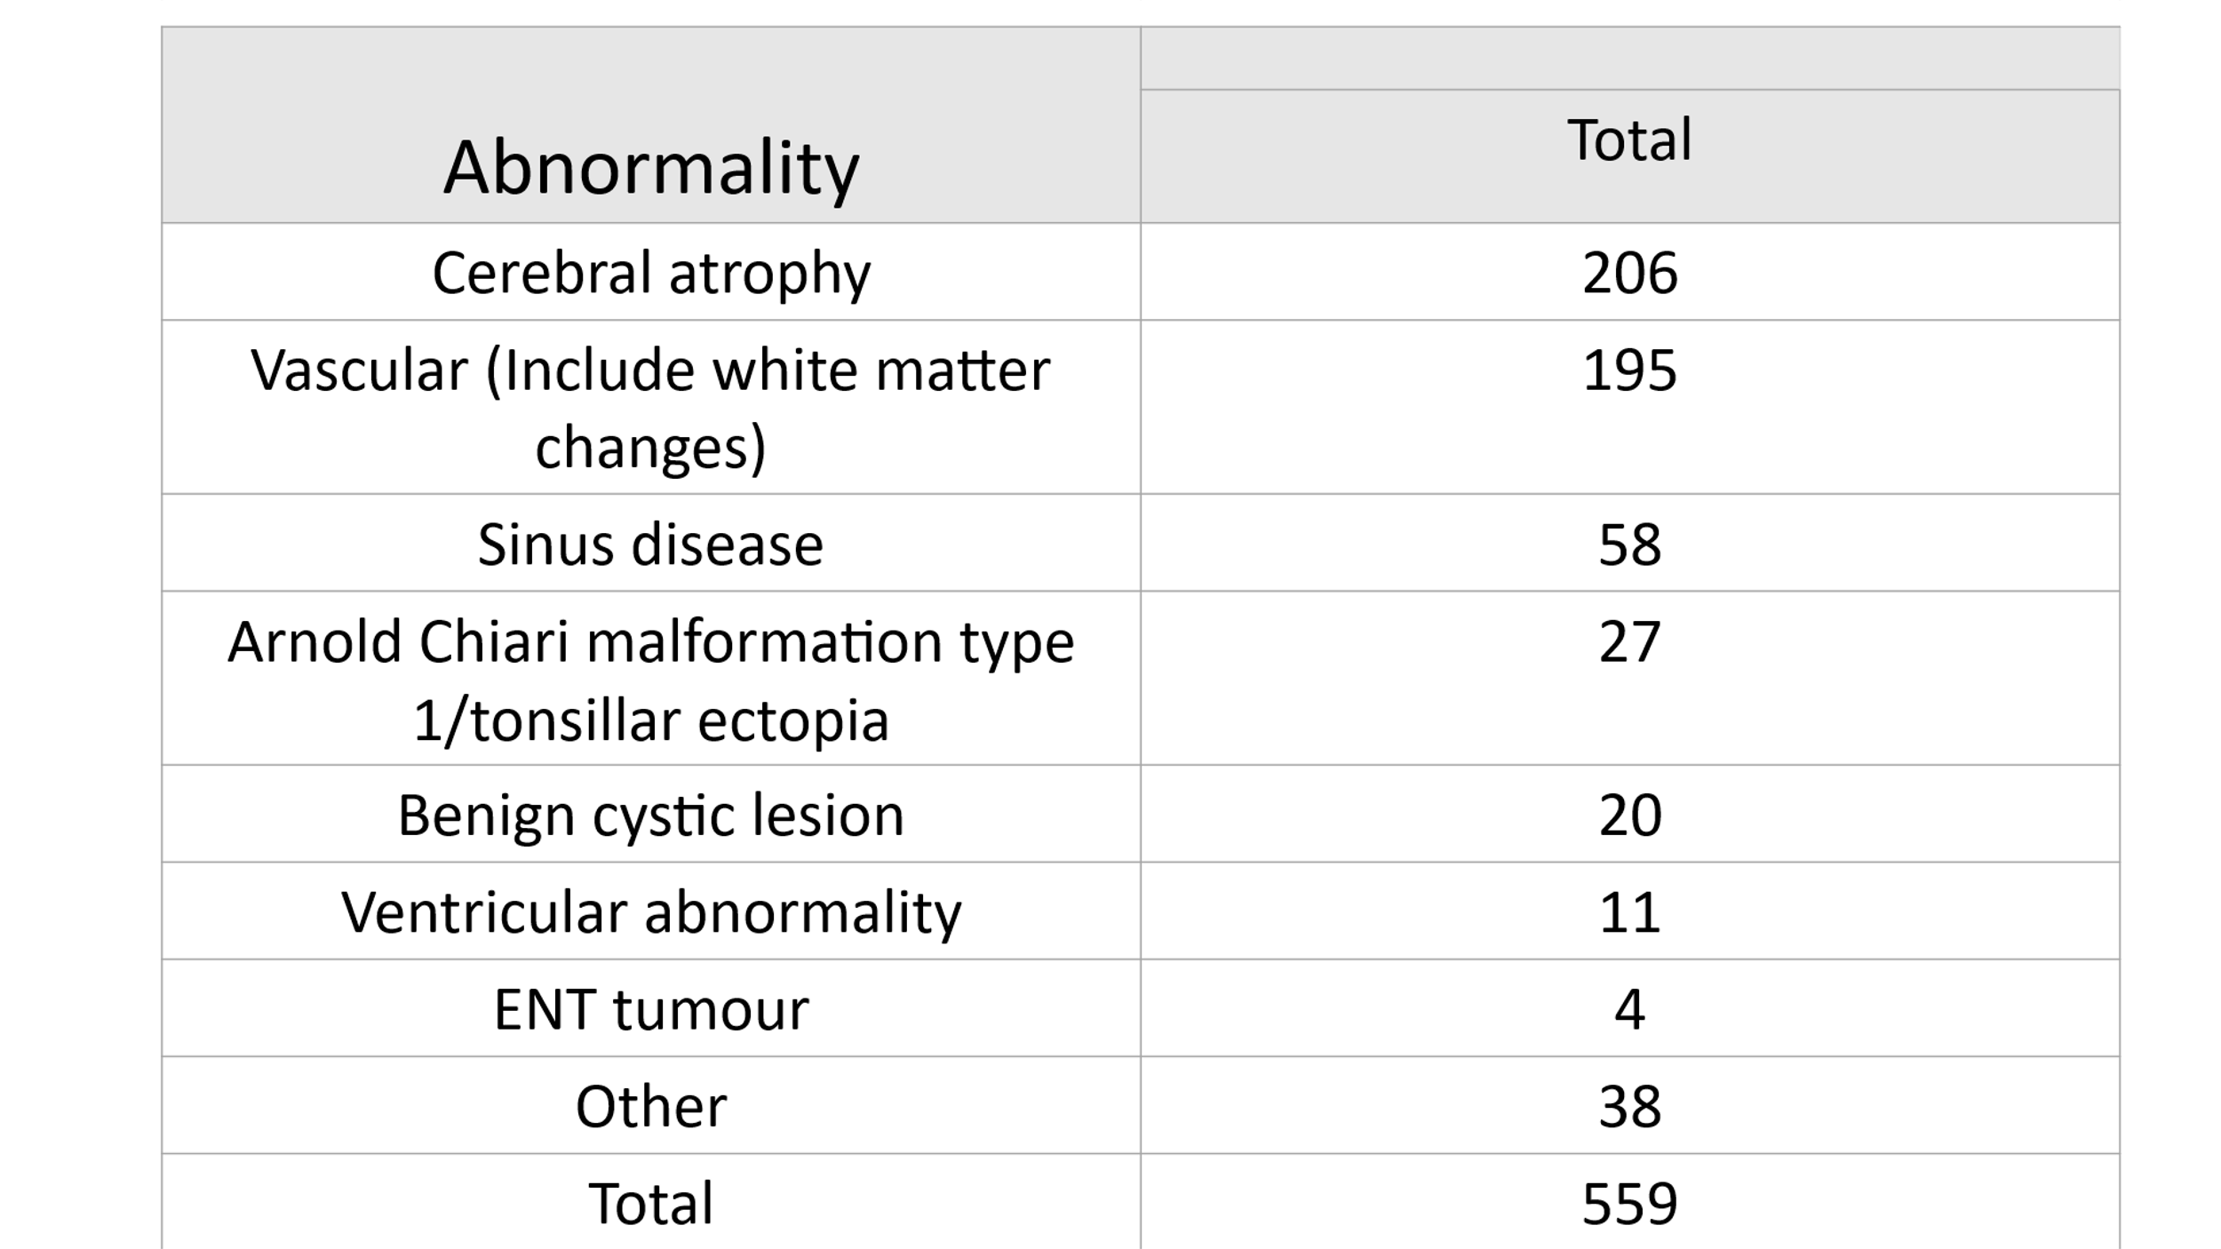
Figure 1. The range of incidental abnormalities, (Zenius 2019.)

2. Investigation guidelines
The evidence base on which to develop guidance is limited. Age is an important predictive feature of tumour. See figure 2.
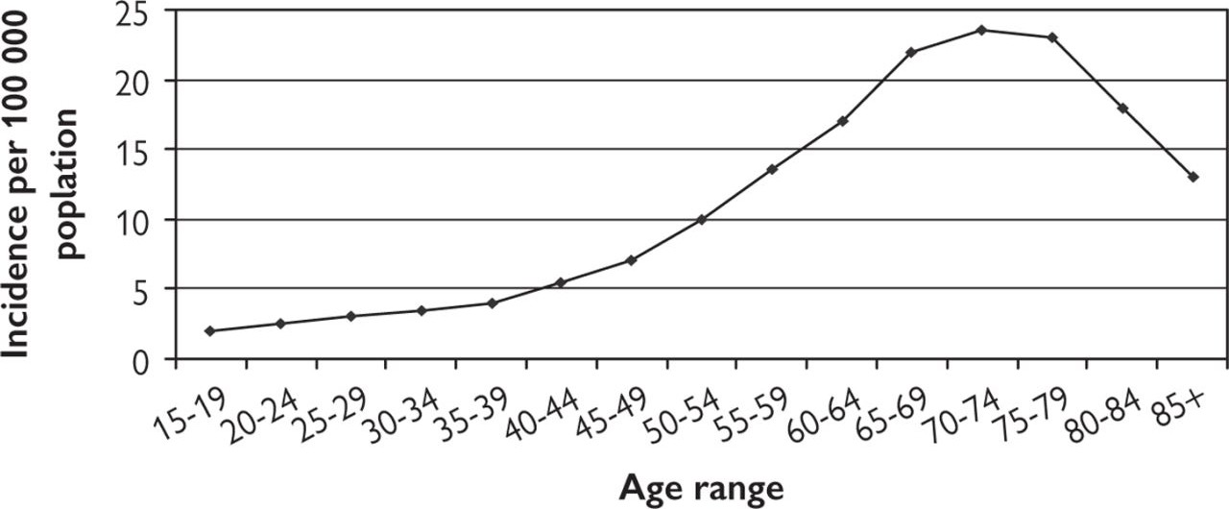

Figure 2. Age-related rates per 100 000 population for malignant primary tumours.

Figure 3. shows guidance for GPs based on the British Association for the Study of Headache guidelines for primary care. A retrospective GP study concluded that the non-specificity of many symptoms associated with brain tumours makes it difficult to identify patients to prioritise for brain imaging, but this guideline can provide assistance to the primary care doctor. (Zienius 2019).

Red flags — presentations where the probability of an underlying tumour is likely to be greater than 1%. These warrant urgent investigation.
• Papilloedema
• Headache with significant alterations in consciousness, memory, confusion, or coordination.
• Headache with seizure.
• Headache with a history of cancer. Breast, lung and prostate most common.
• Headache with abnormal findings on neurological examination or other neurological symptoms (although limited evidence base suggests orange flag).

Orange flags — presentations where the probability of an underlying tumour is likely to be between 0.1 and 1%. These need careful monitoring and a low threshold for investigation.
• New headache where a diagnostic pattern has not emerged after 8 weeks from presentation.
• Headache aggravated by exertion (exercise headache) or Valsalva-like manoeuvre. Headache precipitated is a red flag.
• Headaches associated with persistent vomiting.
• Headaches that have been present for some time but have changed significantly, particularly a rapid increase in frequency.
• New headache in a patient over 50 years. (But always think temporal arteritis).
• Headaches that wake from sleep.
• Headache with memory challenge, personality change.

Figure 3. Guidance for primary care of who to investigate for brain tumour when patients present with headache. (Kernick 2008).

At presentation:
  - Exclude urgent headache (risk >1%).
  - Check blood pressure, fundoscopy as minimum examination and inflammatory markers if >50 years to exclude temporal arteritis.
  - If no diagnosis cannot be made tell patient—‘There is no evidence of anything serious underlying your headache but I would like to review you in 1 month’.
  - Ask patient to keep a headache diary.

At 1 month:
  - Exclude urgent features.
  - Neurological examination, particularly cranial nerves.
  - Assess memory and cognitive function during interview.
  - Assess for symptoms that would indicate primary lesion elsewhere.
  - Consider blood screen to exclude systemic illness or evidence of primary tumour elsewhere—FBC, ESR, CRP, LFT, creatinine, electrolytes, glucose, thyroid function.
  - Access for a primary headache. If diagnosis is still uncertain tell patient ‘There is still no evidence of anything serious but I would like to review you again in another month’.

At 2 months
  - Exclude urgent features.
  - Examination as before.
  - If diagnosis is still uncertain tell patient ‘There is still no evidence of anything serious underlying your headache but we need to discuss whether it would be appropriate to have a brain scan. Up to 10 in every 100 people like you will show an incidental finding that may give rise to unnecessary anxiety. This may have implications for future life insurance cover.
  - Order blood investigations as above if not previously taken, in addition to tests dependent on symptoms and history, e.g. VDRL, Lyme, antiphospholipids (see above)
- If patient and doctor decide against imaging, review again in 1 month. A normal investigation does not eliminate the need for further review and management of the headache.

Figure 4. Pragmatic guidance for headache in primary care where no diagnosis can be made. (Kernick 2024).
Service considerations
1. Specify a clear referral pathway. Emphasise that imaging should not be for reassurance. (NICE CG150).
2. MRI Is the preferred modality, but local circumstances may dictate CT.
(Guidelines from the American Headache Society recommend MRI over CT when neuroimaging is indicated for subacute or chronic headache, based on increased sensitivity and lack of radiation exposure, but this recommendation is not based on direct head-to-head trials.)
3. Incidental abnormalities are likely to be as high as 15% and can cause anxiety. Ensure there is a local protocol to manage these and the patient anxiety arising from them.
4. Ensure a clear management advice channel with local radiologists.
5. Monitor volumes, positive yields, incidental findings.
6. Consider educational opportunities for GPs. (See attached video – not completed)

References

Evans RW, Burch RC, Frishberg BM, et al. Neuroimaging for Migraine: The American Headache Society Systematic Review and Evidence-Based Guideline. Headache. 2020;60(2):318-336. doi:10.1111/head.13720.

Keeney E, Mohiuddin S, Zienius K, et al. Economic evaluation of GPs’ direct access to computed tomography for identification of brain tumours. European Journal of Cancer Care. 2021 Jan;30(1):e13345.

Kernick DP, Ahmed F, Bahra A et al. Imaging patients with suspected brain tumour: guidance for primary care. British Journal of General Practice. 2008 Dec 1;58(557):880-5.
Kernick D. Goadsby P. Headache. A practical Manual. Oxford University Press. Oxford 2024.
Kernick D, Williams S. Should GPs have direct access to neuroradiological investigation when adults present with headache. British Journal of General Practice 2011;61:409-411.
Phelan A, Broughan J, McCombe G, et al. Impact of Enhancing GP Access to Diagnostic Imaging: A Scoping Review. PloS One. 2023;18(3):e0281461.

Rua T, Mazumder A, Akande Y, et al. Management of Chronic Headache with Referral from Primary Care to Direct Access to MRI Compared with Neurology Services: An Observational Prospective Study in London. BMJ Open. 2020;10(10):e036097. doi:10.1136/bmjopen-2019-036097.
Taylor TR, Evangelou N, Porter H, et al. Primary Care Direct Access MRI for the Investigation of Chronic Headache. Clinical Radiology. 2012;67(1):24-7. doi:10.1016/j.crad.2011.02.006.

Thomas R, Cook A, Main G, et al. Primary Care Access to Computed Tomography for Chronic Headache. The British Journal of General Practice: The Journal of the Royal College of General Practitioners. 2010;60(575):426-30. doi:10.3399/bjgp10X502146.

Zienius K, Chak-Lam I, Park J, et al. Direct access CT for suspicion of brain tumour: an analysis of referral pathways in a population-based patient group. BMC Family Practice. 2019 Dec;20:1-0.

