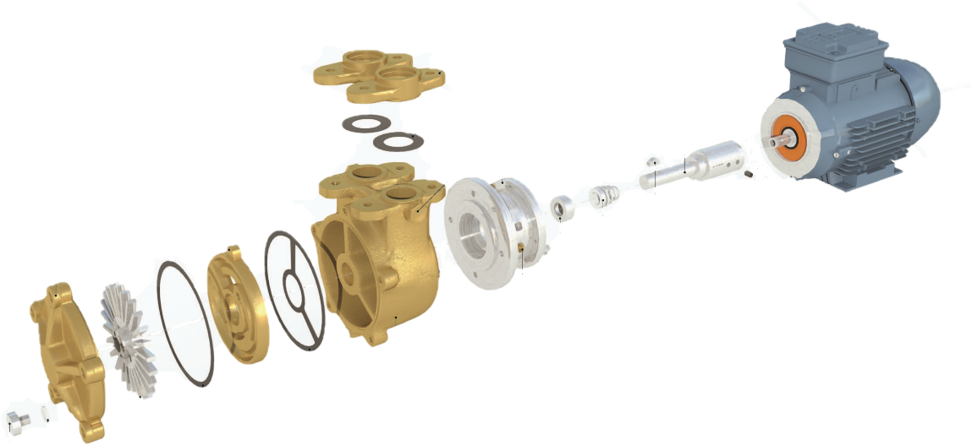

**BY25**

0.75KW 2850RPM 240-1-50

|  |  |
| --- | --- |
| **Item** | **BY25** |
| Motor 0.75kw 2850rpm 240-1-50 | COC005105-NS |
| D80 motor/pump adaptor bracket | COC00D80-1 |
| D80 motor/pump stub shaft adaptor | COC00D80-2 |
| Impeller | CO0000305 |
| Pump casing – cast iron  Pump casing – stainless steel | CO1744501  CO2715302 |
| Counter flange – stainless steel | CO0001105 |
| Pressure plate – brass  Pressure plate – stainless steel | CO0000206  CO0000205 |
| End cover – brass  End cover – stainless steel | CO0000404  CO0000405 |
| Seal kit – klinger – water  Seal kit - klinger – fuel oil  Seal Kit - epdm – chemicals  Seal kit – ptfe – chemicals  Seal kit – T109 stainless steel – chemicals  Seal kit – romet type – water  Seal kit – romet type – alcohol | COSK1  COSK2  COSK2-EPDM  COSK2-PTFE  COSK3  COSK3-WATER  COSK3-ALCOHOL |
| Woodruff key – stainless steel | COSL56-1 |
| Drain plug – stainless steel | COSL52-17 |
| Drain plug washer – red fibre | COSL27-5 |