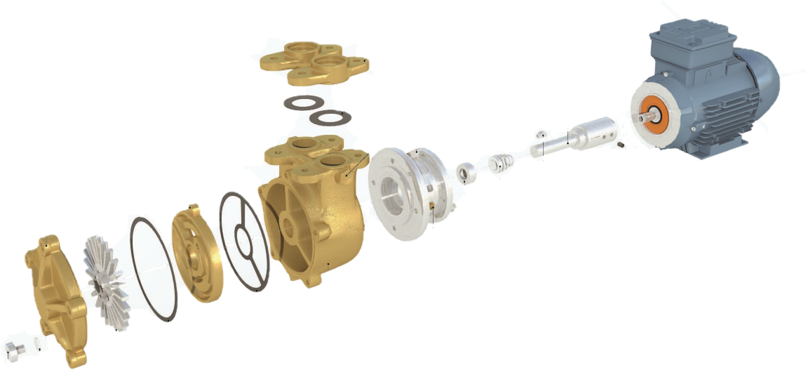

BY40, BY49
1.5KW 2850RPM 240-1-50

Item | BY40 | BY49
Motor 1.5kw 2850rpm 240-1-50 | COC006105-NS | COC006105-NS
D90 motor/pump adaptor bracket | COC00D90-1 | COC00D90-1
D90 motor/pump stub shaft adaptor | COC00D90-2 | COC00D90-2
Impeller | CO0000305 | CO0000305
Pump casing – cast iron  Pump casing – stainless steel | CO1744501  CO2715302 | CO1744501  CO2715302
Counter flange – stainless steel | CO0001105 | CO0001105
Pressure plate – brass  Pressure plate – stainless steel | CO0303305  CO0303306 | CO1543904  CO0001004
End cover – brass  End cover – stainless steel | CO0000404  CO0000405 | CO0000404  CO0000405
Seal kit – klinger – water  Seal kit - klinger – fuel oil  Seal Kit - epdm – chemicals  Seal kit – ptfe – chemicals  Seal kit – T109 stainless steel – chemicals  Seal kit – romet type – water  Seal kit – romet type – alcohol | COSK1  COSK2  COSK2-EPDM  COSK2-PTFE  COSK3  COSK3-WATER  COSK3-ALCOHOL | COSK1  COSK2  COSK2-EPDM  COSK2-PTFE  COSK3  COSK3-WATER  COSK3-ALCOHOL
Woodruff key – stainless steel | COSL56-1 | COSL56-1
Drain plug – stainless steel | COSL52-17 | COSL52-17
Drain plug washer – red fibre | COSL27-5 | COSL27-5

