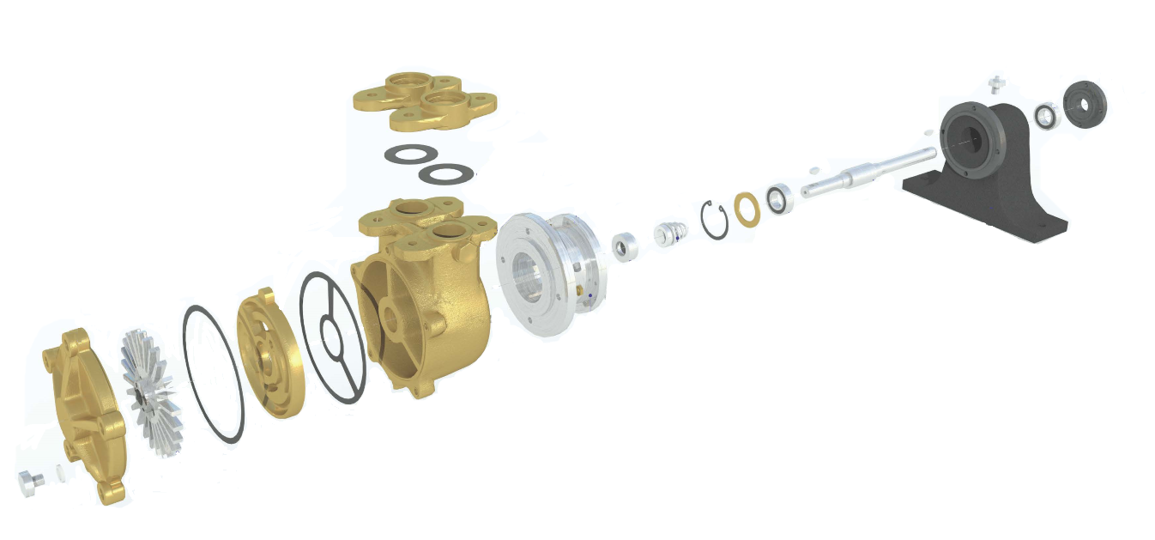

**BY25, BY40, BY49**

A’SET

|  |  |  |  |
| --- | --- | --- | --- |
|  | **BY25** | **BY40** | **BY49** |
| Pedestal bearing housing – cast iron | CO1901200 | CO1901200 | CO1901200 |
| A’ set shaft – stainless steel | CO0000903 | CO0000903 | CO0000903 |
| Impeller | CO0000305 | CO0000305 | CO0000305 |
| Pump casing – cast iron  Pump casing – stainless steel | CO1744501  CO2715302 | CO1744501  CO2715302 | CO1744501  CO2715302 |
| Counter flange – stainless steel | CO0001105 | CO0001105 | CO0001105 |
| Pressure plate – brass  Pressure plate – stainless steel | CO0000404  CO0000405 | CO0303305  CO0303306 | CO1543904  CO0001004 |
| End Cover – brass  End Cover – stainless steel | CO0000206  CO0000205 | CO0000206  CO0000205 | CO0000206  CO0000205 |
| Seal kit – klinger – water  Seal kit - klinger – fuel oil  Seal kit – T109 stainless steel – chemicals | COSK1  COSK2  COSK3 | COSK1  COSK2  COSK3 | COSK1  COSK2  COSK3 |
| Woodruff key – stainless steel | COSL56-1 | COSL56-1 | COSL56-1 |
| Drain plug – stainless steel | COSL52-17 | COSL52-17 | COSL52-17 |
| Drain plug washer – red fibre | COSL27-5 | COSL27-5 | COSL27-5 |
| Water flinger – rubber | COSL27-127 | COSL27-127 | COSL27-5 |
| Bearing Cover - steel | CO0000800 | CO0000800 | CO0000800 |