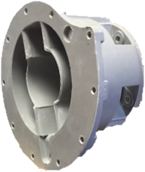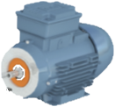

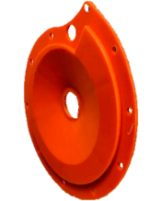

****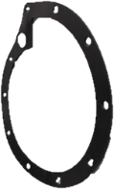

******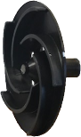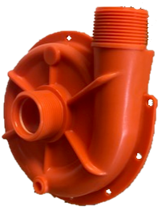**

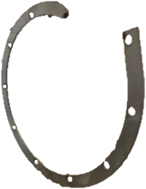



**PV71/72, PV101/102**

0.55KW 2850RPM 415-3-50

|  |  |  |  |  |
| --- | --- | --- | --- | --- |
| **Item** | **PV71** | **PV72** | **PV101** | **PV102** |
| Motor 0.55kw 2850rpm 415-3-50 | COC007002 | COC007002 | COC007002 | COC007002 |
| DMC mounting bracket | CO3103500 | CO3103500 | CO3103500 | CO3103500 |
| Drain plug washer – ptfe | COSL31-93 | COSL31-93 | COSL31-93 | COSL31-93 |
| Drain plug – pp | CO2741602 | CO2741602 | CO2741602 | CO2741602 |
| Extension shaft- st/st | CO000040366 | CO000040366 | CO000040366 | CO000040366 |
| Shaft adaptor – st/st | CO000040367 | CO000040367 | CO000040367 | CO000040367 |
| Spring retaining collar – st/st | CO000040368 | CO000040368 | CO000040368 | CO000040368 |
| Seal – car/cer/nit  Seal – car/cer/epdm  Seal – ptfe/cer/epdm  Seal – ptfe/cer/vit  Seal – car/cer/vit  Seal – sil/cer/epdm  Seal – sil/cer/vit | n/a  COE009592  COE009593  COE009594  COE009595  COE009604  COE009606 | COE009587  n/a  n/a  n/a  n/a  n/a  n/a | n/a  COE009592  COE009593  COE009594  COE009595  COE009604  COE009606 | COE009587  n/a  n/a  n/a  n/a  n/a  n/a |
| Back plate - pp | CO3074201 (orange) | CO3074202 (blue) | CO3074201 (orange) | CO3074202 (blue) |
| Impeller – pp | CO3074801 | CO3074801 | CO3074001 | CO3074001 |
| Gasket – Viton  Gasket - epdm | CO3072901  n/a | n/a  CO3072902 | CO30792901  n/a | n/a  CO3072902 |
| Pump Casing – pp | CO2663301 (orange) | CO2663302 (blue) | CO2663301 (orange) | CO2663302 (blue) |
| Support ring – steel | COE009494 | COE009494 | COE009494 | COE009494 |