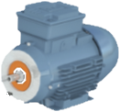
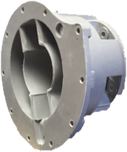
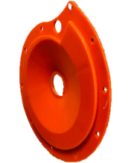
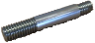
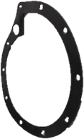
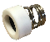
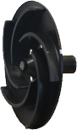
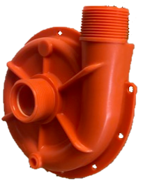
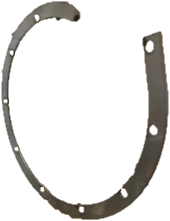
PV91/92, PV121/122
1.1KW 2850RPM 415-3-50

Item | PV91 | PV92 | PV121 | PV122
Motor 1.1w 2850rpm 415-3-50 | COC007003 | COC007003 | COC007003 | COC007003
DMC mounting bracket | CO3100200 | CO3100200 | CO3100200 | CO3100200
Drain plug washer – ptfe | COSL31-93 | COSL31-93 | COSL31-93 | COSL31-93
Drain plug – pp | CO2741602 | CO2741602 | CO2741602 | CO2741602
Extension shaft- st/st | CO3500000 | CO3500000 | CO3500000 | CO3500000
Spring retaining collar – st/st | CO000040368 | CO000040368 | CO000040368 | CO000040368
Seal – car/cer/nit  Seal – car/cer/epdm  Seal – ptfe/cer/epdm  Seal – ptfe/cer/vit  Seal – car/cer/vit  Seal – sil/cer/epdm  Seal – sil/cer/vit | n/a  COE009592  COE009593  COE009594  COE009595  COE009604  COE009606 | COE009587  n/a  n/a  n/a  n/a  n/a  n/a | n/a  COE009592  COE009593  COE009594  COE009595  COE009604  COE009606 | COE009587  n/a  n/a  n/a  n/a  n/a  n/a
Back plate - pp | CO3074101 (orange) | CO3074102 (blue) | CO3074101 (orange) | CO3074102  (blue)
Impeller – pp | CO3074501 | CO3073801 | CO3074501 | CO3073801
Gasket – Viton  Gasket - epdm | CO3075101  n/a | n/a  CO3075102 | CO3075101  n/a | n/a  CO3075102
Pump Casing – pp | CO2800501 (orange) | CO2800502 (blue) | CO2800501 (orange) | CO2800502  (blue)
Support ring – steel | CO2800900 | CO2800900 | CO2800900 | CO2800900

