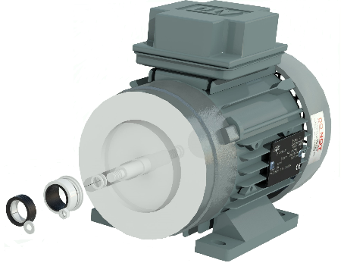

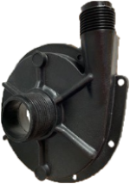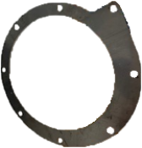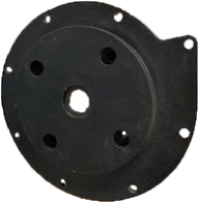

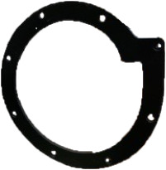

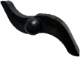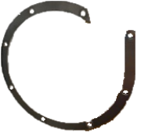

**PV21, PV22, PV41 & PV42**

0.18KW 110/230/415-1/3-50

|  |  |  |  |  |
| --- | --- | --- | --- | --- |
| **Item** | **PV21** | **PV22** | **PV41** | **PV42** |
| Motor 0.18kw 2850rpm 110-1-50  Motor 0.18kw 2850rpm 230-1-50  Motor 0.18kw 2850rpm 415-3-50 | COC007010  COC007010  COC007011 | COC007010  COC007010  COC007011 | COC007010  COC007010  COC007011 | COC007010  COC007010  COC007011 |
| Front support ring - st/st | CO2851600 | CO2851600 | CO2851600 | CO2851600 |
| Back support ring - st/st | CO2851700 | CO2851700 | CO2851700 | CO2851700 |
| Extension shaft – st/st | CO28251/00 | CO28251/00 | CO28251/00 | CO28251/00 |
| Motor bracket – pp | CO28253/92 | CO28253/92 | CO28253/92 | CO28253/92 |
| Gasket - nitrile  Gasket - viton | n/a  CO3007603 | CO3007601  n/a | n/a  CO3007603 | CO3007601  n/a |
| Impeller – pp | CO2835101 | CO2835101 | CO2825001 | CO2825001 |
| Pump Casing – pp | CO2825201 | CO2825201 | CO2825201 | CO2825201 |
| Seal – car/vit/nit  Seal – car/cer/vit  Seal – car/cer/epdm | n/a  COE3113600  COE3113300 | CO000007634/5  n/a  n/a | n/a  COE3113600  COE3113300 | CO000007634/5  n/a  n/a |