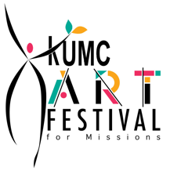
KUMC ART FESTIVAL
IN-KIND CONTRIBUTIONS
FESTIVAL YEAR:2019

Name of Contributor: _______________________________________

Business Name: ___________________________________________

Best phone #: _____________________________________________

Email Address: ____________________________________________

Contact Person: ___________________________________________

Address: ________________________________________________

Description of Contribution:

- Event Sponsor & Underwriter: $2,500+__________________
- Generous Contributor: $1500+________________________
- Event Sponsor: $1000+______________________________
- Sponsorship: $500+________________________________
- Donation: $250+________________________________
- Raffle Donation:
Item: __________________________________________
Value: __________________________________________
Detailed Information, if any: ___________________________
_________________________________________________________
_________________________________________________________
_________________________________________________________

Signature of Contributor: _______________________________________

Signature of KUMC Art Festival Representative: _______________________

Date: _____________________________________________________

KUMC thanks you for your generosity. All Art Festival proceeds go to helping those in need.

KUMC Art Festival 7600 SW 104th St. Village of Pinecrest, Fl 33156
Event held on October 26, 2019, 9:00 AM to 4:00 PM
For more information, go to: kumcartfestival.com

