**Forest Ginseng Production Guide**

Ginseng Québec 2021

50 cm

2 m

50 cm

2 m

40 m

Set up rows 40 m by 2 m with a minimum of 50 cm in between the rows that will be prepared for seeding ginseng under forest cover



Ginseng production in rows

Ginseng production in rows

Ginseng production in rows

**1.** **Identify the sites** where the ginseng will be planted. Sites with more than 70% broadleaf content are interesting, conifers and American beech are to be avoided. The trees should be at least of medium age (no young forests). The following conditions are pre-requisites for a successful plantation

* The site must be well drained. Ginseng does not tolerate an excess of water. Avoid areas that accumulate water in the spring or after large rainfall events. A sandy loam is ideal, but not necessary for cultivation. Clay and silty soils are to be avoided.
* The soil must be deep enough. It is important that the soil is at least 10 cm deep. The presence of some rocks may give the -roots a marketable forest grown shape, but cultivating on a rocky soil is difficult.
* The forest cover is adequate. Ginseng requires at least 70 to 80% canopy cover. The forest cover must be uniform, ginseng planting should avoid gaps in the canopy that would allow excess light and plant competition.

**2.** **Mark each row** with small wooden pickets that may be spray painted orange. Pickets should also be inserted along the rows every 10 meters.

**3.** The entire area of cultivation requires **selective** **thinning.** This means that all regenerating conifers, forest shrubs, forest herbs and some regenerating broadleaf species should be cut and removed from the forest. Regeneration of species such as sugar maple, basswood and white ash should be favored and left to replace the forest cover. Rare herbaceous plants should also be conserved in your woodlot.

**4.** Conducting a **soil analysis**. We are interested in knowing the pH, Ca, P, Mg and K. The pH is very important for ginseng plant growth, the **optimal pH for ginseng is 5.5**.

Minimum concentrations in soil required to avoid deficiencies for forest grown ginseng

|  |  |  |
| --- | --- | --- |
| Nutrient | Minimum concentration (kg/ha) | Minimum concentration (ppm) |
| Calcium (Ca) | 1 000 | 446 |
| Phosphorus (P) | 35-50 | 16-22 |
| Magnesium (Mg) | 75-100 | 34-45 |
| Potassium (K) | 100-150 | 45-67 |

(Nadeau 2002)

**5.** The site preparation includes the removal of dead branches throughout the entire site to facilitate raking the leaves and germination. The leaves are raked off the rows. **Soil amendments** are applied as follows depending on the deficiencies:

* Lime to increase pH and Ca - 3 tons / ha

(Camiré, Ouimet and Moore, U. Laval and MRN)

* Sul-Po-Mag to increase Sulphur, Potassium and Magnesium - 100 kg / ha

(Camiré, Ouimet and Moore, U. Laval and MRN)

* Bonemeal to increase Phosphorus - 100 kg / ha

**6.** Seeding is done in October, until the first snow. There exist multiple methods of **soil preparation and seeding methods**:

(1) Working the soil with a de-thatching rake or a normal rake

* Combined with broadcast seeding method at a density of 45 seeds/m²
* Difficult based on the amount of tree roots in the soil, but works on most soils
* Risk of seed predation by birds and extreme weather (dry or cold)
* Hard work

(2) Creating furrows or small trenches

* Seeds are sprinkled into trenches
* Almost impossible to create trenches in soil with lots of small roots
* Takes a lot of time and hard work
* Small trenches are traced in rows that are 20 cm apart, with 4 rows per meter. Seeds can be sprinkled into the rows with approximately a seed every 10 cm, to achieve 40 seeds / m2 and then the seeds are covered with 3 cm of soil
* Good results, good seed contact with the soil

1 m

10 cm

Seeds can be sprinkled in trenches giving something similar to what is shown below

v

v

v

v

v

v

v

v

v

v

20 cm

1 m

v

v

v

v

v

v

v

v

v

v

v

v

v

v

v

v

v

v

v

v

v

v

v

v

v

v

v

v

v

v

(3) No soil preparation

* Seeds are planted one by one, at a depth of 3 cm into the soil
* Not practical for large surfaces

(4) Mechanical preparation

* Difficult to use a two wheel roto-tiller in the forest
* Formation of excellent seed beds
* May decrease the value of the ginseng roots as they grow faster and resemble the field cultivated ginseng
* May damage tree roots

Immediately after seeding the leaves are raked back onto the rows to ensure that the seeds do not dry out or suffer winter damage. The seeds should germinate the following spring.

**7.** Difficulties associated with forest ginseng cultivation include:

* Slugs herbivory
* Fungal disease
* Plant competition

Ginseng Québec

**www.ginsengquebec.ca**

**ginsengquebec@gmail.com**

Photo ginseng leaf seedlings

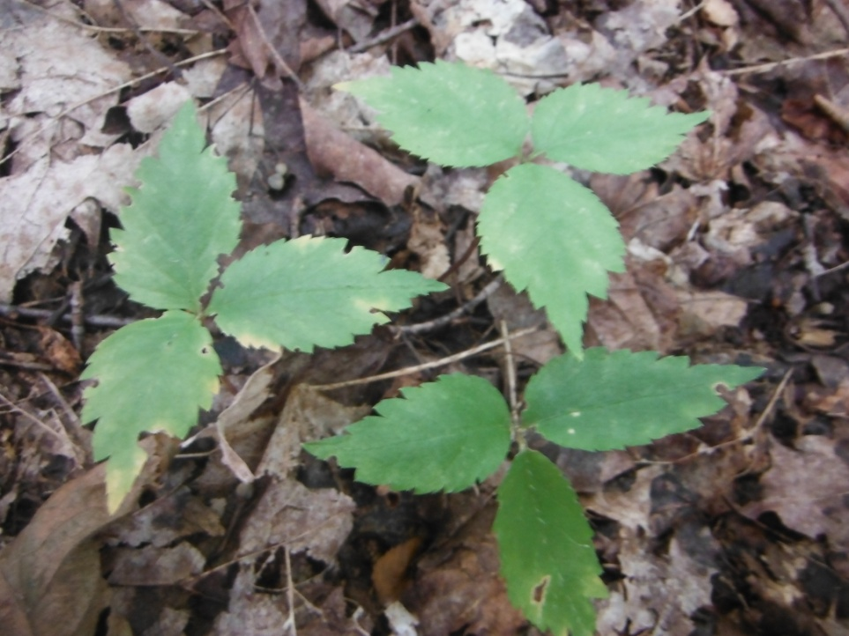

Photo mature ginseng leaf

