[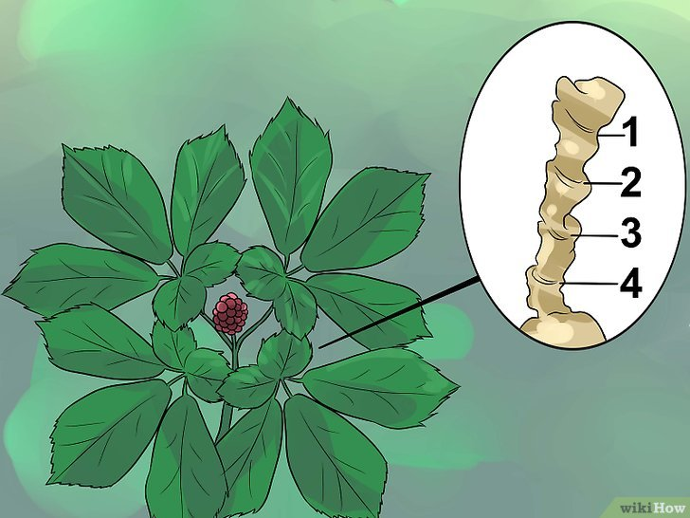](https://www.google.ca/url?sa=i&rct=j&q=&esrc=s&source=images&cd=&cad=rja&uact=8&ved=0ahUKEwinoKWCkZTXAhWh5YMKHREPCHIQjRwIBw&url=https://fr.wikihow.com/trouver-du-ginseng-sauvage&psig=AOvVaw22ADvgVxxr7EgtYSuWjryc&ust=1509307793888529)