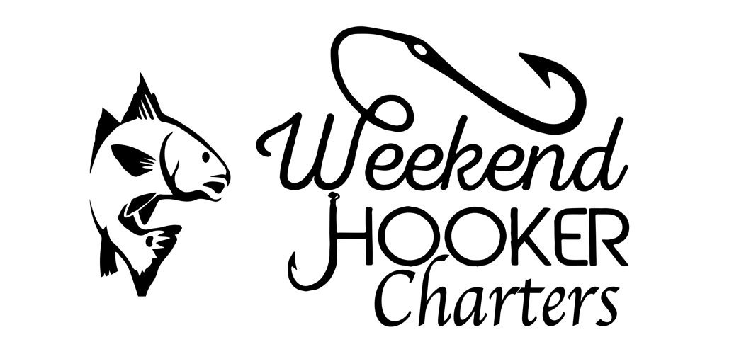

PANAMA CITY FLORIDA

Contracted By: _______

Address:

Phone Number: Departure Date:

Charter Type: Captain: James W. McConnell Jr.

Mission Statement: Weekend Hooker Charters provides clients with a safe, exhilarating, productive charter experience. Weekend Hooker Charters will never discriminate against anyone, regardless of race, nationality, age, gender, or sexual preference. We are passionate about ﬁshing, and we look forward to sharing it with you. Our goal is for you to have fun and enjoy your time on the water.
All laws governing Florida State waters will be strictly adhered to at all times! At no time will the “Rules of the Road”, the rules governing marine traffic, or any other State or Federal laws be disregarded, no matter the situation. Any and all Florida Wildlife Management (FWC) saltwater fishing regulations will be followed as they are written. All fish stored on The Weekend Hooker will meet minimum size requirements and slot and possession limits. The Captain will not possess any limit of fish under his license for the contracting party.
On board the “The Weekend Hooker” you will have a captain that is experienced in traversing the seas as well as ﬁnding the ﬁsh that we are targeting. In addition to being able to run the cockpit for the day of ﬁshing, your Captain will be familiar with safety procedures and work hard to ensure your comfort. The Captain welcomes anglers to be as “hands on” as they would like to be. Some of the aquatic wildlife you encounter, including the fish we catch, are considered dangerous. Always check with you Captain before attempting to handle any wildlife.
All questions are encouraged!
Agreement for charter clients and Weekend Hooker Charters
Liability Agreement: We, the undersigned, fully understand that we are boarding a charter ﬁshing vessel to ﬁsh in open water. I understand and assume the risks and hazards associated with inshore and offshore ﬁshing. These risks and hazards include, but are not limited to, the following:
Sun, rain, lightning, sea spray, and any other weather conditions; sea sickness; pitching and rolling; slippery and wet decks; injuries, internal or external, from: boarding and disembarking the vessel; injuries caused by ﬁsh, ﬁshing, ﬁshing tackle, and gear; and the unintentional conduct of any other persons on the boat.

I understand and agree that I will not hold the Captain, Crew, or Corporation liable for risks and hazards associated with inshore or offshore ﬁshing, and I expressly release them from all such risks and hazards. Moreover, I am not in possession of any illegal substances, and I release the Captain, Crew, and Corporation from any liability whatsoever for any illegal actions taken by myself on the vessel.

SIGNATURE OF PARTY REPRESENTATIVE____________________________________________________

Included: The charter will include all the gear, bait, fuel, and ice necessary to supply chosen ﬁshing trip. Clients are more than welcome to bring their own gear if they’d like. Except for small food/drink coolers, clients should leave coolers for their catch in their vehicles.
NOT included: Beverages and food are not supplied. We always have a supply of water on board; however, this is typically reserved for emergency use. If bringing sandwiches, we suggest you place them in Ziplock bags to ensure dryness.
Sea sickness: Sea sickness can occur to anyone; we suggest that anyone who has even the slightest concern about being seasick takes an over-the-counter motion sickness medicine prior to departure. It’s cheap insurance to make sure you have the most enjoyable day on the water.
Alcohol / Drugs: Beer is permitted on the trip. No liquor, please. Beer MUST be cans; NO bottles are permitted per Coast Guard regulations. Please limit your alcohol consumption. We believe 100% in being safe and responsible on the water. Your Captain will never have so much as a drop of alcohol on your trip. Absolutely NO DRUGS of ANY sort! The last thing I want is to cut the trip short and call the Coast Guard for them to meet you at the dock. Any trips cut short from alcohol or drugs will not be issued a refund.

Cancelation Policy: Cancelations can be made, with no penalty, up to 48 hours prior to the scheduled time of your trip. Your deposit money will be refunded or placed toward a rescheduled trip, whichever you request. Cancellations made less than 48 hours before the scheduled trip will be subject to 50% forfeit of deposit. No shows on the scheduled charter date will result in 100% forfeit of deposit.
Weather and Seas: The Captain is constantly following current weather/sea conditions and future forecasting. If the Captain deems seas not conducive to safe ﬁshing conditions, the Captain may cancel the trip. If the Captain cancels the trip, you will be issued a refund of your deposit or credit toward a future booking, whichever you prefer. In many instances we will contact our client prior to a trip to bring you up to speed on conditions. If the client opts to cancel due to seas that may prove uncomfortable, your deposit can be applied to a future trip.
Tackle, gear, and equipment: Thousands of dollars in equipment have been invested to make your experience productive and enjoyable. We ask that you take care in handling our gear. The Captain will be there to help keep things problem free and educate you in proper handling. If a passenger proves negligent in the handling of gear and breaks/loses something you agree to pay the replacement cost of such gear. This would be a rare occurrence, but a couple examples would be dropping something overboard or throwing something on the deck or stepping on it, causing breakage.
Tips: Your Captain is working for you. He/she will be working hard throughout the day. This is “ﬁshing”. Some days are better than others regarding our catch. Please base your tip on the work that the Captain puts in to catching ﬁsh as some days we’ll limit out and some days we won’t.
Fish cleaning: Weekend Hooker Charters does not offer fish cleaning. There are many professional cleaning services and “Hook & Cook” restaurants located in the local area. Upon return to port if you would like your ﬁsh cleaned for you, they will be happy to do it. Please ask you Captain for more information. Should you wish to take your catch home to clean, we will gladly help load your coolers into your vehicles.
Payments: Cash and electronic payment are accepted only please.
Questions or concerns can be answered via phone or email.
Captain James (850) 866-4669
captain@weekhooker.pro
SIGNATURE OF PARTY REPRESENTATIVE:

Name: Date:

Signature:

