

**Seeking Full-time OD**

**Haliburton Highlands**

Troy Optical is seeking an Optometrist to join its professional and upbeat team. Located on the leading edge of the Haliburton Highlands in Minden Ontario, our office is only 1.5 hours from the GTA. Minden is a busy and rapidly expanding cottage, family and early aged retirement area, with an endless amount of recreational and social activities to keep you engaged year-round. It is an incredible place in which to grow, with many coming for the cottage life, and staying for caring and flourishing community.

Opened in 2017, Troy Optical is a new venture in an under-served eyecare district, and our expectations of success have been greatly exceeded. Our eye exam waiting list is constantly building and we have plenty of daily walk-ins, in addition to our established client base from our previous temporary doctors.

The successful candidate will have a unique, full-time or adaptable opportunity within this turn-key operation to determine a schedule that best suits their own, and our patients’ needs. Since you’ll be joining us near the beginning of this amazing journey, you can also enjoy the excitement of a rising business.

For more information about this exciting role in one of Ontario’s best kept residential secrets, please contact Troy at the following:

Check us out!

<https://www.youtube.com/watch?v=p85wZMXHPnc>

<https://troyoptical.com/>

[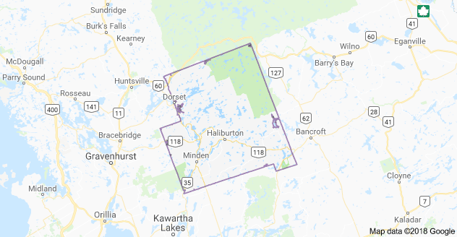](https://www.google.ca/maps/place/Haliburton+County,+ON/data=!4m2!3m1!1s0x4cd44b5838d2618d:0x6e536670ee39ec21?sa=X&ved=0ahUKEwiF_c3sko_aAhXL1IMKHRTXAg4Q8gEIJjAA)[](https://www.facebook.com/troyoptical/?ref=page_internal)[Image result for instagram logo](https://www.instagram.com/explore/locations/1396066177108754/troy-optical/) (705) 286-0727 troy@troyoptical.com