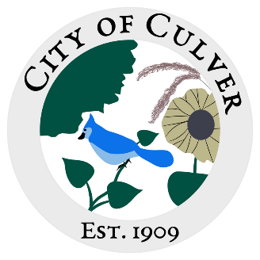
City of Culver Council Meeting Agenda
May 8th 2024 City Hall 7:30pm

- CALL TO ORDER, ROLL CALL
- READING AND APPROVAL OF MINUTES-
- PUBLIC CONCERNS: *We will be addressing public concerns. Anyone with a public concern will have the floor to present their issue. This is the ONLY time the public is allowed to speak. Each council member, starting from the right of the mayor, will then be allowed to ask further questions to the citizen. One at a time. All public concerns may not be fully addressed or voted on in the same meeting it is brought up in. Council members- one speaking at a time during discussion please!

a. Ashley Trow (Citizen)- Park Rules

- Clerks Report:
  - Request to purchase Swiffer
  - Payroll, Clerk or Treasurer. If I do it, I request hours are turned into me SEVEN days prior to the mid month meeting.
- OLD BUSINESS:
  - Website ideas (Trish has a great idea, she will not be present, tabling to next meeting)
  - APAC
    - Total to spend
    - Estimated time for road maintenance to be completed
    - Rock, what is it being used for? Will we have enough to be consistent for the entire town?

- NEW BUSINESS:
  - Spraying for City

- WORK TO DO:
  - Burn Pile

- WORK DONE:
  - Board is painted, we need to hang everything up, and touch up paint.

- WATER REPORT & WATER BILLS:
  - Billing issues resolved?

- READING OF THE BILLS:

FINAL: MEETING ADJOURNED

