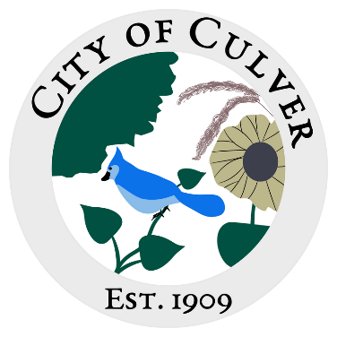
Meeting Minutes for City of Culver Council Meeting
Meeting Details-
Date: 07/10/2024 Time: 7:00pm
Location: City of Culver, City Hall

Meeting was called to order by: Jim Murphy

Roll call was taken.
Attendees: Jim Murphy, Ashley Florke, Patricia Velasquez, Sam Davis, Renee Mattison, LouAnn Inscho.
Visitors: Kari Stanley (Winot), Brandon Florke, Holdan and Erin Hartman, Joey and Kara Shroyer, Steven Velasques, David Stanley, Jerry Amon, Venus Davis

Absent: Ashley Trow, Carol Murphy

Read and approved meetings from last month’s meeting. Minutes were approved with corrections.

Executive Session for 20 minutes, came out and went back for an additional 15 minutes.
7:10pm to 7:30pm
7:31pm to 7:46pm (Did not take full 20)
Jim Murphy called meeting back to order

Patricia made a motion to terminate and replace water superintendent, Ashley Florke 2nd. Motion carried.

Ashley Florke made a motion to send registered letter of termination of water super and request documents, keys, and all unofficial and official mail, anything water related. By July 31st 2024. Patricia seconded and motion carried.

Patricia made motion terminate treasurer effective July 10th 2024. Sam seconded, motion carried.
Ashley Florke made a motion to send a certified letter to the treasurer to advise of termination and request to return all keys, documents-official and unofficial, mail- official and official. Patricia second, motion carried.

Ashley Florke made a motion to take our Carol Murphy off of all bank accounts, charge accounts, entities, effective immediately. Patricia second, motion carried.

Jim Murphy put Lou Ann Inscho forward as treasurer. Ashley Florke made motion to hire Lou Ann as treasurer, Renee second, motion carried.

The public was asked for any interest in council, Kara Shroyer came forward. Jim Murphy stated we will discuss it at next meeting.

Public Concerns: Venus Davis thanked the group, The People of Culver for movie night. A public concern was addressed from the drop box. Accusing Allan Drowns dog of killing her chicken, there was no photo proof of the killing, however the dog was seen running at large. Ashley Trow will mail a letter about our ordinance of dogs at large. Keith Johnson’s dogs were also an issue, Kara and Paul Shroyer, and Rick McCall. Ashley Trow will mail them all letters as well.

It was announced that Aaron Ziegler will be a guest at next meeting per citizen request.
Kari Stanley requested public sky fire, advised we were well off from that. She also stated that she was opening a store, asked what her plans were. She was going to be selling many different things. She will present her business licenses to the council as she obtains them. And we will discuss at that time.

Lou Ann Inscho brought up David Stanley’s idea to clean up the community. To borrow someone’s dump truck and help clean up the city and then take the dump and the city would pay for those fees. Ashley Florke stated we would need to get quotes on dump truck quotes and price of different material dumps.

What we owe Ginder’s was brought up for the cylinders on the equipment. Ashley Florke inquired on the reasoning behind not getting quotes, it was stated that they knew of no other options. She also inquired on why Jim allowed that much to be spent without council permission. Lou Ann and Jim Murphy stated the $500 max was not a rule. Ashley Florke, Sam Davis, and Patricia Velasquez stated it was a rule.
Ashley Florke made a motion to pay Ginder Hydraulics $1,932.33 for cylinders to equipment, Patricia second, motion carried.

We will discuss park ordinances; it will be started from scratch.
Ashley Florke brought the termite quotes to councils’ attention, they stated they were too expensive and we needed to find cheaper options.

Ashley Florke made a motion for Jim Murphy to return keys for well house, filtration, water drop box, mail box by Sunday July 14th to the clerk. Patricia second, motion carried.

It was discussed how many keys were out and to what property, we will begin working on a list.

Ashley Florke brought Art Webb’s water audit to councils’ attention. Ashley Florke made a motion to accept, Patricia second, motion carried. Charity Donahue and Jimmy Murphy’s audits need cleaned up and mail a letter with payment arrangement.

Ashley Florke made a motion to pay the bills, Patricia second, motion carried.

Patricia made motion to adjourn the meeting, Ashley second, motion carried.

Clerk Report: NONE- Clerk was absent.

