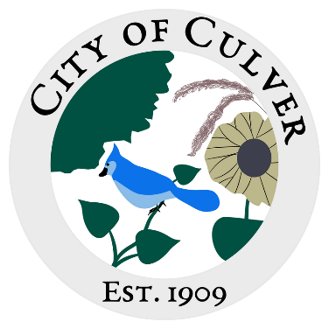
Meeting Minutes for City of Culver Council Meeting
Meeting Details-
Date:08/21/2024 Time: 6:00pm
Location: City of Culver, City Hall
Meeting was called to order by:

Roll call was taken.
Attendees: Renee Mattison, Patrcia Velasquez, Sam Davis, Kara Shroyer, Ashley Trow, Lou Ann Inscho.
Visitors: NONE
Absent: Jim Murphy, Erin Kerby

Read and approved meetings from last month’s meeting. NONE. Budget Meeting.
LouAnn discussed the budget on behalf of the clerk. Each person has a copy of the budget in front of them during discussion. Lou Ann stated our levy decreased. We decreased the ad volorum tax because we got a lot of delinquent tax last year. Salary and wages, utilities, and street lights, supplies and postage, equipment repairs, insurance publications and classes all increased. We have $8,000 in special highway, and $4,000 in reserve. The water section should be doing good, we have $3,000 in reserve and $5,000 for bond payment. Increased payroll for water, supplies were bumped up as well. Renee inquired on how much money the park had. About $1,400. Lou Ann asked if anyone had any questions. There were none. Renee made a motion to accept the budget, Kara second, motion carried. Council members signed the document.

Public Concerns: N/A

New Business: N/A

Clerks Report: N/A

Work To Do: N/A

Work Done: N/A

Water Report and Water Bills: N/A

Reading of the Bills: N/A

Motion to adjourn the meeting was made my Renee, Kara second, motion carried.

