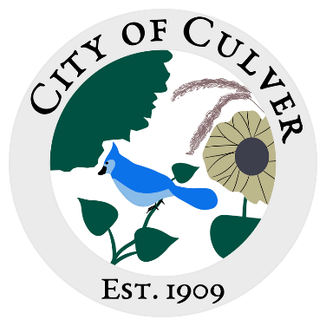

Meeting Minutes for City of Culver Council Meeting

Meeting Details-

Date: 05/28/2025 Time: 7:00pm

Location: City of Culver, City Hall

**Meeting was called to order by: Jim Murphy.**

**Roll call was taken.**

**Attendees: Jim Murphy, Ashley Trow, Renee Mattison, Erin Kerby, Kara Shroyer.**

**Absent: Patricia Velasquez, Sam Davis, and Lou Ann Inscho.**

**THERE WAS NO QUARAM. NO MEETING.**

**Guest:**

**Read and approved meetings from last month’s meeting.**

**Public Concerns:**

**Clerk Report:**

**Old Business:**

**New Business:**

**Work To Do:**

**Work Done:**

**Water Report & Water Bills:**

**Reading of the Bills:**

**Motion to adjourn the meeting was done by**