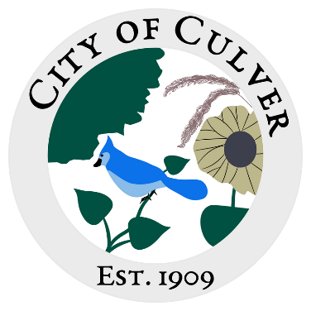
Meeting Minutes for City of Culver Council Meeting
Meeting Details-
Date: 10/08/2025 Time: 7:00pm
Location: City of Culver, City Hall

Meeting was called to order by: Jim Murphy

Roll call was taken.
Attendees: Jim Murphy, Sam Davis, Lou Ann Inscho, Erin Kerby, Kara Shroyer, Ashley Trow, Patricia Velasquez.
Absent: Renee Mattison
Guest: Jerrel Forbes

Read and approved meetings from last month’s meeting. Erin made a motion to accept the minutes, Lou Ann second, motion carried.

Public Concerns: NONE

Clerk Report: Lou Ann made a motion to go to one meeting a month on the second Wednesday of each month. Erin made a motion to accept ordinance 215, Sam second, Patricia, and Lou Ann agreed, motion carried. Erin made a motion to accept ordinance 216, Sam second, Patricia and Lou Ann agreed, motion carried.

Old Business: We have not heard about the water meter extenders, Lou Ann will be in Salina tomorrow and will check on them. No update on Keith Johnson. Lou Ann asked if Erin knows that she will need to contact the city again to have her lines remarked, Ashley will send her an email.

New Business: NONE

Work To Do: Jim found some sand and he will be mixing it in with the rock to fill in the pot holes.

Work Done: NONE

Water Report & Water Bills: Kara stated that she would like the councils opinion on acct 703. They have only been paying partial amounts. Erin stated this would be a disconnect notice because they are still technically behind. If payment is not made on time this month, by the 15th a disconnect notice will be sent. Kara also stated we need to purchase chlorine. We only have a 1/3 of a barrel. It will be being ordered.

Reading of the bills: Lou Ann inquired on the deposit from the State of Kansas. Kara stated we received more in sales tax than normal. Patricia made a motion to pay the bills, Sam second, motion carried.

Kara stated the mail lady left another note about our potholes. She left a list of addresses.

Final: Motion to adjourn meeting was done by Patricia, Sam second, motion carried.

