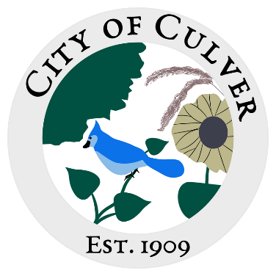
Meeting Minutes for City of Culver Council Meeting
Meeting Details-
Date: 12/22/2024 Time: 5:30pm
Location: City of Culver, City Hall

Meeting was called to order by: Jim Murphy

Roll call was taken.
Attendees: Ashley Trow, Renee Mattison, Kara Shroyer
Visitors:

Absent: Jim Murphy, Lou Ann Inscho, Sam Davis, Patricia Velasquez, Erin Kerby

NO QUARUM- No Meeting

Read and approved meetings from last month’s meeting.

Public Concerns:

Clerk Report:

Old Business:

New Business:

Work To Do:

Work Done:

Water Report & Water Bills:

Reading of the Bills: NONE

Motion to adjourn the meeting was done by

