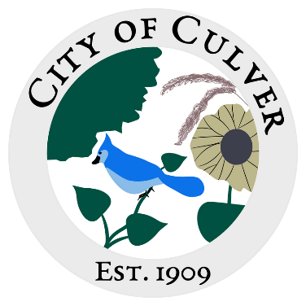
Meeting Minutes for City of Culver Council Meeting
Meeting Details-
Date: 08/27/2025 Time: 7:00pm
Location: City of Culver, City Hall

Meeting was called to order by: Jim Murphy

Roll call was taken.
Attendees: Jim Murphy, Ashley Trow, Kara Shroyer, Erin Kerby, Samuel Davis.
Absent: Patricia Velasquez, Renee Mattison, Lou Ann Inscho
Guest: NONE

NO MEETING HELD- NO QUARAM

