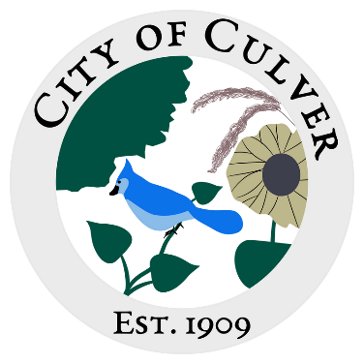
Meeting Minutes for City of Culver Council Meeting
Meeting Details-
Date: 12/10/2025 Time: 7:00pm
Location: City of Culver, City Hall

Meeting was called to order by: Jim Murphy

Roll call was taken.
Attendees: Jim Murphy,Erin Kerby, Kara Shroyer, Ashley Trow, Renee Mattison
Absent: Patricia Velasquez, Lou Ann Inscho
Guest: None

Read and approved meetings from last month’s meeting

Public Concerns:

Clerk Report:

Old Business:

New Business:

Work To Do: Same work, Hartmans culvert, potholes in town still need filled.

Work Done: NONE.

Water Report & Water Bills:

Reading of the bills:

Final: Motion to adjourn meeting was done by Lou Ann, Sam second, motion carried.

