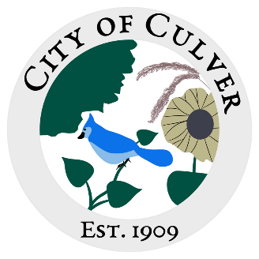
City of Culver Council Meeting Agenda
March 24th, 2024 City Hall 5:30pm

- CALL TO ORDER, ROLL CALL
- READING AND APPROVAL OF MINUTES- The Clerk was absent for the meeting held on March 13th 2024. There were notes taken, the recording cut off after 10 minutes. There was also a lot of bickering, yelling, and chaos during the meeting.

- PUBLIC CONCERNS: * We will be addressing public concerns. Anyone with a public concern will have the floor to present their issue. This is the ONLY time the public is allowed to speak! Each council member, starting from the right of the mayor, will then be allowed to ask further questions to the citizen, ONE AT A TIME. All public concerns may not be fully addressed or voted on in the same meeting it is brought up in. Council members- one speaking at a time even in discussion.
  - Trow Household Letter

- CLERK REPORT:
  - Email from the Sheriff
  - Website
  - Signature Card

- OLD BUSINESS:
  - Holdan/Erin road
  - Kid with gun issue
  - Asphalt Millings Scheduled
  - Next Link

- NEW BUSINESS:
  - Ordinance 135 and 135a

- WORK TO DO:

- WORK DONE:

- WATER REPORT & WATER BILLS:
  - Florke Water Audit
  - Water department hiring meter reader, do we have an ordinance? If not, why did we vote on firing Keith and hiring Holdan?

- READING OF THE BILLS:

FINAL: MEETING ADJOURNED

