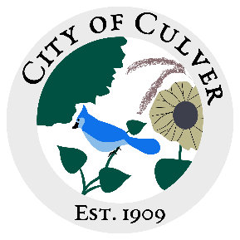

City of Culver Council Meeting Agenda

March 13th, 2024 City Hall 7:00pm

- Call to Order, Roll Call

- Reading and Approval of previous minutes.

- Public Concerns/Citizen Complaints:
We will address any public concerns at this time. This is the publics ONLY chance until next meeting to have their issues addressed. Reminder: all public concerns may not be fully addressed or voted on in the same meeting.
- See letter from Ashley Trow
- More complaint forms are in your box, please remember that if a citizen has a complaint, they need to fill the form out and turn it into a council member, clerk, or mayor. This is to ensure that it is being handled accordingly and record is made of the issue. This also allows the clerk to plan a meeting and the meetings be completed in a timely fashion.

- Old Business:
- Asphalt Millings, please provide THREE days that would work best so that Ashley can schedule with APAC. Per APAC, they will not charge an additional amount to drop the millings as they are driving.
- Corner of Hiland and East St- the grating was completed, but not done well. There are still severe ruts.
- Ashley has reached out to Ottawa County several times about the ditch on Hiland, no response. She will keep trying.

- New Business:
- Decide what ordinances will be discussed at next meeting

- Work To Do:

- Work Done:

- Water Report & Water Bills:
- Holdan is no longer interested in the water meter reading position. Need to hire someone else.
- Ashley Florke water bill resolved?

- Clerks Report:
- Signature card, everyone please sign and leave for me. Lou-Ann, I need a photo copy of your DL.
- Message Board for front of building, see attached for what I am requesting approval of!

- Reading of the Bills:

FINAL: Meeting Adjourned

