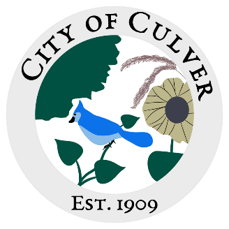
City of Culver Council Meeting Agenda
April 10th, 2024 City Hall 7:00pm

- CALL TO ORDER, ROLL CALL
- READING AND APPROVAL OF MINUTES-
- PUBLIC CONCERNS: *We will be addressing public concerns. Anyone with a public concern will have the floor to present their issue. This is the ONLY time the public is allowed to speak. Each council member, starting from the right of the mayor, will then be allowed to ask further questions to the citizen, one at a time. All public concerns may not be fully addressed or voted on in the same meeting it is brought up in. Council members- one speaking at a time during discussions please!
  - Hartman Household Water Billing
- CLERKS REPORT:
  - Power at the citizens building
  - Ordinance 135 and 135a
- OLD BUSINESS:
- Hartman Road/Ditch
- Asphalt Millings- found people to work equipment?
- Mowing
- Website, found any new options?

- NEW BUSINESS:

- WORK TO DO:
- Burn Pile

- WORK DONE:
  - Park was cleaned up from limbs/debris, shelters anchored back down.

- WATER REPORT & WATER BILLS:

- READING OF THE BILLS:
FINAL: MEETING ADJOURNED

