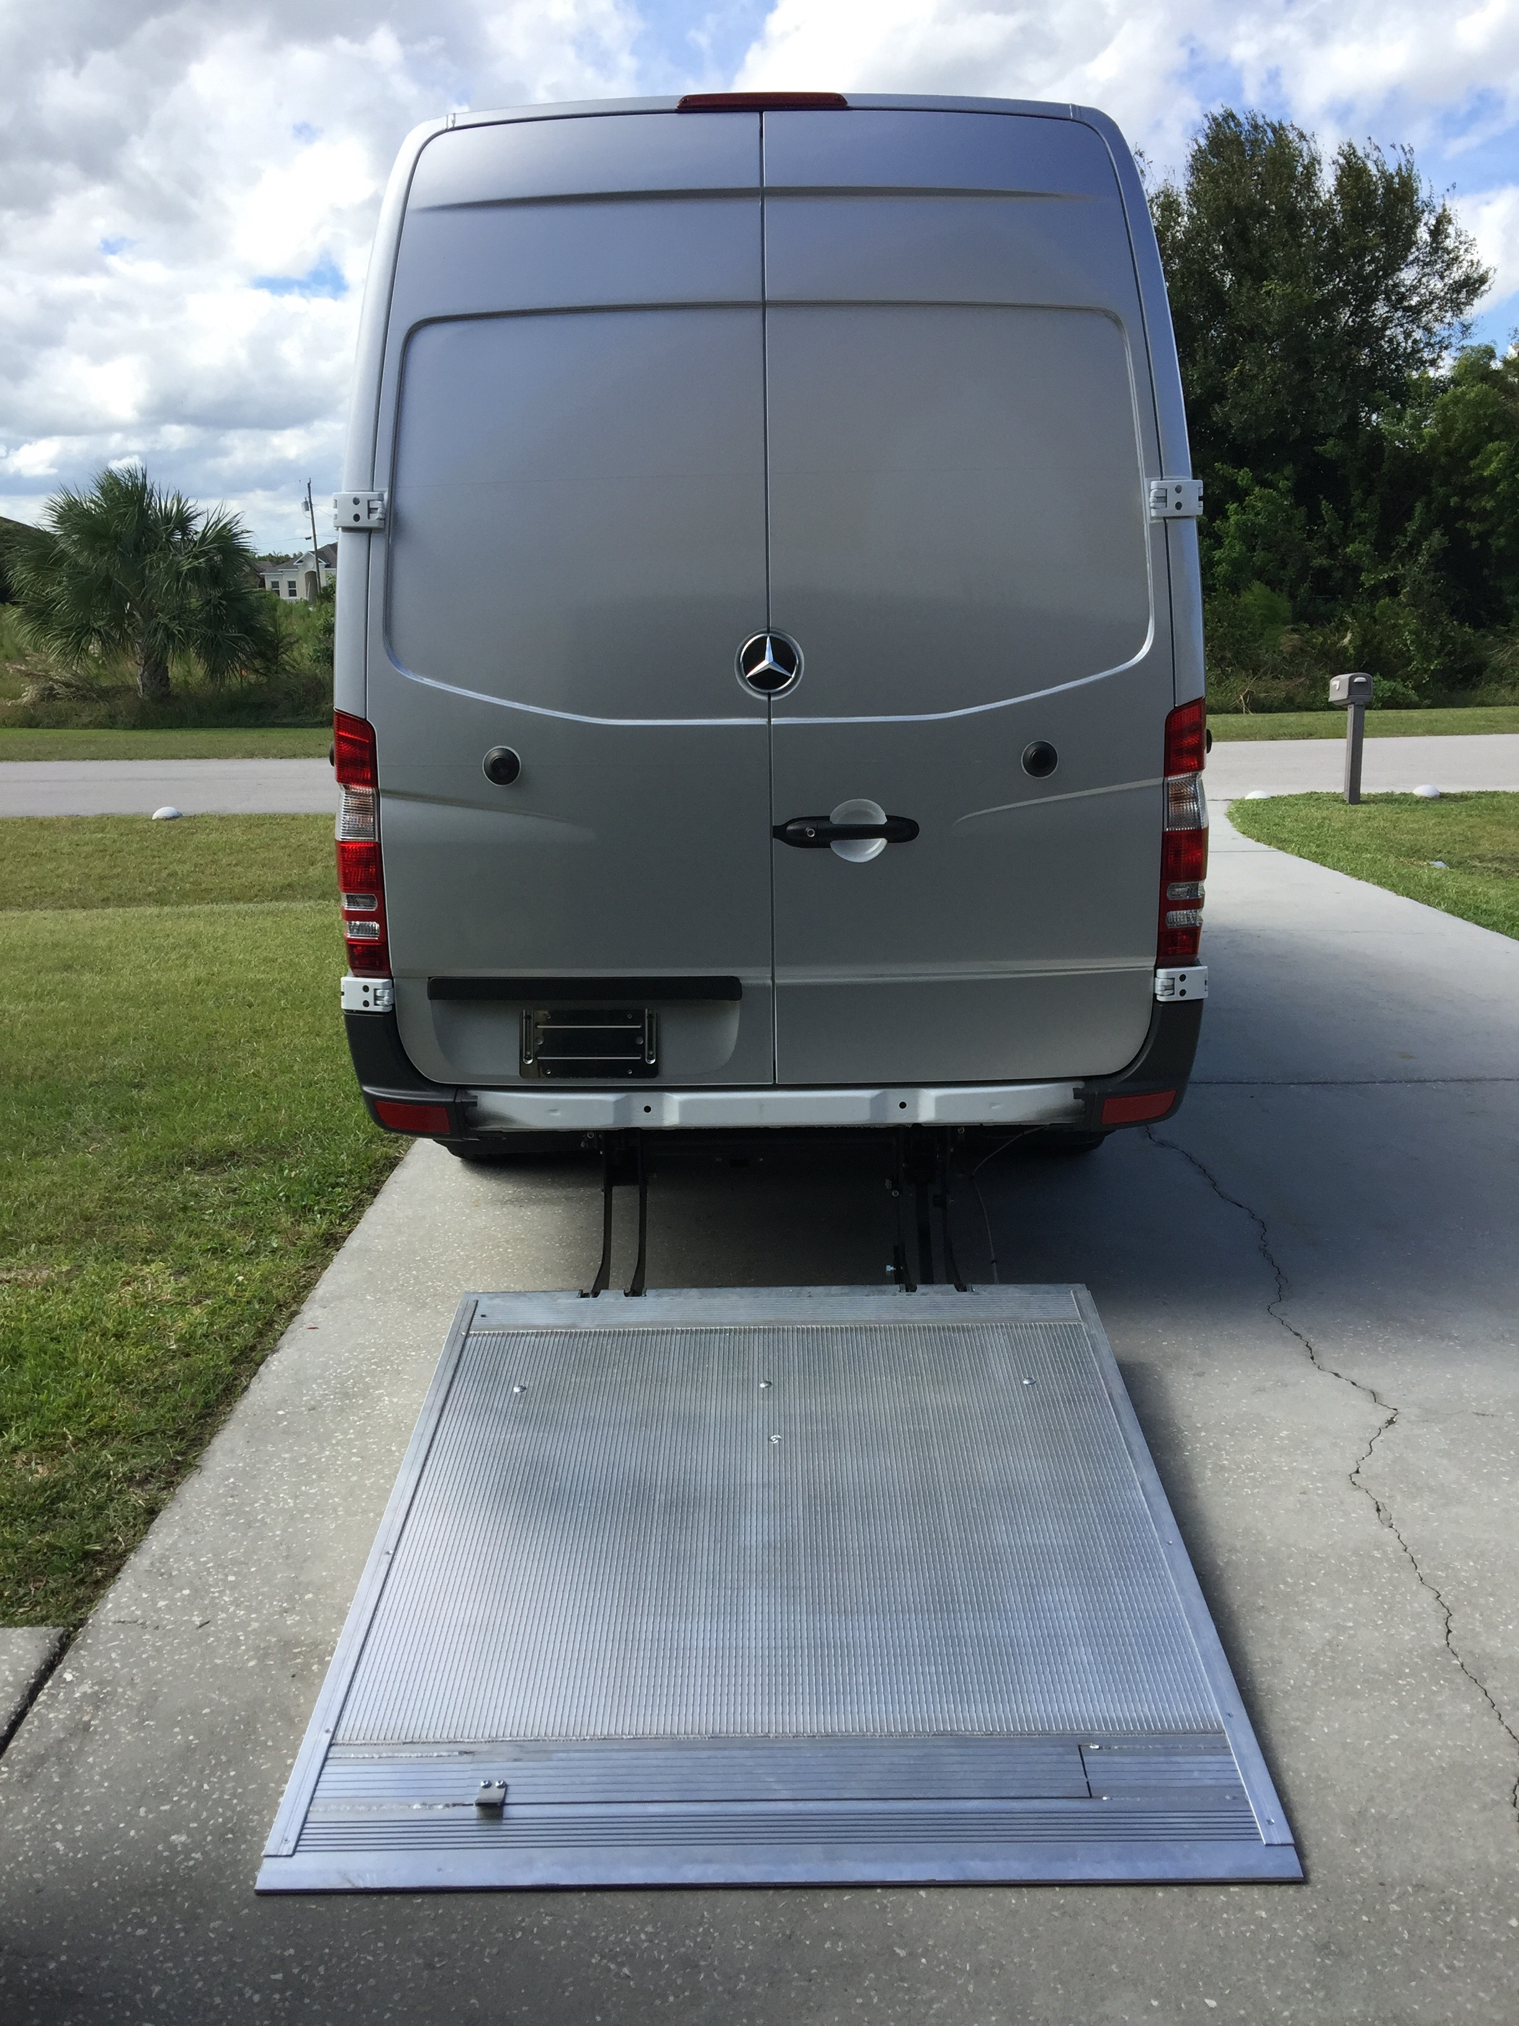` 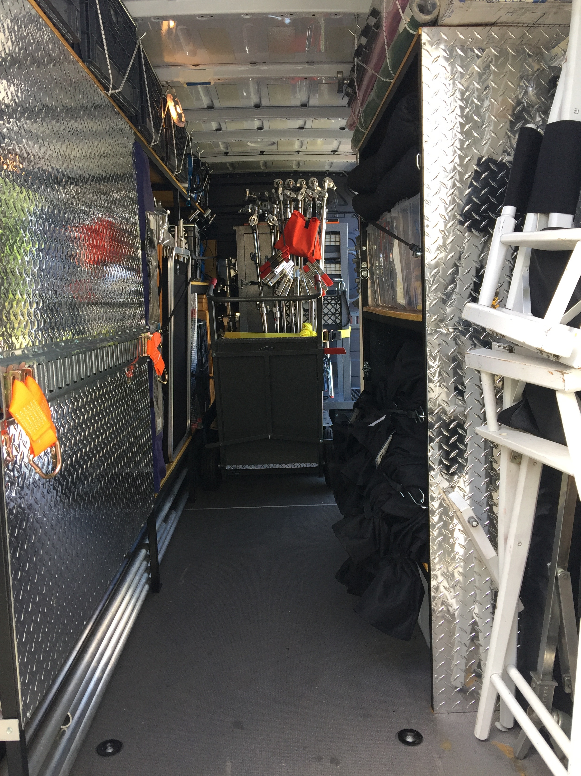

**SPRINTER 3 TON GRIP PACKAGE WITH LIFTGATE**

|  |  |  |  |  |  |
| --- | --- | --- | --- | --- | --- |
| **QTY.** |  |  |  | **QTY.** | **EXPENDABLE LOG** |
| 12 | C-STANDS W/GRIP HEAD AND ARMS | 12 | SPRING CLIPS #1,#2,#3 | 4 | 4 X 8 FOAMCORE BLACK/WHITE |
| 2 | BABY C-STANDS W/GRIP HEAD AND ARMS | 4  2 | CARDELLINI END JAW  CENTER JAW | 2 | 4 X 8 B-B0ARD WHITE/SILVER |
| **2** | HI-BOY STANDS | 2  2 | RIGID CHEESEBORO  SWIVEL CHEESBORO | 2ea | Show CARDS B/w, shiny silver and gold dull-silver/gold |
| 2 | MEDIUM ROLLER STANDS | 4 | JUNIOR NAIL ON PLATES | 1 | 12” BLACK WRAP  24” BLACK WRAP |
| 6 | 3-RISER COMBO STANDS | 4 | BABY NAIL ON PLATES | 2 | #8 SASH CORD  “10 SASH CORD |
| 2 | LOW COMBO STANDS | 4 | DROP CEILING SCISSOR CLAMPS | 25  50,’ | BAILING WIRE  GRIP CHAIN |
| 6 | 3-RISER BEEFY BABY STANDS | 4 | BABY PIPE CLAMPS | 1 | BAGS OF CLOTHES PINS C-47 |
|  | **48” X 48” FLAGS** | 2 | JR. PIPE CLAMPS | 1 | BAG OF SCREWS AND NAILS |
| 6 | EMPTY FRAMES | 2 | CHAIN VISE GRIPS | 1 | MIRROR TILES (1X1) |
| 4 | SOLID FLOPPY | 1 | PIPE WALL SPREADER 1”1/4 | 1ea | DULLING,PLEDGE,WD-40,ADHESIVE SPRAY |
| 2 | SILK | 1 | JR OFFSET ARM | 1 | RAKE,SHOVEL,BROOM |
| 2 | DOUBLE NET | 1 | BABY OFFSET ARM | 1 | FIRST AID KIT |
| 2 | SINGLE NET | 1 | JR TRIPLE HEADER | 1 | FIRE EXTINGUISHER |
|  | **24” X 36” FLAGS** | 2 | 750/2K ADAPTOR | 2 | SAFETY CONES |
| 4 | SOLID | 2 | MAFFER CLAMPS | 1 | ROLL OF DUVY |
| 2 | EMPTY FRAMES | 6 | 4-1/2” GOBO HEADS | 1 | ROLL OF RUBBER MATTING |
| 2 | SILK | 2 | 2-1/2” GOBO HEADS |  | **TAPES AS USED** |
| 2  2 | DOUBLE NET  SINGLE NET | 2 | FOAM CORE HOLDERS/DUCKBILLS |  | 2”GAFFER (BLACK,GREY,WHITE)  1’’ GAFFER(BLACK,GREY,WHITE) |
|  |  | 2 | 4” C-CLAMPS W/STUD |  | 2”BLACK PAPER TAPE |
|  | **18” X24” FLAGS** | 2 | 6” C –CLAMPS W/STUD | 1 | 2”BLACK PAPER TAPE  2” J-LAR |
| 2 | SOLIDS | 2 | 8” C-CLAMPS W/STUD | 50’ | Trick line (black/white) |
| 2 | EMPTY FRAMES |  | **APPLE BOXES** | 10ea | 25’ stingers  50, stingers |
| 2 | SILK | 4 | FULL |  | Cube taps |
| 2  2 | DOUBLE NET  SINGLE NET | 4  4 | 1/2  1/4 | 6ea | QUICK ON(MALE,FEMALE)  GROUND ADAPTORS |
| **2** | **24”x36” SOLID FLOPPY** | 4 | PANCAKE | 2 | Power strips |
|  | **OVERHEAD FRAMES & RAGS** | 24 | TRACK WEDGE 2”X4”X12” | 1ea  1ea | PHASING TAPE(BK,BL,G,R,W)  ZIP CORD (BLACK/WHTE) |
| 1 | **12X12 SET,FRAME,EARS,CORNERS** | 24  12 | 2” X4”X10” CRIBBING  1”x3”x12” CRIBBING |  | **GELS/DIFFUSION**  **AS USED** |
| 1 | **8X8 SET,FRAME,EARS,CORNERS** | 1 | 4 X 8 BIRCH PLYWOOD | 1ea | **216/250/251/253,OPAL FROST/LT GRID** |
| 1 | **6X6 SET FRAME,EARS,CORNERS** | 1 | 4’ LADDER | 1ea | **CTO**:FULL,1/2,1/4,1/8  **CTB:**FULL./2,1/4,1/8 |
| 1ea | **SOLID,SILK,SINGLE ,DOUBLE,** | 1 | 6’ LADDER | 1ea | **CTS:**FULL,1/2,1/4,1/8 |
| 2 | 4 X 4 SILVER REFLECTORS | 2 | TARPS | 1ea | **Plus/minus green**,full1/2,1/4,1/8 |
| 30 | 30LB. SAND BAGS W/CART | 4 | FURNITURE PADS | 1ea | **ND3 ND6 ND9** |
|  |  |  |  |  |  |