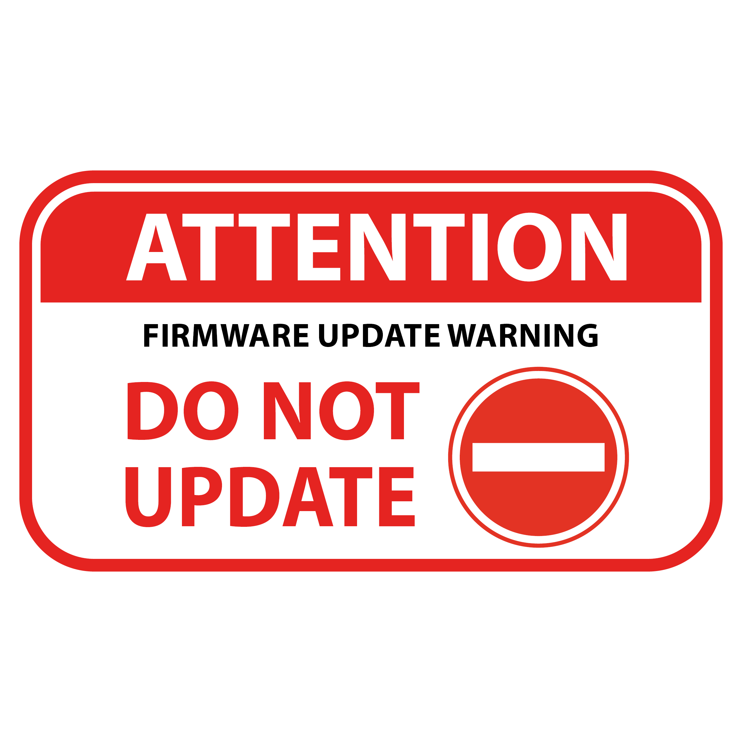
From time to time, Epson, Canon, HP and other printer companies release new versions of the printer firmware on its most recent models. In many cases, these firmware updates serve to disable third-party auto-reset chips like the ones on our compatible cartridges. Although we are constantly updating our chips to combat this, keeping ourselves up to date with all Epson updates, it is still highly recommended that you disable automatic updates of the printer software.
Note that automatic updates only occur if the printer software is installed on a Windows computer. If you currently have the printer installed on a Windows computer, follow these steps to disable automatic updates:
- Access the printer's icon on the Windows taskbar.
- Right-click the icon to reveal the menu, then choose Software Update Settings.
- Set all update frequencies to Never.
- Be sure to repeat this on all Windows computers that have the printer software installed.
If needed, please google how to shut off updates to your printer for your specific printer model.

From time to time, Epson, Canon, HP and other printer companies release new versions of the printer firmware on its most recent models. In many cases, these firmware updates serve to disable third-party auto-reset chips like the ones on our compatible cartridges. Although we are constantly updating our chips to combat this, keeping ourselves up to date with all Epson updates, it is still highly recommended that you disable automatic updates of the printer software.
Note that automatic updates only occur if the printer software is installed on a Windows computer. If you currently have the printer installed on a Windows computer, follow these steps to disable automatic updates:
- Access the printer's icon on the Windows taskbar.
- Right-click the icon to reveal the menu, then choose Software Update Settings.
- Set all update frequencies to Never.
- Be sure to repeat this on all Windows computers that have the printer software installed.
If needed, please google how to shut off updates to your printer for your specific printer model.

