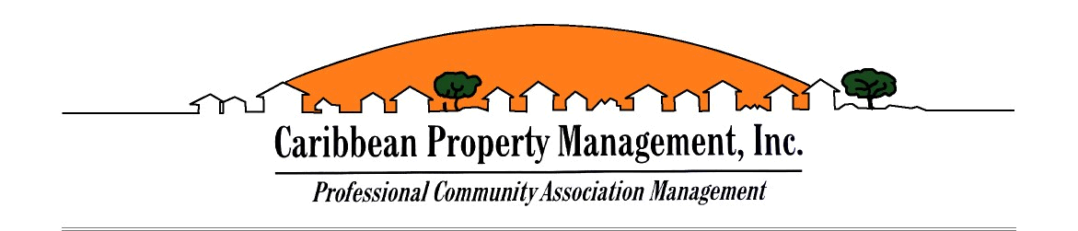
Bridgepoint HOA Meeting
Bridgepoint Community Meeting Minutes
Date: September 18, 2025
Start Time: 7:01 PM
Location: Zoom Meeting
Meeting Summary:
- Presentation by Fernando (Fiber Now Representative):
Fernando, a representative from Fiber Now, provided a presentation introducing the company as a potential new cable and internet service provider for the community.
- Overview of Services:
All owners present received information about Fiber Now’s offerings, including internet speeds, service plans, and customer support features.
- Construction Timeline:
Fiber Now informed attendees that full construction will take place at the rear of the units.
  - Estimated Completion Date: February 2026
- Owner Questions and Discussion:
Attendees were given the opportunity to ask questions and share comments regarding the potential new service.
Adjournment:
The meeting was adjourned at 8:15 PM.
1.Presentation by Fernando (Fiber Now Representative):
Fernando, a representative from Fiber Now, provided a presentation introducing the company as a potential new cable and internet service provider for the community.
2.Overview of Services:
All owners present received information about Fiber Now’s offerings, including internet speeds, service plans, and customer support features.
Vanessa Perez
Assistant Property Manager
Caribbean Property Management
12301 SW 132 Ct. Miami, FL 33186
Ph:305-251-3848 Ext: 108
Fax: 305-251-384

