**Santa Rosa Republican Women, Federated**

**Americanism**

March 2025

Human evil thrives in shade.

Seventy-nine years ago this month, the world was served notice, ten months after Nazism had been vanquished, that civilization had entered another, new era of darkness. That light of freedom’s victory had shone briefly before another shadow crept over the world.

In March of 1946, the great statesman and rabid anti-communist, Winston Churchill, whose nation was the only democracy left in Europe in 1940 to resist Nazi tyranny and aggression, delivered his famous **“Sinews of Peace” address** at Westminster College in Fulton, Missouri.

Tanks of the Red Army were parked from the Baltic to the Adriatic Seas: Churchill seized this opportunity in Missouri to warn the free world that an “iron curtain” had descended all along the eastern European frontier. “Police governments,” as Churchill called them, had arisen in this region, with the Red Army present to enforce them.

As ever, history repeats itself: Another hegemonistic agenda is evinced today by the shadow cast by the globalists and the Chinese Communist Party, and by the Marxists in the state houses across our country. All that’s missing are the tanks.

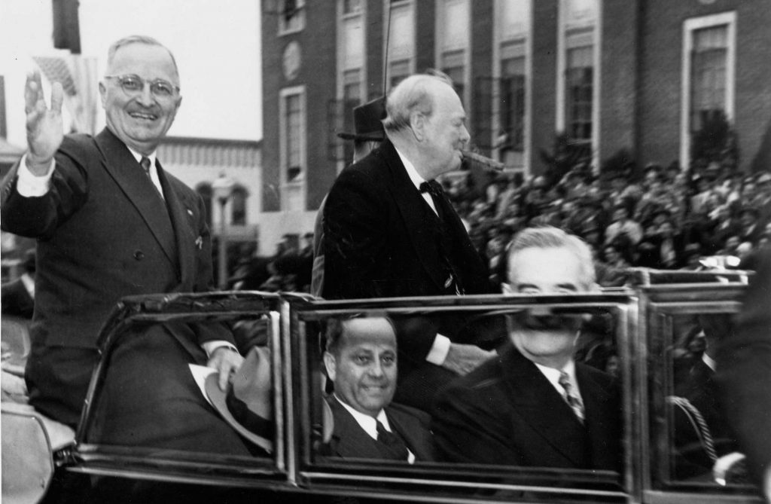

Other historical dates in March:

**5 March**: Five Americans are killed in the Boston Massacre. (1770)

**23 March**: Patrick Henry addresses the Virginia Convention, demanding liberty (“or death”). (1775)

**30 March**: President Reagan survives an assassination attempt. (1981)

**31 March**: L. B. J. informs America that he will not seek a second term as president. (1968)