**Santa Rosa Republican Women, Federated**

**Americanism**

April 2025

The heavyweight champion of the world refused to fight.

**How far does freedom of religion extend—especially as it pertains to lawful civic duty and responsibility?** Muhammad Ali, the world’s heavyweight champion, was registered for Selective Service but refused to be inducted into the Armed Forces when drafted in 1967. The war in Southeast Asia was going on, with around four hundred and eighty-six thousand soldiers, sailors, marines, and air men deployed. Ali, identifying as a conscientious objector, refused to serve in the Army for personal and religious reasons. At the time, he famously commented, “I ain’t got no quarrel with those Viet Cong.”

Ali was convicted of draft evasion. Numerous boxing commissions took away his heavyweight title, and he was suspended from boxing. Additional punishment included a fine of ten thousand dollars and a ten-year prison sentence.

As heavyweight champion of the world Ali was, of course, prominent in America’s celebrity class, and was later vindicated (see note, below). Undoubtedly, however, few if any ordinary Americans can expect their religious beliefs to exempt them from their civic duties.

**Historical footnote**: ***In an eight-to-nothing verdict, the Supreme Court overturned Ali’s prior conviction in* Clay *versus* United States*, 1971.***

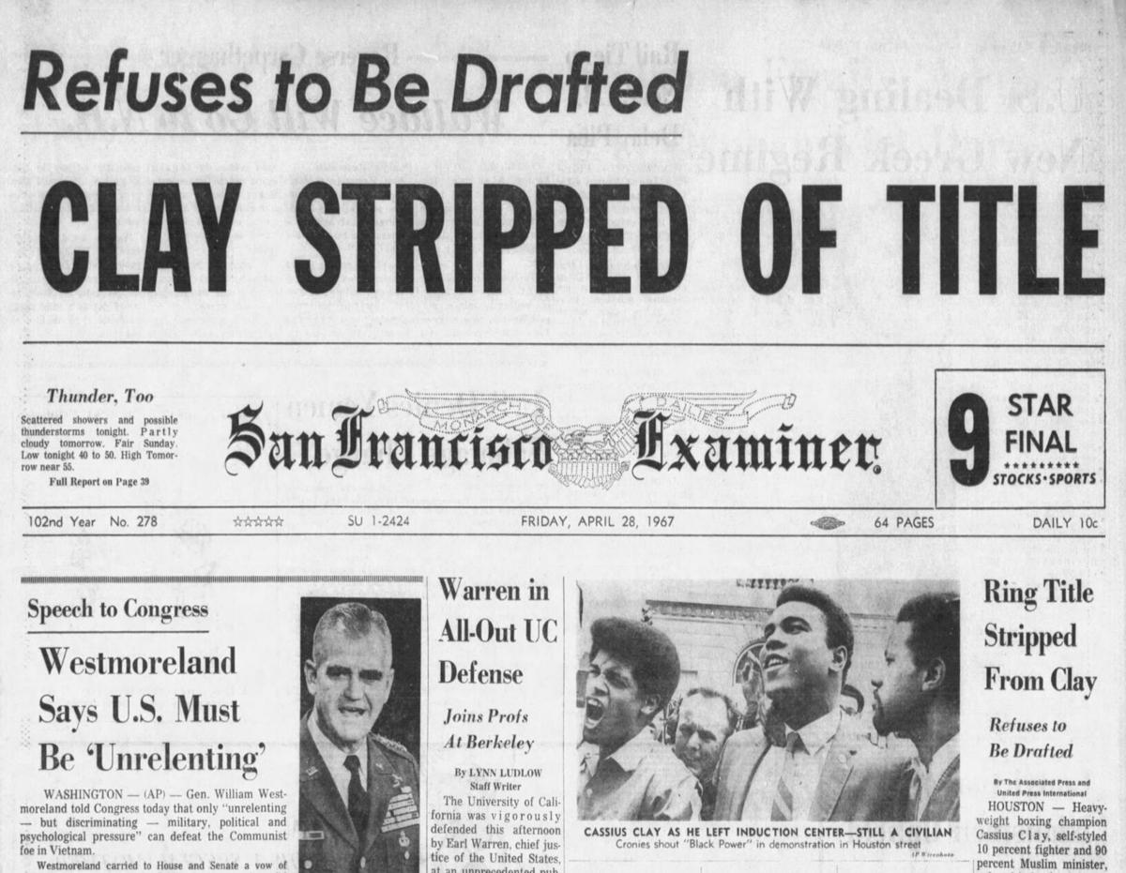

Other historical dates in April:

**3 April:** Marshall Plan enacted. (1948)

**5 April**: Booker T. Washington born. (1856)

**9 April**: Surrender of Army of Northern Virginia (1865)

**18 April**: Sons of Liberty’s “Midnight Ride” (1775)

**24 April**: Library of Congress established. (1800)