**Santa Rosa Republican Women Federated**

**Americanism**December 2024

With typical patriotic fervor, the Club recently concluded its annual Constitutional Scholars Contest, and it appears that the younger generation of American citizens has some distinct views on mass media and the First Amendment.

This year’s challenge was to *“discuss the need (or lack thereof) for a ‘fourth estate’ (of the news media) to ‘safeguard’ democracy in the United States.”*

This timely topic was inspired by Peggy Maddock, who also served as one of three judges evaluating the essays. The topic was given to the students in an A. P. Government class at Cardinal Newman High School.

As far back as deTocqueville’s long-ago peregrinations in the United States, the news media has been perceived, rightly or wrongly, as a watchdog over the government, thus acting as a “fourth estate” of the nation’s government. That unearned, amorphous trust had deteriorated steadily over the past one hundred and eighty years.

How truthful, reliable, and objective are the nation’s news media in reporting the news? How credible is the content found on social media, when all but the deluded among us know it’s manipulated by foreign and domestic enemies of the United States?

The students seem to think that the Fourth Estate is necessary to safeguard democracy in the United States, yet many acknowledge that the media is susceptible to misinformation, censorship, and flagrant political bias.

Third Place: Jenna Lubas

Second Place: Penelope Kantor

First Place: **Michaela Comfort**

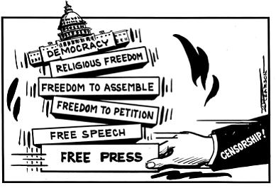

**Bill of Rights Day: 15 December**