A Report On School Library

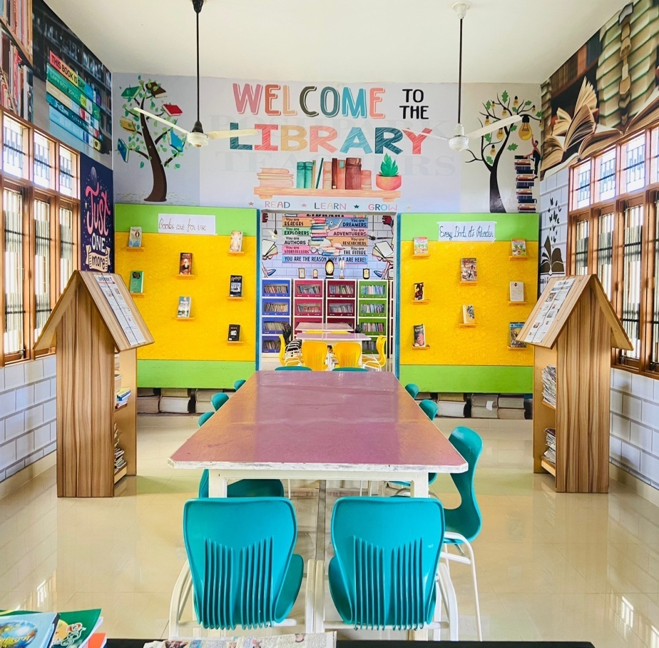

*Name of the school: Nankana Sahib Public School, Rampur Chhanna.*

*Incharge of Library:*

*Ms. Ramanjot Kaur. The incharge deals with provision and maintenance of information including books, electronic resources, newspapers , magazines etc.*

*According to the information collected the following report has been prepared.*

*The library contains approximately 3200 books which are divided into following sections.*

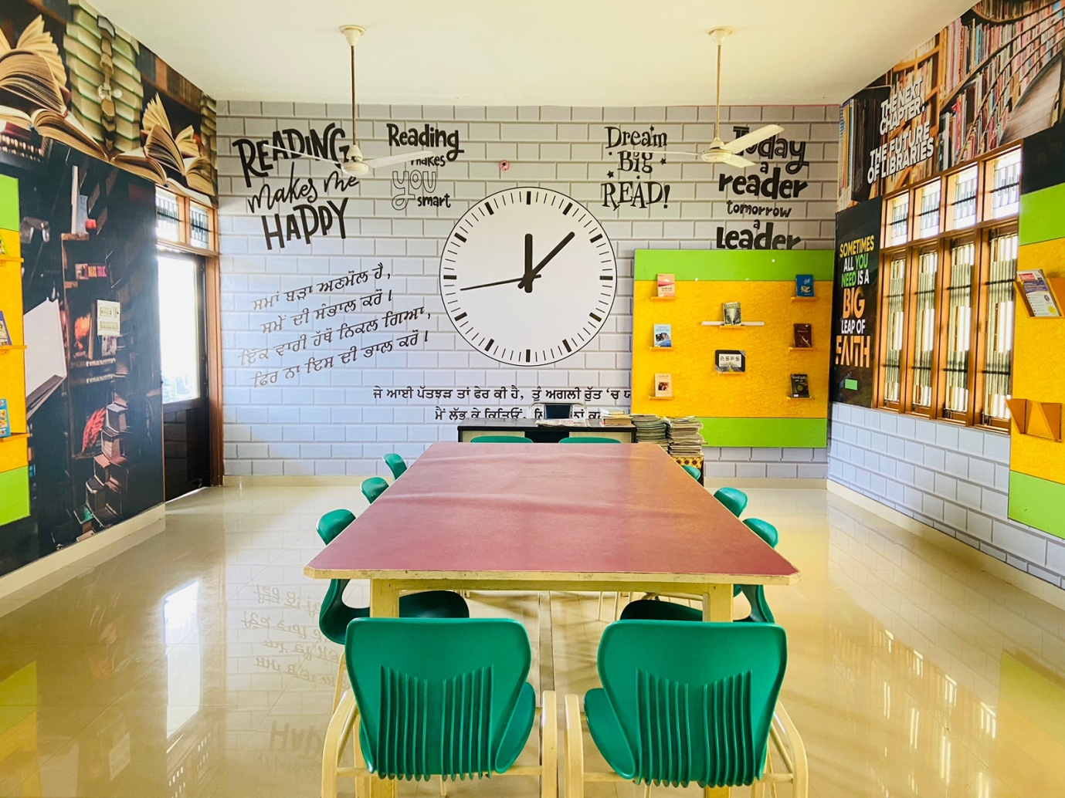

|  |  |  |  |
| --- | --- | --- | --- |
| Section name | No. of books | Type of books | Authors |
| Mathematics | **200** | **Algebra, Geometry, Calculus and Statistics & Probability** | **R.D. Sharma, J.P. Mohindru, R.S. Aggarwal , T.R. Jain etc**. |
| Biology | **150** | **Botany, human biology, microbiology and zoology**. | **B.B. Arora, P.S. Dhami, R.K. Sabarwal , B.P. Pandey etc.** |
| Chemistry | **180** | * **Organic Chemistry. ...** * **Physical Chemistry. ...** * **Inorganic Chemistry. ...** * **Biochemistry.** | **VKJaiswal (Inorganic), MS Chauhan (Organic) and N Awasthi (Physical) etc.** |
| Physics | **200** | **Optics , Mechanics, Electromagnetic** | **Uttam Narayan Tripathi, Amit Gupta, Satish K Gupta etc.** |
| English | **530** | * **Adventure stories.** * **Classics, Autobiographies, biographies,** * **Crime.** * **Fairy tales, fables, and folk tales.** * **Fantasy.** * **Historical fiction.** * **Horror.** * **Humour and satire**. | **Jane Austen, Charles dickens, William Shakespeare , A.PJ. Abdul kalam, H.G. wells, Chetan Bhagat, Rudyard Kipling, etc.** |
| Punjabi | **632** | * **Action and Adventure.** * **Anthologies.** * **Classic Fiction.** * **Contemporary Fiction.** * **Crime, Mystery and Thrillers.** * **Essays.** * **Historical**. | **Nanak Singh, Amrita Pritam, Jaswant Singh Kawal, Bhai Veer Singh, Kartar Singh Duggal, Shiv Kumar Batalwi, etc.** |
| Hindi | **470** | * **Fairy Tales, Fables, and Folk Tales.** * **Fantasy. Autobiography and memoir** * **Biography** * **Essays** * **Non-fiction novel** * **Self-help** | **Munshi Premchand, Harivansh Rai Bacchan,**  **Tarun Goyal, Nirmala Verma, Som Sudha etc.** |
| Religious books | **100** | **Holy books and Encyclopaedia’s** |  |
| Reference books | **490** | **Encyclopaedia, Atlas, Dictionaries.** |  |
| Some extra books | **360** | **Political science, History, Physical Education, Accounts, Psychology, Geography etc.** |  |

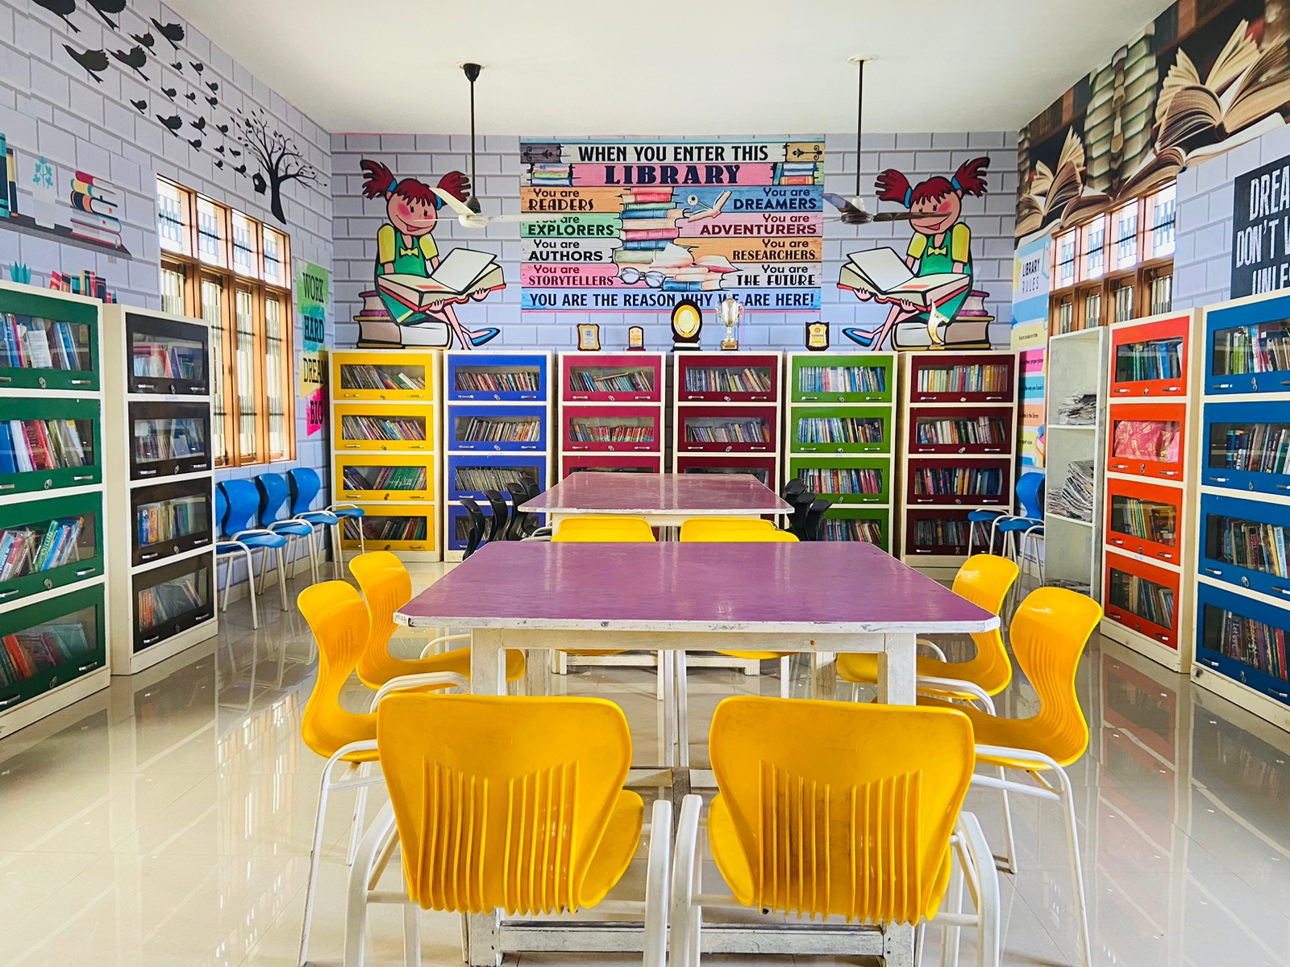

**For Staff:**

**1.Teachers can issue 4 books at a time, which they have to return within 15 days. If books are to be reissued, entry in the issue register is compulsory after 8 days.**

**2.During Library period as librarian would be busy in issuing books to the students concerned teacher should take care of the discipline for the class.**

**3.Teachers are requested to keep books, charts, Globe or any other teaching aid on the table or counter after use instead of arranging in the cupboards.**

**4.If books are to be used only for a day, entry in day book register is compulsory.**

**5.All books should be deposited in the library on last working day of the academic session.**

**6.Arrange chairs & switch off the fans & lights before leaving the Library.**

**For students:**

**1. Students should maintain absolute silence in the library during library period.**

**2. Books will be issued in the library period and will be taken back in the library period only. Book will not be issued unless previous book is returned.**

**3.If book is not returned in library period late fee of Rs.1 per day will be charged.**

**4. If the book is lost cost of the book is to be deposited in the library or in case of story book student can replace the book with same or any other good title.**

**5.Secondary section students can get the books reissued after 14days only after presenting the book on the counter and making an entry of reissue in the book issue register.**

**6. Students should not bring their personal books in the library in library period.**

***Rules and Regulations of Library***