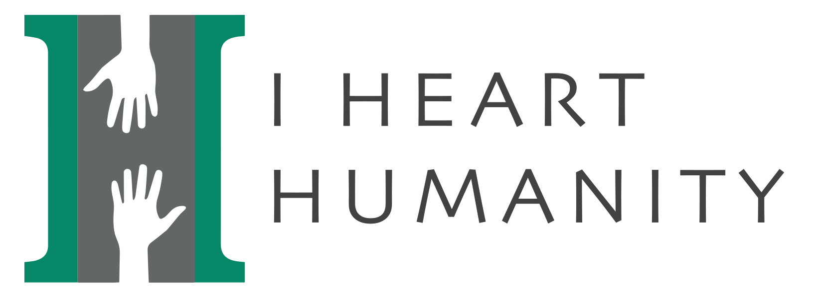
We are a local nonprofit sponsored through the United Way of Weld County. We provide laundry vouchers to a local laundry facility and detergent for those with low to no income or that are experiencing homelessness. Vouchers are distributed at the Housing and Navigation Center in Evans, CO.

Support our fundraiser and purchase a t-shirt or make a donation at the link below.
https://kwshirts.com/i-heart-humanity/

Please follow us on Facebook @
https://www.facebook.com/I-Heart-Humanity-113893583645400/?ref=bookmarks

Find us on the web @
https://www.ihearthumanity.org

