Prairie Dogging Instructions

We will share public and possibly private land prairie dog town locations to match participants. We will share the locations using the OnX app. This app will allow you to see land ownership so you can make sure you are not trespassing, will allow you to see public roads, and navigate using your phone as a GPS even without cell service.

Guidelines for Dogging:
1. No license is required by the state of Wyoming
2. Follow all safe gun handling rules
3. A vehicle with ground clearance is recommended. 4x4 is a good idea. If you are on dirt roads and it begins to rain leave immediately.
4. You more than likely will not have cell service. Go as a group.
5. DO NOT TRESSPASS ON PRIVATE LAND WITHOUT PERMISSION.

Follow these steps to set up your Onx.

1. OnX generally has a 30 day free trial. Wait until right before your trip or once you get to your hotel to down load the app.
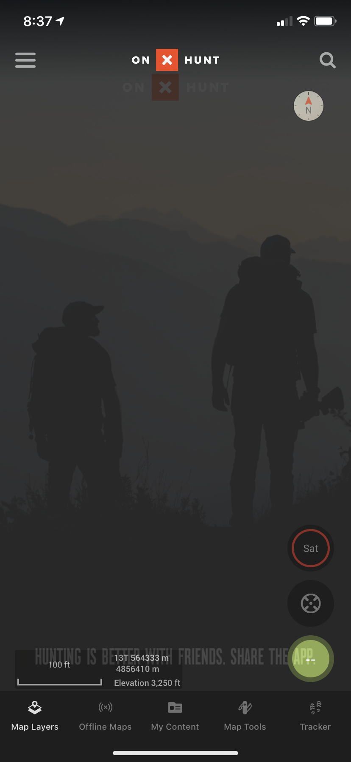
2. Down load the lowest resolution offline map for the entire eastern side of Wyoming. Go to the OFFLINE MAPS tab at the bottom then click NEW OFFLINE MAP.
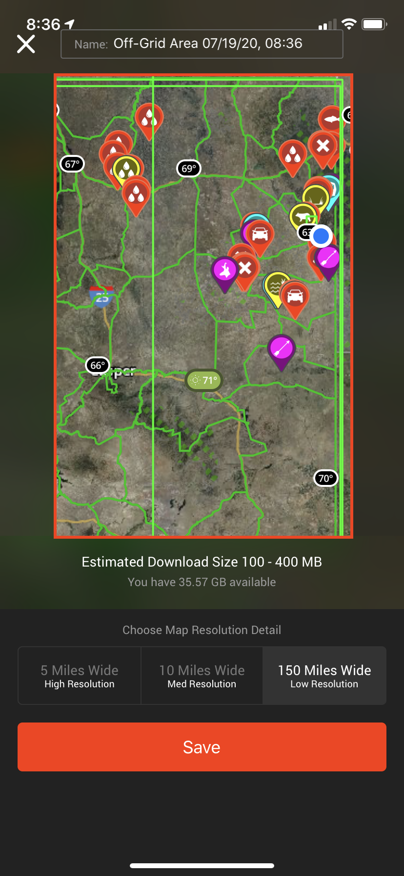
3. After the down load is complete (don’t let the screen go to sleep while downloading) you are all set.
4. After HHC I will send out locations via text. You will simply click on the link and it will save the point in your OnX.
5. When driving you will go in and out of cell service. It is best to set your phone to AIRPLANE MODE. OnX works off your phones GPS and does not require a cell signal.

