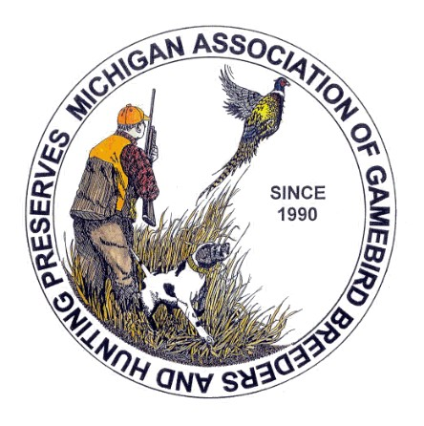

MICHIGAN ASSOCIATION OF GAMEBIRD BREEDERS & HUNTING PRESERVES (MAGBHP)
17109 Day Rd. Dundee, MI. 48131
Phone .734-216-1089
magbhp@gmail.com

Application For Membership

Your Business Name…
Name of Owner/Manager…
Name of Co-Owner/Asst./Spouse
Address

City.. | State.. | Zip Code.. | County..

Telephone.. | Fax..
Web Page.. | Email..
Are you a Gamebird Breeders.. | Are you a Hunting Preserve..
Do You belong to any other association, such as | NAGA

MUCC | NRA
Michigan Farm Bureau | Others

If joining between January 1st through June 30th………New Member total…..$65.00
If joining between July 1st through December 31th…..New Member total……$35.00
Annual dues are $60.00 due January 1st of each year
I hereby make application for membership in the Michigan Association of Gamebird Breeders & Hunting Preserves. The objectives of the association shall be to foster, improve and protect the breeders and hunting preserve operators, its allied businesses and activities and to promote and assist in the re-establishment of game birds and hunting of game birds.
I understand that if my application is not accepted, I will be given a full refund. I also understand that I must be a licensed game bird breeder, hunting preserve or have a vested interest in the positive growth of the gamebird and hunting industry. I understand the dues include owner and co-owner.
I agree to abide by the Standards of the association and to further the interest of this association whenever possible. I understand that my dues payment is good until January 1st and if my membership falls in the arrears for 30 days my membership will be dropped and if I want to be reinstated I will have to pay a reinstatement fee of $5.00 plus dues.

Signature of Owner.. | Date..
Signature of Co-Owner.. | Date..

MAGBHP
QUESTIONAIRE FOR MEMBERSHIP REDERENCE LIST--------Page 2
Your Business Name..

Are you a ? | Gamebird Breeder | Hunting Preserve | Both

If you are a GAMEBIRD BREEDER please answer the following questions
Do you sell to | Public.. | Preserves.. | Field Trials.. | Anyone

Please check the following that you sell: (Place an X by what you offer)
Pheasants | Quail | Chukar | Huns | Ducks
Adults | Adults | Adults | Adults | Adults
Chicks | Chicks | Chicks | Chicks | Chicks
Eggs | Eggs | Eggs | Eggs | Eggs
Dressed | Dressed | Dressed | Dressed | Dressed
Feathers | Feathers | Feathers | Feathers | Feathers

Do you want us to give your name out to others interested in buying ? | YES | NO
Sometimes we have organizations call looking for someone to donate bird to their cause. Would you consider doing this ? | YES | NO
Would you consider helping school projects in your area? | YES | NO

If you are a HUNTING PRESERVES please answer the following questions

Are You ? | Private | Membership Only | Open to Public

What kinds of birds do you offer | Pheasant | Quail | Chukar | Huns | Ducks

What counties is your preserve in?
Do you have a clay course ? |  | Do you have guides
Do you have a European hunts ? |  | Do you offer hunters safety classes
Do you have a Shooting Range ? |  | Do you train dogs
Do you have club house ? |  | Would you be willing to host a hunt to people that may help us to pass laws or rules
Do you a dog training area ? |  | Would you be willing to host a Outdoor or TV person to do a story about preserves
Do you sell dogs ?
What kind of do you sell?
Comments or other things you offer not mentioned.

MAGBHP
MEMBERSHIP STANDARDS & CODE OF ETHICS…………….Page 3

To promote this association and its membership we ask that its members he held to good business standards, practices and ethics. Any member tha is found to be in violation of the following may be expelled. All members will be required to display our poster of membership in good standing in an area that can be viewed by their customer.

1. Obey All Laws (laws meaning all state & federal laws pertaining to be a legal game bird breeder & hunting preserve business)

2. MAGBHP By-Laws

3. Provide high quality birds, both in appearance and performance

4. Birds will be raised in proper size pens with flight pens having adequate bird cover

5. Management and all employees will maintain professional appearance and attitude and
will be easily identifiable to guest.

6. The facility will be maintained in a clean and sanitary manner.

7. Provide excellent bird hunting areas of sufficient size and with challenging cover to
assure fair chase hunts .

8. Adherence to fair trade practices.

9. Honest, truthful advertising

10. Sale of sound birds and hatching eggs

11. Strict compliance with all guarantees and promises.

I agree to abide by these standards:

Signature of Owner: | Date:
Signature of Co-Owner: | Date:

Fill out form, mail with check payable to MAGBHP to address above.

