Besides the Items listed in the Entertainment File here are:
30 things to do in Heber Springs, Arkansas.

- Sandy Beach Public swim area (Free)
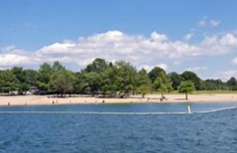

- Bridal Veil Falls / Cornelius Falls (Free)
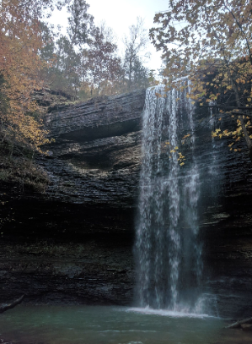

- JFK Dam Overlook (Free)
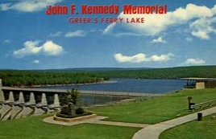

- Dam Site State Park Cliff Jumping and Swim Area ($5 / Vehicle)
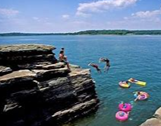

- Frozen Yogurt Bar at Heber Springs Resort
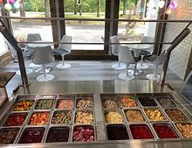

- Coffee or Ice Cream at Jitterbug
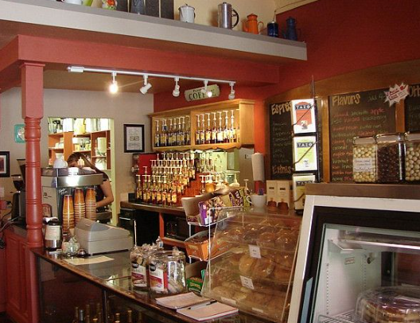

- See a game at the Sports Complex (Most are Free)
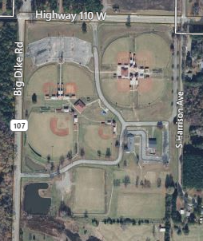

- Rodeo at the fairground (Fee vary based off the event)
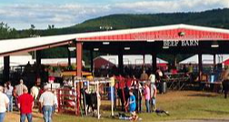

- Spring Park Natural Water Spring, Playground Amphitheater, Skatepark (Free)
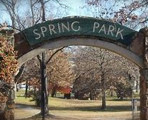

- Hike Sugar Loaf (Free)
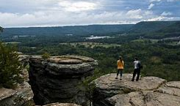

- Drinks / Food Riverside at Cafe Klaser
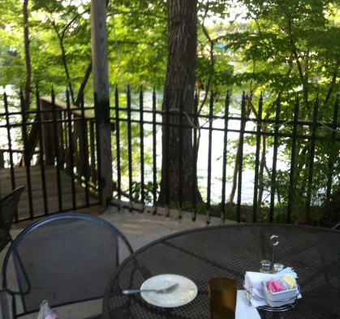

- Visit Collins Creek Cascade (Free)
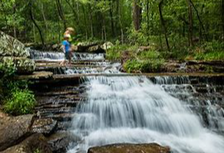

- Mossy Bluff Buckeye Trail (Free)
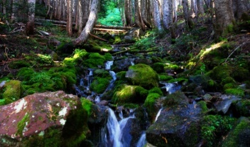

- Visit area Flea Markets
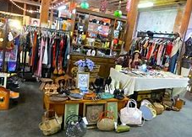

- Have Tea at Woodgrove Antiques
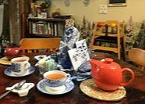

- Visit Ozark Country Market for locally sourced goods.
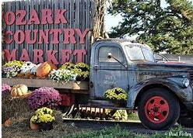

- View Trumpeter Swan at Magness Lake (Free)
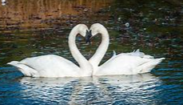

- Fish Greers Ferry Lake or the Red River (Free, Adults need a License)
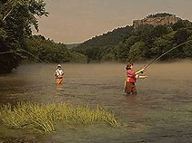

- Rent a boat at Eden Isle or Dam Site Marina
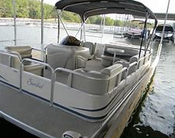

- Rent a Canoe, Paddleboard, or Kayak from Sulpher Creek Outfitter
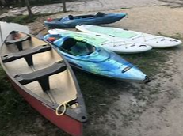

- Have a Shaved Ice from Summer Thang Tropical Shave Ice booth.
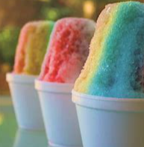

- Visit Aromatique Headquarters and gift shop
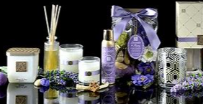

- Play Disc Golf at Mossy Bluff Park (Free)
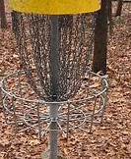

- Hike Josh Park Memorial Trail (Free)
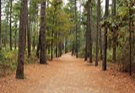

- Hike Sulfur Creek Trail (Free)
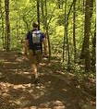

- Food Trucks or live music at Back Alley Eats


- Visit the Courthouse lawn (Free)
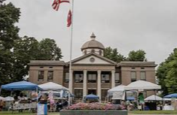

- Visit Chamber of Commerce for area Fairs, Festivals, Special Events, Brochures.
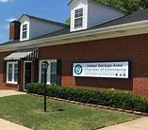

- Scenic Overlook from Mossy Park (Free)
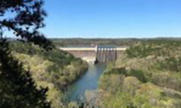

- Jim Kress Wildlife Management Area (Free)
