Alcohol, Narcotics, Substance, and other Addictions.

Narcotic Anonymous (Heber - United Methodist host location)
(501)362-2696
Alcoholic Anonymous (Heber – Hope Lutheran host location)
(870)818)1003
The Other Side (faith based)
(501)365-7003
John 3:16 Ministries (faith based)
(870)217-5603, location one
(870)799-2525, location two
PFH Health Resource of Arkansas for Substance Abuse
(501)250-1104
Wilbur D Mills Center
(501)268-7777
Refuge
(501)691-1221

AR Take Back – (Narcan)
(501)618-8175

SAMHSA (Free and confidential help to find substance abuse treatment)
(800)662-4357

LGBTQ Friendly Rahab – treatment finder
(888)865-0713

Willow Springs (Bastrop, TX)
(844)616-3400

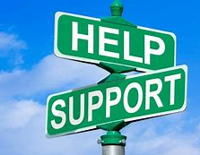
Quitline (tobacco)
1(800)-quit-now

National Problem Gambling Hotline
(800)522-4700

Arkansas Addiction Hotline
(866)210-1303

