Vision Assistance

Lions Club

501-691-3370

Prescription Assistance

Prescription Assist
(888)477-2669

UAMS Medication Assistance
501-268-5000

Park West Pharmacy
(501)224-3499

Poison Control
(800)222-1222

Health Care
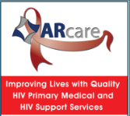
White River Area Agency on Aging
(800)382-3205

AR Care (HIV & AIDS Resource Program)
(870)347-2534

AR Care Clinic Heber
(501)362-9426

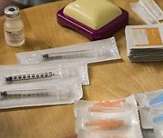
Baptist Health Medical Center (Hospital)
(501)887-3000

Unity Health Medical office
(501)362-5800

Sherwood Urgent Care (Quitman)
(501)589-3015

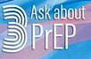
Cleburne County Department of Health
(501)362-4602

American Cancer Society
800-227-2345

American Heart/Stroke Association
501-375-9148

