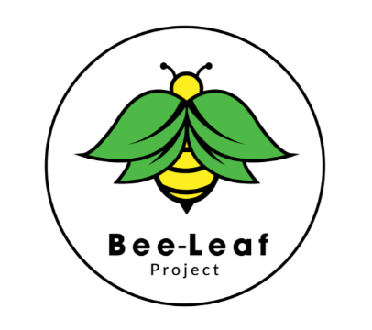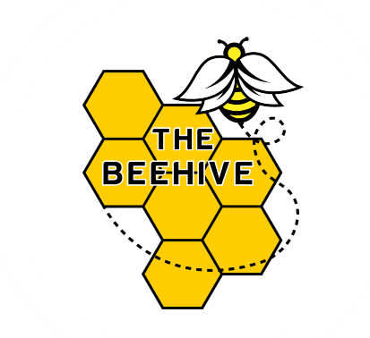

The Beehive Independent School

Curriculum at a Glance
The Beehive offers a bespoke, flexible curriculum designed to meet the individual needs of students with barriers to education including SEND, SEMH, trauma, and disrupted learning histories.
Our curriculum focuses on:
- Core academic skills (English, Maths)
- Life skills and independence
- Social, emotional, and mental health development
- Vocational and creative subjects
Core Subjects:
- English
- Mathematics
- Life Skills Programme (LSP)
- Personal and Social Development (PSD)
Optional Subjects:
- Project (ASDAN Personal and Social Effectiveness)
- Creative Design (Arts Award)
- Food Technology (AQA, ASDAN)
Post-16 Programme:
- Continued English and Maths
- Employability skills development
- Preparation for transitions to further education, training, or work

Qualifications:
Students work toward Pearson, ASDAN, AQA, and Arts Award certifications.

Progress Tracking:
- Continuous assessment
- Weekly and termly progress reports
- Qualification achievements tracked through Learn Trek
Ethos:
A trauma-informed, relationship-based model ensuring students build resilience, self-esteem, and confidence for future success.

