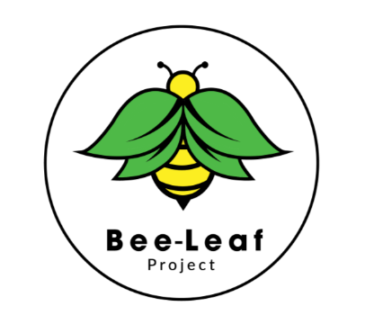

**Admissions Policy**

**Bee-Leaf Project & The Beehive School**

1. **Introduction**

Our policy reflects the DfE guidance, in particular ‘School Admissions Code’ (DfE 2021).

This policy should be read in conjunction with the policies listed below:

• Safeguarding and Child Protection

• Curriculum Policy

This policy aims to outline the admissions process of our Indpendent School, The Beehive School & our Alternative Provision Service, as well as provide relevant information to families and students.

The purpose of this policy is to:

• Ensure the company / service discharges its legal responsibilities

• Ensure the company / service is able to meet the needs of the pupils referred & the requirements of their EHCP

• Ensure new referrals do not adversely affect the learning of those pupils already attending

• Ensure it is inclusive in its approach to student needs

• Ensure admission is linked to the school ethos and vision for learning

1. **Admissions Arrangements**

Bee-Leaf Project is an independent Alternative Provision Service for pupils between the ages of 9 and 18 and an Independent School for 14-18 year olds. We offer placements to students with a range of Special Educational Needs, complex needs and for whom their educational journey has been disrupted or fractured. We do also consider referrals for young people who fall outside of this age bracket on a case-by-case basis.

We accept referrals from the Local Authority and schools.

Entry points for students can be at any time, in any year group. We also offer the option of providing Alternative Provision outside of school terms, on a 52-week basis.

Our admission’s criteria is;

* Student’s must have an EHCP that stipulates a specialist education provision is required, or be going through an EHCP process with supporting professionals of the view that this is likely to be required
* Students are unable to manage and navigate mainstream education and an alternative provision is felt to be an option to support this
* Funding must have been agreed from the LEA or commissioning body

Alongside these two criteria, admissions will be made based on each individual student’s needs, background and experiences. We believe in ensuring we are able to optimise the educational opportunities and attainment for students. Thus, as part of the referral process, staff will visit potential students and will discuss with them and their parent(s) the needs set out in their EHCP or referral and how we may be able to meet them.

We believe in building up students' confidence and part of our approach to this is ensuring any work is targeted at an accurate level and that any gaps in learning are identified quickly. Adjustments will be made where necessary to ensure each student is working at the appropriate level and can be challenged to fulfil their potential. This can and will be reviewed at any time in the school year, and we will gather information from the educators and assessments to guarantee that these assessments are based on accurate data. All Alternative Provision support will be a mix of educational, vocational and PHSE based work and support.

Written by: Taner Fikret

Date; 29/07/24

Reviewed; 11/01/25

To be reviewed: 11/01/26