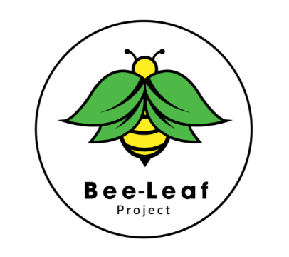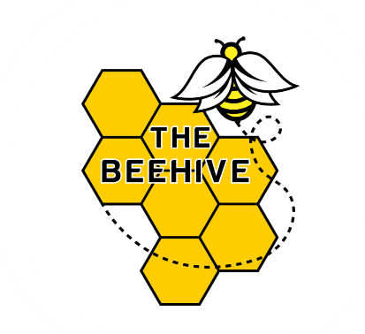

The Beehive Independent School

Curriculum Policy
Reviewed: April 2025
Next Review: April 2026

1. Statement of Intent
At The Beehive Independent School, our curriculum is carefully designed to meet the individual needs of every student. We deliver a bespoke educational experience that considers the varied and complex barriers our students face, including SEND, SEMH, trauma, and gaps in their educational journeys.
Our primary focus is on developing strong foundational skills in English and Mathematics, alongside essential life, independence, and self-esteem skills. Through a personalised and flexible curriculum, we empower students to re-engage with education, achieve their aspirations, and prepare for the challenges of adult life.
We offer a broad, practical, and creative curriculum that bridges learning gaps, develops social communication skills, and supports emotional well-being. Our environment provides students with a safe space to explore, express, and develop a wide variety of skills, both academic and vocational.

2. Focus and Ethos
At The Beehive, we recognise that not all students are "ready to learn" at every stage of their journey. Therefore, we adopt a relationship-based, trauma-informed approach that places the student’s moral, emotional, and domestic needs at the forefront.
Teaching and learning are delivered flexibly through:
- One-to-one and small group sessions
- On-site and off-site education
- Academic and vocational mentoring
- Student-led activities and mentor-guided interventions
We promote healthy decision-making and reflective practice, embedding these principles in both staff development and student learning. Our ethos is centred on building positive relationships, fostering resilience, and encouraging every student to take ownership of their educational journey.

3. Curriculum Structure
The Beehive’s curriculum is designed to be flexible and personalised, enabling each student to work towards accessing a full and varied timetable.
Each student follows an individualized Pathway Plan, developed in collaboration with staff, the student, and their family. The plan sets clear goals and milestones, encouraging motivation, ownership, and empowerment.
A full subject timetable is accessed once students demonstrate:
- The social, emotional, and mental health capacity to engage in a small group learning environment
- Progress, achievement, and motivation in core subjects
Pathways are regularly reviewed and adapted to meet students' evolving needs, ensuring a dynamic and responsive learning experience.

4. Core Subjects
All students access English, Mathematics, the Life Skills Programme (LSP), and Personal and Social Development (PSD).
English focuses on communication, reading, writing, and creative literacy across the school day, with incentives for daily reading.
Mathematics integrates numeracy across practical and academic activities, leading to Functional Skills qualifications.
Life Skills Programme (LSP) builds confidence, self-esteem, independence, and respect for self, others, and the community.
Personal and Social Development (PSD) helps students explore key life topics such as relationships, mental health, safety, and future aspirations.

5. Additional Subjects
Students access additional subjects based on interests and pathways, including:
- Project (ASDAN Personal and Social Effectiveness)
- Creative Design (Arts Award Qualifications)
- Food Technology (AQA Units and ASDAN FoodWise)
These subjects promote creativity, independence, and vocational skills.

6. Post-16 Subjects
Post-16 education focuses on preparing students for adulthood through:
- Continued English and Maths study (to Level 2)
- Employability skills development
- Vocational training
- Transition planning
Students work towards AQA and ASDAN qualifications relevant to future pathways. Students also have opportunities to continue exploring a range of new skills and interests, such as food technology, sports and hobbies, supporting a well-rounded development alongside their academic studies.

7. Cross-Curricular Aims
Skills in English, Maths, and PSD are embedded across all curriculum areas, helping students refine abilities and build confidence.
Cross-curricular outcomes are tracked via our Learn Trek portal, enhancing recognition of progress across subjects.

8. Fundamental British Values
Students explore democracy, the rule of law, liberty, and respect through:
- AQA British Values programme
- Student Voice elections each term
- Embedded values within curriculum content

9. Levelling
Student levels are determined during referral and transition phases based on:
Baseline assessments
Tutor feedback
Observations and Learning Walks
Levels are reviewed regularly by the team to ensure challenge and celebrate all progress.

10. Curriculum Planning
Curriculum planning includes:
- Long-Term Plans (curriculum structure and goals)
- Medium-Term Plans (termly, differentiated schemes of work)
- Short-Term Plans (flexible daily lesson plans)
The Director of Education reviews planning regularly to ensure high quality and relevance.

11. Delivery of the Curriculum
The curriculum is delivered through:
- Alternative Provision / Life Skills Programme
- The Beehive School Placement
- The Pathway Approach
Teaching methods include small group sessions, 1:1 and 2:1 support, distance learning, and work placements where appropriate.

12. Curriculum Evidencing
Student progress is evidenced through:
- Reflective journals
- Worksheets and portfolios
- Practical project work and creative outputs
- Annotated photos/videos
Evidence is used for assessment, planning, and reporting purposes.

13. Pupil Assessment Procedures
Assessment is ongoing and includes:
- Daily formative feedback
- End-of-lesson assessments (Independent/Supported work)
- End-of-topic/unit reflections (Independent/Supported work)
- Observations and group work reviews
- Termly moderation of work contributing to qualifications

14. Qualifications
Students work towards accredited qualifications:
- Creative Design: Arts Award Discover/Explore/Bronze/Silver
- Maths and English: Pearson Functional Skills Entry Level 1–3, Level 1–2
- Science: ASDAN Short Course
- PSHE: ASDAN Short Courses
- ICT: Pearson Functional Skills
- Food Studies: ASDAN FoodWise
- PE: ASDAN Short Courses
- Project: ASDAN Personal and Social Effectiveness
- Pathways: Internal AQA Unit Awards

15. Progress Data
Progress is monitored through:
- Termly student progress reports
- Weekly attendance and behaviour data
- Learn Trek portal tracking
- Qualification outcomes
Senior leadership meets regularly to ensure data informs intervention and planning.

Definitions and Abbreviations
SEND: Special Educational Needs and Disabilities
SEMH: Social, Emotional, and Mental Health
ASDAN: Award Scheme Development and Accreditation Network
AQA: Assessment and Qualifications Alliance
PSD: Personal and Social Development
LSP: Life Skills Programme
CPD: Continuing Professional Development

