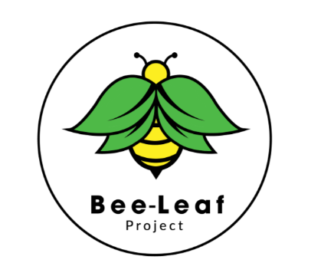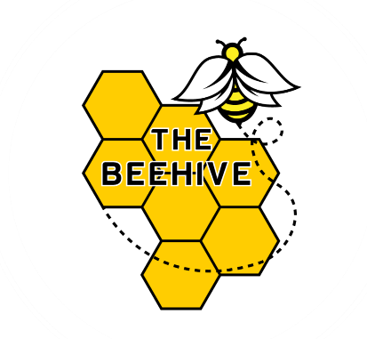

**Admissions Policy**

1. **Introduction**

Our policy reflects the DfE guidance, in particular ‘School Admissions Code’ (DfE 2021).

This policy should be read in conjunction with the policies listed below:

• Safeguarding and Child Protection

• Curriculum Policy

This policy aims to outline the admissions process of our school, as well as provide relevant information to families and students.

The purpose of this policy is to:

• Ensure the school discharges its legal responsibilities

• Ensure the school is able to meet the needs of the pupils referred & the requirements of their EHCP

• Ensure new referrals do not adversely affect the learning of those pupils already attending

• Ensure it is inclusive in its approach to student needs

• Ensure admission is linked to the school ethos and vision for learning

1. **Admissions Arrangements**

The Beehive School is an independent school for pupils between the ages of 11-18 years. We offer placements to students with a range of Special Educational Needs, complex needs and for whom their educational journey has been disrupted or fractured.

The school accepts referrals from the Local Authority and will also be open to consider privately funded admissions if appropriate.

Entry points for students can be at any time, in any year group; however the school are of the view that it is often better for students if they start their placement with our school at the beginning of a term/half term for transitional and preparation reasons.

The school’s admission’s criteria are;

* Student’s ideally must have an EHCP that stipulates a specialist / SEN school is required or be in the process of having one written.
* The school would also consider students without an EHCP if there are additional needs that could potentially mean an EHCP is required. Please discuss with Head of School in advance.
* Funding must have been agreed from the LEA to fund the placement with The Beehive Independent School

Alongside these three criteria, admissions will be made based on each individual student’s needs, background and experiences. The Beehive School is of the view that careful matching of student and educational provision can be key in optimising the educational opportunities and attainment for students. Thus, as part of the referral process, staff will visit potential students at home and will discuss with them and their parent(s) the needs set out in their EHCP and how The Beehive may be able to meet them. If the school feel they are able to meet the student’s needs, initial visits will be used to create a Pathway with the learner and their parent/carer to determine the areas that they need support and development in.

A decision on where the student will start in terms of levels will be made during the transition process, with this considering the students' abilities, experiences, and confidence. At The Beehive believe in building up students' confidence and part of our approach to this is ensuring any work is targeted at an accurate level and that any gaps in learning are identified quickly. Adjustments will be made where necessary to ensure each student is working at the appropriate level and can be challenged to fulfil their potential. This can and will be reviewed at any time in the school year, and we will gather information from the educators and assessments to guarantee that these assessments are based on accurate data.

Written by: Charlotte Pratt

Date; 29/07/24

To be reviewed: 29/07/25