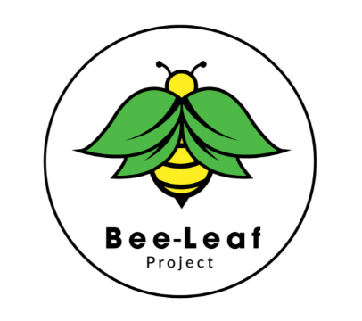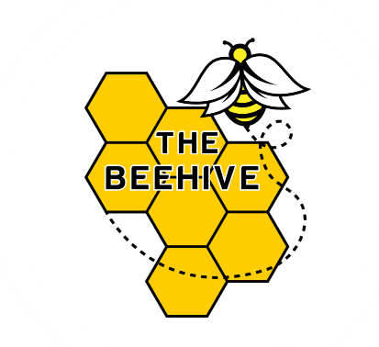

**Statement of purpose**

**Who are we?**

Bee-leaf Project Ltd is an independent community organisation offering individualised and needs based, youth mentoring and other specialist intervention services to the children, young people & families.

Bee-leaf Project is made up of 3 main directors who have many years of experience and expertise in working with children and families. The background of the company’s board of Directors is within the fields of social work, youth work, residential childcare, and special education.

Throughout the careers of the Directors, they have developed first-hand experience and knowledge around the power, that a positive and healthy relationship with those we work with, is key to them getting the best from those supporting them.

**About Bee-leaf Project**

Our mission is to meet the following the outcomes:

* Unearth the excellence of youth through meaningful relationships
* Raise awareness and understanding of the struggles and challenged faced by individuals and groups
* Improve the resilience and emotional health of our community
* To challenge and address areas of harm, including those more hidden, that young people, and their families face
* To challenge and address oppression, discrimination and stereotyping faced by young people, families and society
* To provide positive, enduring, trusting, loving, genuine and meaningful relationships to young people and families.

Our mission is to help young people develop healthy strong relationships that allow them to reach their full potential by creating a world in which children and young people's social and emotional needs are better understood and met.

**Services we are currently offering**

Bee-leaf Project services are tailor made to meet individual needs, meaning we are able to be more personal, flexible and accommodating.

**Alternative Provision packages**

Individualised learning experience package which could include mentoring in the school setting, within the home or out in the community during and after traditional school hours (part time provision only)

**Family respite Support packages**

Flexible hours to provide respite for young people and their families to support the family to remain together or to support kinship carers who are caring for children within their family.

**Specialist Intervention packages**

Specially designed for young people who are at risk in the community, for example experiencing sexual or criminal exploitation, are involved in anti-social behaviour, are involved in the criminal justice system or have frequent missing periods from home.

**Whole Family Specialist Intervention packages**

Designed for ‘high risk’ families who currently have children's services involvement but for whom standard services are ineffective or not appropriate, and where there is a high risk of family breakdown.

**The Beehive Independent School**

Bee-Leaf Project are passionate about the access to a fair and appropriate education that meets the needs of all young people. We believe that there should be a holistic approach taken to education, with there being focus and support on academic attainment, social skills, physical/ emotional health, independence and life skills. The Board of Directors have experienced many young people not being provided with an education that considered their individual needs, often resulting in placements ending, challenging behaviour being displayed or non-attendance.

The consistency and routine of an educational establishment where all children feel safe and that they belong to are paramount to them developing their full potential. The Bee-Leaf Project school, which we will be calling The Beehive Independent School, will ensure no child that enters our doors will ever feel alone, scared, let down or rejected. There is a large gap in East Sussex for schools that are able to work with students that require a more individualised approach, and Bee-Leaf alternative education & The Beehive Independent School have been designed to address this. We will cater for students that require flexibility in teaching styles and environments, and not that simply fits within traditional education systems and societal expectations.

**About the Beehive Independent Schools Provision.**

The Beehive will take a bespoke approach to teaching and learning. It aims to address the basic moral and domestic needs of the students, whilst recognising that not all of them are ‘ready to learn’ at all points in their educational journey. This will be achieved through a model of one to one and group learning, on and off-site education, academic and vocational focus mentoring and relationship-based practice. There will be a focus within our curriculum on encouraging students to make healthy decisions for themselves through student-led activities and mentor-guided interventions.

Bee-leaf project & The Beehive Independent School believes firmly in a reflective practice model, and this is incorporated into the curriculum both in terms of staff and students.